Health Announcements Grade 6-12 2019
October – Vaccines Work
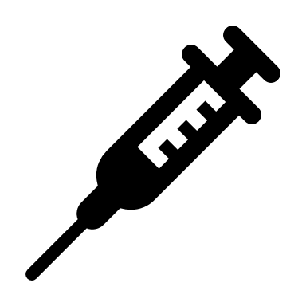
- As you grow, the protection you receive against diseases from some childhood vaccines begins to wear off. For the protection to continue, boosters are required against these diseases. Protect yourself and stay up to date with your vaccinations!

- Vaccines save lives. Without vaccines, we can expect to see more outbreaks of the diseases that we are now protected against. Protect yourself from disease and get vaccinated.

- Vaccines protect the people who get them and the people around them. When enough people are vaccinated, those who are not immune to the disease (like those who have lowered immune systems) are protected too! Protect yourself and others and get vaccinated.

- The best way to ward off illness, like the flu, is to take care of yourself. Eat well, drink lots of water, get enough sleep, wash your hands frequently and get your flu vaccine.

- This month is immunization awareness month. We remember that immunization is the best way to protect our health from diseases that could cause serious complications and harm. We thank those who get all of their vaccines to keep our students safe and our school healthy.

