Canterbury High School News  80 Main Street, Canterbury, NB. E6H 1L3 |  |  | April/May 2015  Newsletter
Vice- Principal: Mr. Jeff Tompkins Phone: 279-6000 Website: http://web1.nbed.nb.ca/sites/district14/chs Principal: Susan Mabie
Important Dates  April, 2015  3^{rd &} Good Friday Holiday  6th Easter Monday Holiday  7th K-12 Report cards to home  8th HPV #3 Gr. 7 girls’ immunizations  Also, Gr. 9 students who missed  Meningitis vaccine last fall –bring  In permission slips before the 8th.  9th 5:30 pm PSSC  7 pm – Course selection information Session gr. 9-12  10th No school for students  9 am –Course selection  information Session gr. 9-12  am-Parent/Teacher interviews  pm – PD for teachers  23rd 9 am –Meduxnekeag presentations in library  30th 4-ll:30 pm –Evening trip to the  Playhouse in Fredericton. Permission slips were sent home.  May, 2015  1st Provincial Council Day  No school for students  11th NBTA Branch Day  No school for students  14th 6-8 pm-Art Show/Music Performances/Open House  (mark this date on your  calendar, don’t miss it!)  17th Victoria Day Holiday  20th 9-10 am-Volunteer Tea in Library  21st Marne Run  27th 7 pm -Athletic Banquet (Adm: $3)  28th Noon – Track & Field -6-12  CHS ATHLETICS  Badminton Regionals April 10/11 at CHS (TBD)  Badminton Provincials April 17-18 @ Saint Quentin (beginning at 6 pm on April 17th)  Track and Field training (run, jump, throw) for Middle & High School students will begin on Tuesday, April 14 @ 3:00pm. More details to follow.  Crabbe Mountain & Clay Café  Thank you to our supervisors. We had several compliments on our students’ manners and behavior at both venues.  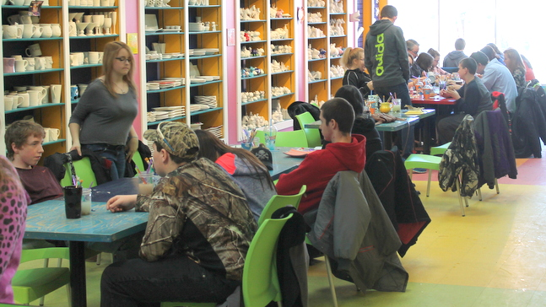  April 2015 Cafeteria Menu  Tues Wed Thurs Fri  31 Ham & French Toast or Pancakes, orange slices 1 Chinese Plate Rice, eggroll, honey garlic meat balls, stir fry 2 Pizza Day Regular, barbeque chicken or veggie 3 Good Friday No School  7 Subs served with Seasoned Potato Wedges 8 Chicken & Veggies in gravy served on a biscuit 9 Pizza Day Regular, barbeque chicken or veggie 10 No School Parent Teacher AM CD day PM  14 Lasagna & Cesar Salad 15 Pork roast with potatoes and veggies 16 Chicken Fajita & Seasoned Potato Wedges 17 Pizza Day Regular or Veggie Pizza  21 Beef Stir Fry, Rice, & veggies 22 Orange Ginger Chicken & Rice or 23 Bacon Wrapped Barbecue Chicken, Potatoes, Veggies 24 Pizza Day Regular, Hawaiian or veggie pizza  28 Shake & Bake Chicken, potatoes, veggies 29 Hawaiian Pineapple Chicken, potatoes, Veggies 30 Pizza Day Regular, Hawaiian, Veggie or BBQ chicken May 1 No School Professional Development Day  May 2015  Tues Wed Thurs Fri  5 Quiche & Homefries, fruit 6 No Cafeteria (Dessert Theatre) 7 No Cafeteria (Dessert Theatre) 8 Pizza Day Regular, barbeque chicken or veggie  12 Beef & Veggie Stir Fry served on rice Milk & Dessert 13 Soft wrap beef tacos & toss salad, dessert, milk 14 Spaghetti & Garlic Bread, Caesar Salad 15 Pizza Day Hawaiian, regular, veggie, Meal  19 Hawaiian Chicken, Rice, Veggies 20 Breakfast Meat, eggs, pancakes 21 Barbeque Items 22 Pizza Day Hawaiian, regular, veggie, Meal  26 Barbeque Items 27 French Toast & Ham 28 Barbeque Items 29 Pizza Day Hawaiian, regular, veggie, Meal  Skip-a-thon for K-12 on May 28 @ Noon--Donations to benefit Mrs. Grant.  FREE SALAD BAR: A big “thank you” to our friends at Sabian for sponsoring our free salad bar. It was enjoyed by all! | YEARBOOK INFORMATION  Yearbook---Last call for any final parent messages to their graduates as well as anyone who wishes to buy a congratulatory ad with grad's environmental -1/8 size ad 25.00, 1/4 size ad 40.00, ½ page ad 60.00 and full page ad -110.00. These will be due on April 09th.  PRE-K ACTIVITIES  Library Mornings - April 7, 14, 21, 28 & May 5, 12 from 10 – 11:00 am.  Monday, May 25th – 9-11:30 am. Pre-K day for next year’s Kindergarten class. Present Kindergarten students stay home.  GUIDANCE NEWS  April 1st – registration deadline for the Student Legislative Seminar for gr. 11 & 12  April 2nd –8:30 am - Canadian Forces presentation for students interested in learning more about the opportunities with the Reserves.  Register by April 16th for the 9th Annual NB English High School Programming contest held at UNB-SJ on Friday, May 8th.  Grads: Visit the CHS website under “Guidance” to view the monthly calendars for scholarship information. It is updated regularly with new and exciting opportunities for all students!  " Making a Difference With Muffins" by Grade 2  Each year the grade twos raise money for a specific charity. This year students sold muffins and lemonade in support of Grandmothers Against Poverty and Aids (GAPA) a self- help project in Khayelitsha Township, outside Cape Town. African grandmothers are central to the life of their communities. With almost no support, they have stepped forward to care for millions of orphaned children.  The money raised by the CHS grade two class was forwarded to Miss Sumner’s sister Alex who works in Cape Town, South Africa. Desperately needed non-perishable food items along with household and educational goods were purchased and placed directly into the hands of four GAPA volunteers including two of the grandmothers themselves. The $184.00 raised converts to over 1800.00 South African Rand (ZAR), a significant amount of money in S.A. which goes much further in terms of its purchasing power than it would in Canada.  We would like to thank the many teachers and parents who baked muffins for our fundraiser and those who supported us through sales and donations. Miss Sumner  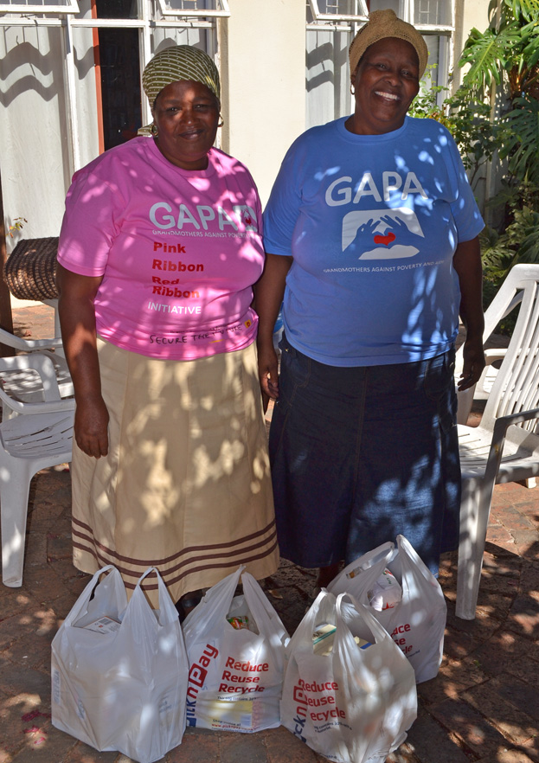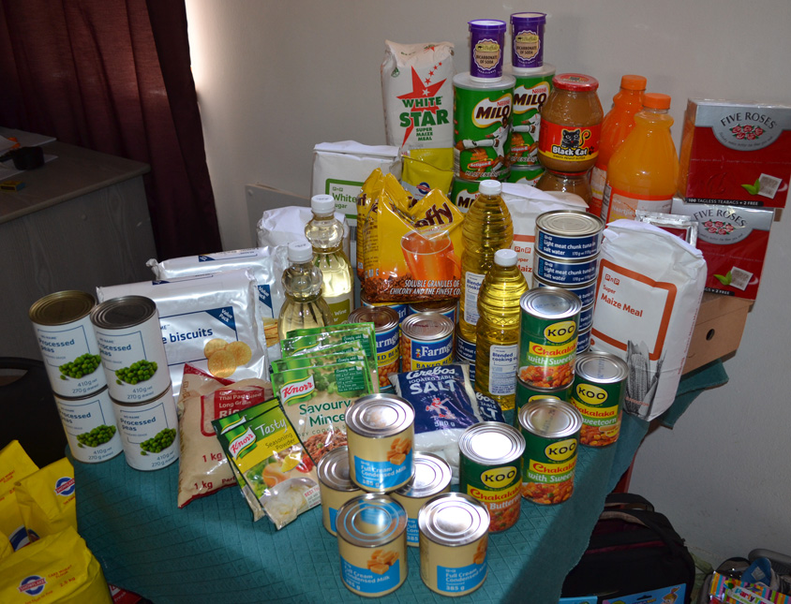  Some of the supplies purchased.  