Post-Secondary Reminders

 | January 2016
Sun | Mon | Tue | Wed | Thu | Fri | Sat
 |  |  |  |  | 1 | 2
3 | 4 | 5 | 6 | 7 | 8 | 9
10 | 11 Donald R. Sobey Scholarship  *********************************  King’s Theatrical Society Award  Herbert H. Carnegie Future Aces Foundation | 12 | 13 | 14  CEMF Women Engineering | 15  Top 20 Under 20 | 16
17 | 18 | 19 | 20 | 21 | 22 | 23
24 | 25 | 26 | 27 | 28 | 29 Union plus Scholarship  *********************************  McEuen Undergraduate Scholarship For study in Scotland | 30
31 | Notes: 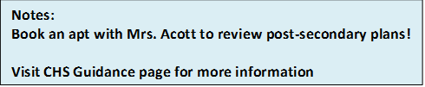
Visit: www.scholarshipscanada.com
www.studentawards.com
www.canlearn.ca
www.studentaid.gnb.ca

