Canterbury High School News  80 Main Street, Canterbury, NB. E6H 1L3 |  |  | November/December Newsletter  2015
Vice- Principal: Mr. Jeff Tompkins Phone: 279-6000 Website: http://web1.nbed.nb.ca/sites/district14/chs Principal: Susan Mabie
November 18th – 20th
Wednesday & Thursday – noon hour for students and K-5 will have scheduled class visits if you wish to send money with your child. Parents can check out the Book Fair Thursday evening -3-7 pm or Friday morning 8:30 – 11:30 am.

Thanks to our Sponsor Board Donors:
- Murray’s Restaurant
- Cummings’ Irving
- Fillion Forestry Ltd.
- Village of Canterbury
- Reg Keilty Ltd.
- Ayr Motor Express
- Village of Meductic
- All Seasons Realty
- Gauvin Flooring
- NBCC Woodstock
- Prism Construction/Trenchless Solutions Inc.
- Stairs Building Ltd.
- Susie’s Photography
- Keilty’s Septic
- Currie’s Hardware

Dance Oct. 29th - $5.00
Dance for grades 6-12 from 7-9 pm Admission is $5 which includes a ticket for the Sundae Bar and a water/ pop.

Sr. Basketball Parent Meeting Oct. 29th 7:15- 7:45 pm for ALL Parents at the CHS Library
If you are unable to make this mandatory meeting, please call the school and set up an appointment with Mrs. Wright and Administration to go over the new athletics policies and changes for CHS teams (One parent must attend before play begins.)

Book Fair

Important Dates
November
3rd 2 pm –MADD assembly
Grades 9-12 in gym

4th Gr. 9 -Take Your Kids to Work
Gr. 10 First Aid training

5th 10-11am –Live Different Pres.
Grades 7-12

8th 2 pm – Remembrance Day
Service for community

9th 10:50 am –Remembrance
Day Assembly for school

11th Remembrance Day No School
13th 9-12 Report Cards go home

19th K-8 Report Cards go home
4-7 pm –Parent-Teacher

20th 8:30-11:30 am Parent-Teacher
PD for teachers- afternoon
No School for Students

26-27th WE day –Halifax - Selected
Middle & High school students

28th School Picture Retakes

December
2nd 7 pm –Dessert Theatre
“Robin Hood”
4th UNB Presentation 9-12

9th Christmas Dinner – Free
Sponsored by Sabian Employees

10th 7-9 pm Winter Semi-Formal
Dance Grades 6-12

17th 9 am & 1:30 pm
“Christmas Concert”

18th Last day of school before
Christmas Break – full day

 | Voice Mail-When messages are sent, if you hear a silence, you may simply press “1”, which sends a signal that a live person is on the line. The silence allows for a recording, background noise or other noise before it begins.
Pre –Kindergarten Dates
EYE – Da Assessment – Nov. 16th
Parent Info Meeting Oct. 29 at 5:00 pm
Welcome to Kindergarten Visit #1 for students is January 21st 2:30 -3:30 pm

Cross Country Results
Landy Graham (1st) & Alexa Grant (2nd) in Grade 3 Elementary Cross Country.(below left)
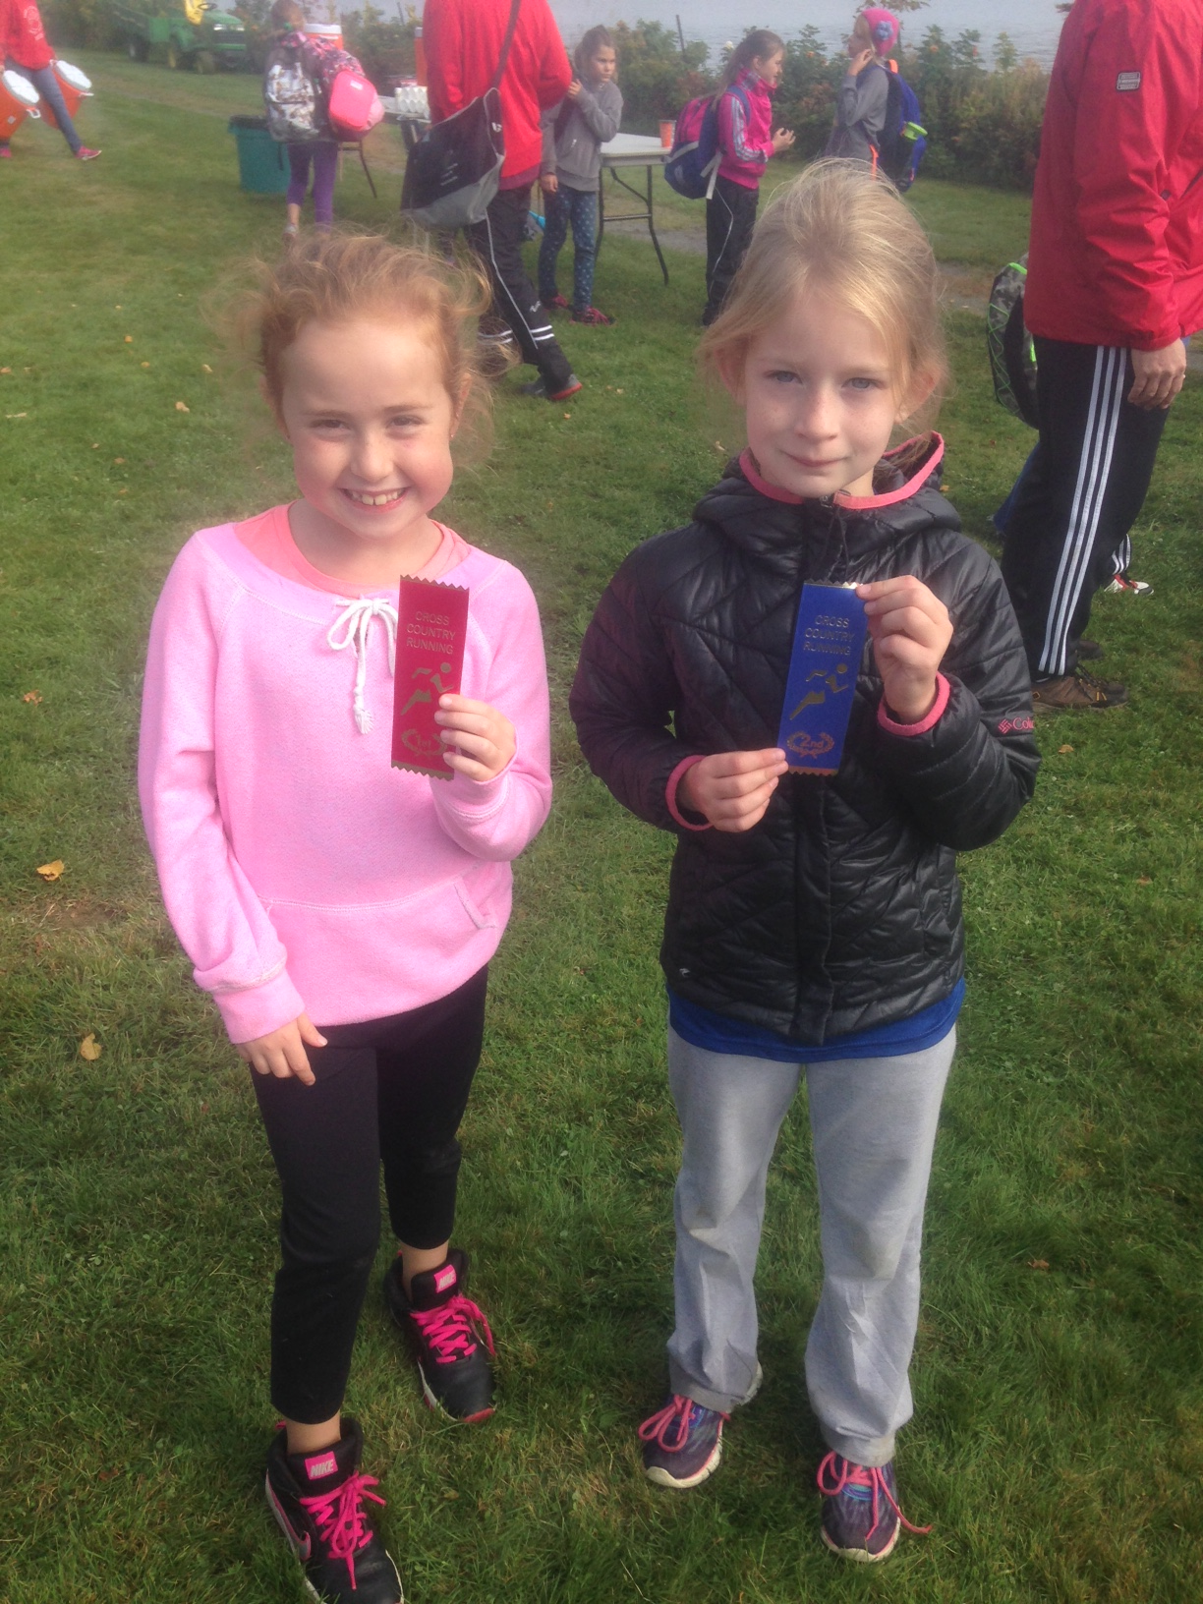
Paige Luimes at JV Cross Country Regionals. (Above right)

Samantha Taylor, Riley Taylor & Addison Bell qualified for the 2015 Team NB Atlantic Cross Country Championship .
Congratulations!
Athletic News

Tuesday, Nov. 17
HHS @ CHS Varsity Girls 6:00pm
HHS @ CHS Varsity Boys 8:00pm
Wednesday, Nov. 18
CHS Mini Boys @ HCS Mini Boys 6:15pm
CHS Varsity B Boys @ WHS JV Boys 7:45pm
Nov. 20-21
CHS Varsity B Boys @ NHS Tournament
Tuesday, Nov. 24
CHS Varsity Girls @ NHS Varsity Girls 6:00pm
CHS Varsity Boys @ NHS Varsity Boys 8:00pm
Monday, Nov. 30
JCS Varsity Girls @ CHS Varsity Girls 6:00pm
JCS Varsity Boys @ CHS Varsity Boys 8:00pm
Thursday, Dec. 3
CHS Varsity Girls @ WHS JV Girls 7:45pm
Friday/Saturday Dec. 4-5
CHS Varsity B Boys Home Tournament
CHS Varsity Girls @ Peggy McAleenan Tournament
CHS Varsity Boys @ FCA Tournament
Tuesday, Dec. 1st
Grade 6 Badminton Zones hosted by CHS
Wednesday, Dec. 2nd
Grade 7 Badminton Zones hosted by Townsview
Thursday, Dec 3rd
Grade 8 Badminton Zone hosted by Meduxnekeag
CHS Varsity Girls @ WHS JV Girls 7:45pm
Monday, Dec. 7th
WHS JV Girls @ CHS Varsity Girls
WHS JV Boys @ CHS Varsity B Boys
Tuesday, Dec. 8
CHS Varsity Girls @ FCA Varsity Girls 6:00pm
CHS Varsity Boys @ FCA Varsity Boys 8:00pm
Friday, Dec. 11
CHS Celtics Home Tournament
CHS Varsity B Boys @ Hampton High Tournament
Monday, Dec. 14
NHS Varsity Girls @ CHS Varsity Girls 6:00pm
NHS Varsity Boys @ CHS Varsity Boys 8:00pm
Tuesday, Dec. 15
WHS Mini Boys @ CHS Mini Boys 6:00pm
Thursday, Dec. 17
HCS Varsity Girls @ CHS Varsity Girls 6:00pm
HCS Varsity Boys @ CHS Varisty Boys 8:00pm
Friday, Dec. 18/19
CHS Varsity Boys @ Harvey High Tournament
Friday, Dec. 18-20
CHS Mini Boys @ HCS Mini Boys Tournament

Thank you to Mrs. Wright for coaching our Cross Country Teams!

