
CHS January/February
Newsletter 2016
Phone: 279-6000
Principal: Mrs. S. Mabie
V P: Mr. J. Tompkins
80 Main Street
Canterbury, NB
E6H 1L3

Important Dates**Revised Jan. 25th  January  25-29 th Exams Grades 9-12  February  1st Grade 5 – first day of English term  1st & 2nd Turn Around Days- Grades 9-12  3 First day of semester 2  5 K-8 Theatre NB presentation at CHS  8 Report cards grades 9-12  17 Active Boys (gr. 8 boys to Nackawic)  21 Pre-K -9:30-11:00 in Library  March  2 Dance Grades 6-12 from 7:00-9:00 pm  3 Grades 6-12 field trip –Crabbe Mountain  or Curling/Bowling in Woodstock  3 Elementary Fun Night 3-5 pm  7-11 MARCH BREAK  21 9:30-11:00 am- Pre-K in Library  22 Grades 5-8 –Field Trip to Science East &  École Ste. Anne – French music show  24 8:30-noon –K-12 students  African Culture & Dance Performance  25 Good Friday Holiday – No School  28 Easter Monday Holiday – No School | Congratulations to our December Students of the Month  K-1 Jaylynn Dickison  1-2 Tanika Pawsey  2-3 Landen Graham  3-4 Gavin Irwin  5 Kyla Jewett  6-7 Eliza VonKeutz  7-8 Jennifer Ketch  9 Allyson Cummings  10 Jonathan Williams  11 Kyle Churchill  12 Sarah Grant  PSSC Meeting Wednesday, Jan.27th - 5:30 pm  ATHLETICS  Thank you to our sponsor board sponsors!  - Murray’s Restaurant  - Cummings’ Irving  - Fillion Forestry Ltd.  - Village of Canterbury  - Reg Keilty Ltd.  - Ayr Motor Express  - Village of Meductic  - All Seasons Realty  - Gauvin Flooring  - NBCC Woodstock  - Prism Construction/Trenchless Solutions Inc.  - Stairs Building Ltd.  - Susie’s Photography  - Keilty’s Septic  - Currie’s Hardware
Winter Carnival – Feb. 29th to March 4th
We will be having a regular week of instruction. There is a dance March 2nd for grades 6-12 and an K-5 Fun Night March 3rd. Dress up days: Mon- PJ Day, Tues- 80’s, Wed. – Team Jersey, Thurs- Blue Gold, Friday- Crazy Hair/Hat or clothing.
Raz Kids K-4 Reading Program
Don’t forget your children have passwords to an on line fun reading program from K-4. If you have lost their password, teachers would gladly send it to you. Some student have been on line reading for over 60 hours since we introduced this program in the fall. Don’t forget Family Literacy Week!

Valentine Carnations and Roses For Sale – Delivery February 11th or 12th
Orders can be placed at noon hour on February 4th & 5th
Roses $3.00, Carnations $2.00 each
Elementary Fun Night – March 3rd from 3:00 - 5:00 pm (K-5)
Our teachers K-5 are organizing an elementary fun night on Thursday, March 3rd. Cost is $3.00 which includes pizza and a drink box or milk. Please be here to pick your child up by 4:55 pm.
After School Art Club grades 4-8
We are pleased to share that we will be starting a 6 week after school art club in March-April organized by the Andrew and Laura McCain Art Gallery in Florenceville and sponsored by Sabian. This is a great opportunity for students to have art lessons and time to explore art. Details have not yet been finalized but we will soon be asking students about their interest in this program and permission slips will be sent home with those interested. It will run for 6 weeks from 3:00- 5:00 pm.
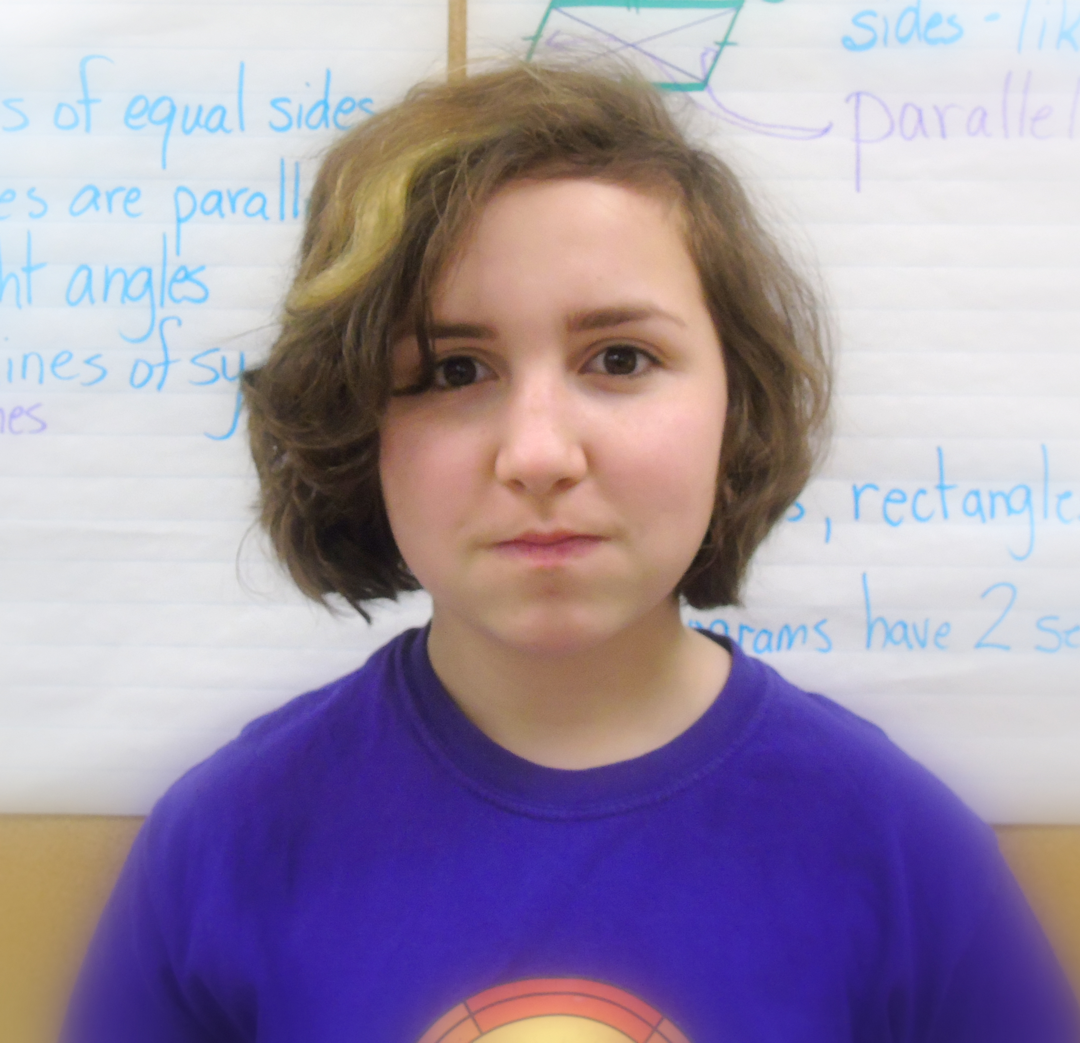
CHS Published Author: Rachel Brown, Grade 5
We would like to congratulate Rachel who recently had her story, “The Waking World”, published in a book called, The Chance by Polar Expressions Publishing. Rachel loves to write and we look forward to reading more from this young author!

Staff Changes:
Welcome to Mrs. J. Reynolds who is teaching high school in the mornings and our grade 2-3 class in the afternoons.

Mrs. Acott is our guidance teacher until June should you have any guidance related questions. Congratulations to Mrs. MacDougall on the birth of a baby boy!

Mrs. Dempsey will be on leave second semester and a new music & art teacher will be joining us.

