
Phone: 279-6000
Principal: Mrs. S. Mabie
V P: Mr. J. Tompkins
80 Main Street
Canterbury, NB
E6G 1L3

October/November NEWSLETER -2017
OCTOBER  23 3:05-4:25 pm- K-5 Elementary Fun Night  Send in Permission slip & $3.00 (hot dog, milk  and snack)  24 Professional Learning ½ Day - Noon Dismissal  Buses arrive home 3 hours earlier than usual  25 AARAO Tour –Nackawic grades 10-12  Grades 7 & 9 student immunizations  (Please send in signed permission)  26 8:30 am- RETAKES –Harvey Studios  7-9 pm –Halloween Dance –Grades 6-12  $3 (includes Slice of pizza)  Prizes for best costumes!  30 EYE-DA -Pre-K assessment by appointment  November  1 Take Your Kid to Work Day –Grade 9  5 Remembrance Day Service-community  6 10:30 am-Remembrance Day Assembly  7 9-12 Field trip- Fredericton Playhouse  am-Fredericton Symphony Orchestra  pm – Quartermain Earth Science Centre  10 No School for Students (Professional  Learning Day for staff)  13 No School –Remembrance Day holiday  (in lieu of 11th)    20 REPORT CARDS Grades K - 12  23 4-6:30 pm – PARENT-TEACHER meetings  Book Fair Week  24 No School for Students  Parent-Teacher am; PL –pm  29 Grades 3-8 –Calithumpians 9am-11am  30 WE DAY –leaving November 29th  Suitcase Theatre  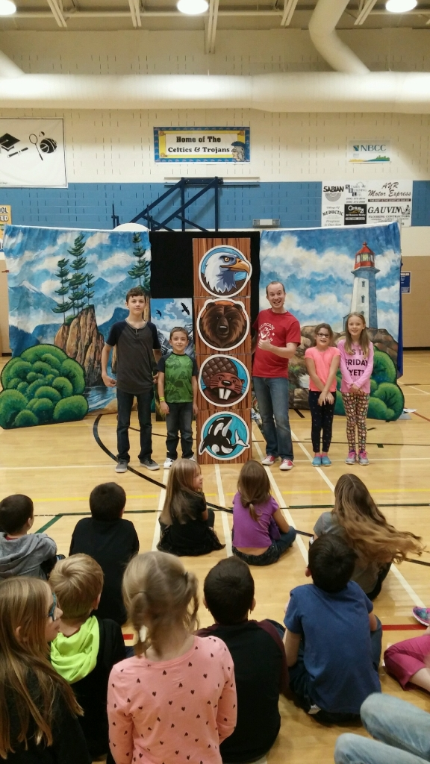  "Suitcase Theatre is a not-for-profit charitable organization created by one of the creators of Mr. Dress-up. For the past 7 years we have been bringing live theatre into schools, libraries, community centres and hospitals throughout the GTA. Our mandate is simple; we strive to create and facilitate arts experiences that are accessible to all audiences, providing a positive and lasting influence to both children and families alike. | Guidance News  See CHS Website for post-secondary info and scholarship & bursary postings  Fire Safety Week Presentations  Thank You to the Canterbury and surrounding area fire departments for their Fire Safety Presentations. K-8 students toured the vehicles after a video presentation and talk. Grades 9-12 had the chance to use a simulator to put out a flame with an extinguisher. Thank you to all the volunteers!  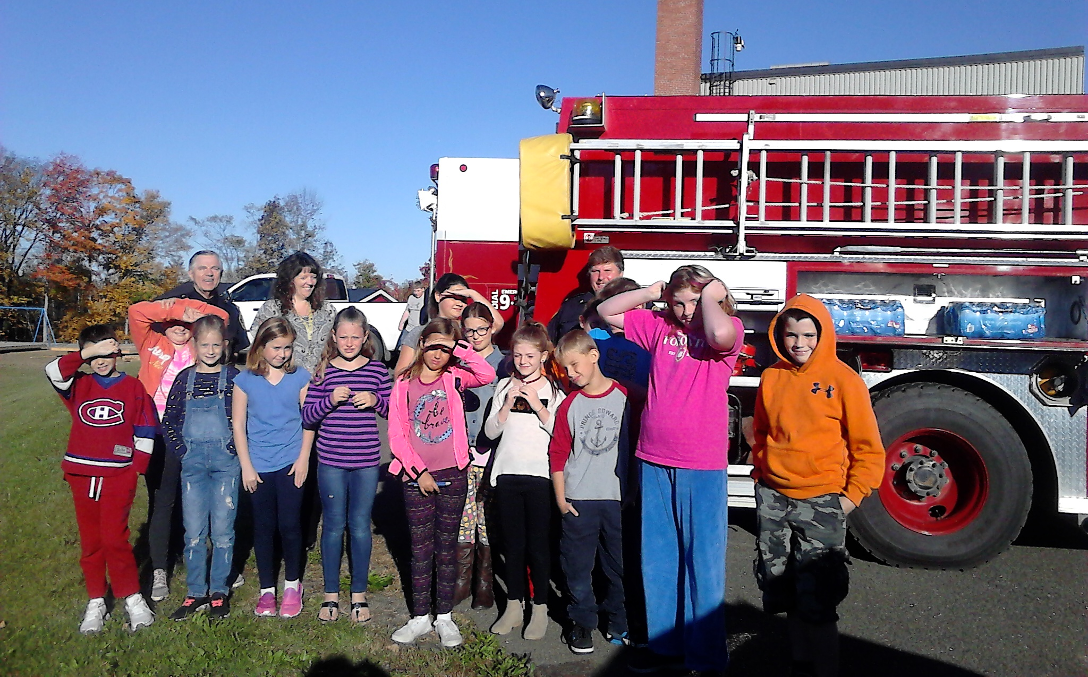  Grade 5 with the Fire Department  ******************************************  Thank You to The Canterbury TOPS 2233 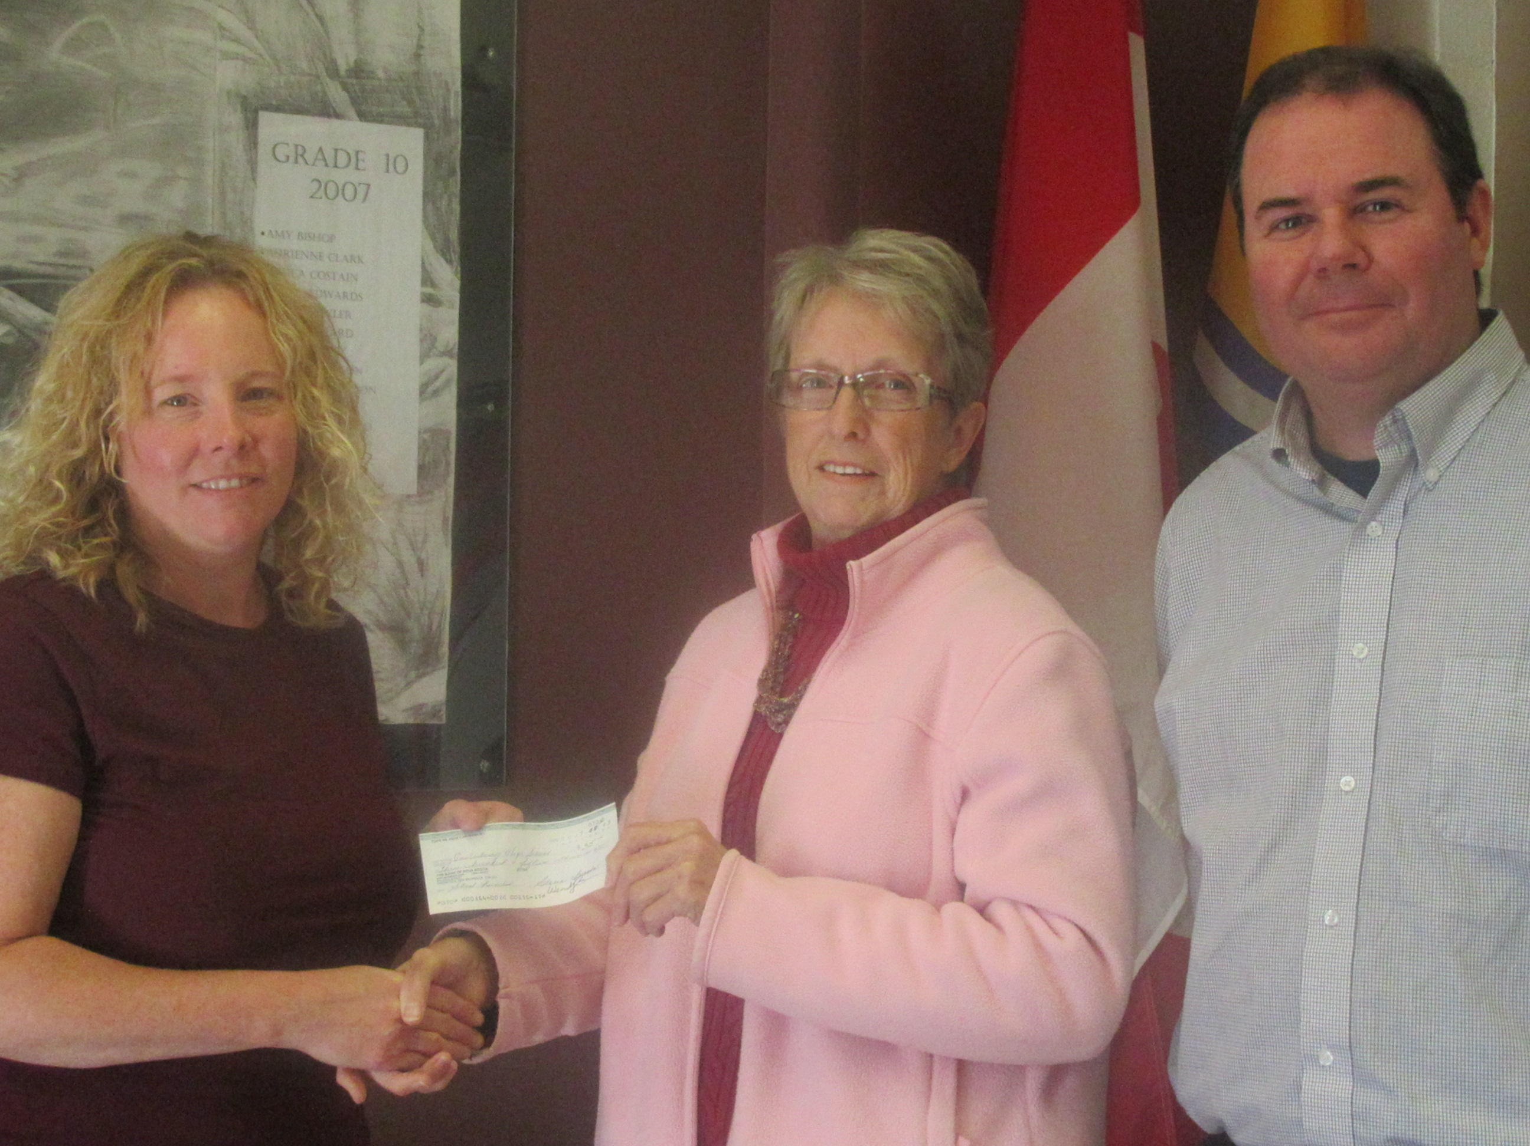  Patricia Reid presented $315 donated by Tops members for the hot lunch program.  K-5 Fun Night  Monday, Oct. 23 from 3:00 -4:25 pm  Cost $3.00  Suitcase Theatre continued…  Our most recent show "All Aboard” is an action-packed journey where the audience gets to be a part of the wonderful discovery of what makes Canada such an amazing place to live and learn. There’s something for everyone on this exciting trip across our great land! All Aboard – your Canadian adventure awaits!  School Clothing Sale in November  **Order forms will soon be sent home and orders will arrive in time for Christmas!  Book Fair  Nov. 21-24th  Welcome to Sheri Dymond who is starting as our library worker!  Yearbook News  Grads need to get photos and information as soon as possible.
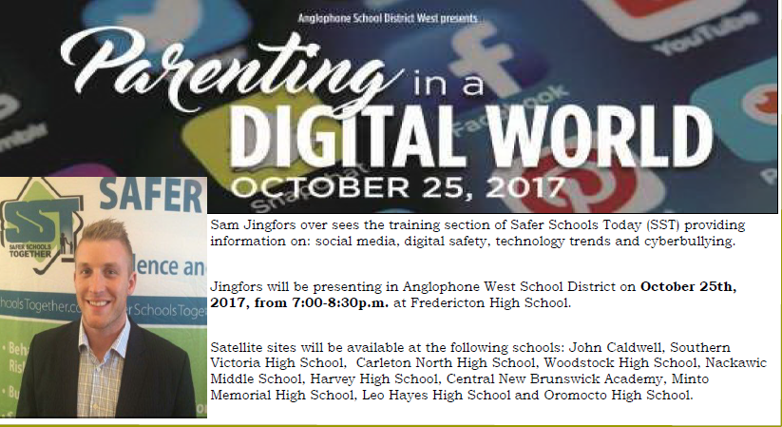
Parent Meeting for Athletes
Mandatory for each player to have a parent/guardian/family member attend in order for the player to begin practices & play. (If you are unable to attend, we will schedule an after school meeting 3-4 pm on an alternate date. Please call the office to leave your name if you are unable to attend the Nov. 7th meeting.
November 7th, 2017 from 6-7 pm
Parents can pay fees at this meeting. Fees must be paid prior to Nov.10th when the first games are scheduled.


Host Families Needed

Atlantic Education International (AEI) and our Homestay Coordinators are seeking interested host families to meet the growing demand of the NB International Student Program (NBISP) in our high schools.
Homestay families are making a difference in the lives of bright, caring students wanting to improve their English and learn about Canadian culture. Single parents, families with or without children, retirees and empty-nesters make up the hundreds of families who welcome international students in their home through NBISP each year. Students from around the globe attend our schools for varying length of stays from 8 weeks to 10 months.
It is a win-win for our schools and communities to host NBISP students. Families receive a monthly stipend to cover expenses and participating schools receive a financial contribution per student. There are over 600 international students in NB this year and we are still receiving applications from students around the world for second semester and next year.

Welcoming a student from a different country and culture into your home is both an enriching and a challenging experience. By sharing your home and offering guidance, your family becomes an important part of the international student’s life. It’s also a wonderful opportunity to develop friendships that will last a lifetime.

For more information and how to apply, contact Debbie Lutes, Homestay Coordinator for Canterbury and Woodstock High School, at debbie.lutes@bellaliant.net
or see our website: http://www.aei-inc.ca/international-student-program

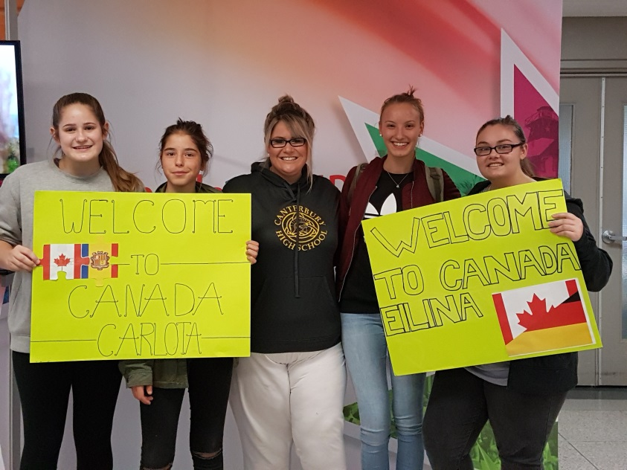

Cloutier Family welcomed two International Students to their home and to Canterbury High School

September 2017

Walk-A-Thon Fundraiser
Thank you to the Canterbury Fire Department for assisting with our annual walk-a-thon. Students raised $2875 to support.

November &December Cafeteria Menu 2017
November 6  No Cafeteria | 7  Chicken in mushroom gravy, potatoes & veggie | 8  Free Salad Bar | 9  Pizza Day | 10  No School
13  No School | 14  No Cafeteria | 15  Barbeque Pulled Pork Sandwich, potato wedges | 16  Chicken rice & cheese casserole with salad | 17  Pizza Day
20  No Cafeteria | 21  Chicken breast with cranberry & cheese, potato & veggie | 22  Roast Beef Dinner, Mash potatoes & gravy | 23  Pizza Day | 24  No School  Parent Teacher AM
27  No Cafeteria | 28  Chicken Kiev, rice & veggie | 29  Alfredo Chili or Soup & grilled cheese or biscuit, fruit or yogurt, milk | 30  Shaken Bake Chicken, bake potato | December 1  Pizza Day
4  No Cafeteria | 5  Beef Stir Fry, Rice & Veggie, dessert & milk | 6  Chicken Alfredo or spaghetti, salad, dessert & milk | 7  Subs & potato wedges, dessert, milk | 8  Pizza Day
11  No Cafeteria | 12  Lasagna & Garlic Bread, milk, dessert | 13  Tomato Soup & Grilled Cheese | 14  Christmas Dinner  K-2 $4.00  3-6 $4.50  7-12 $5.00 | 15  Pizza Day
18  No Cafeteria | 19  Subs & Chli, dessert & milk | 20  No Cafeteria  Holiday Concert  9 am and 1:30 pm | 21  Pizza Day | 22  No Cafeteria

All meals include a milk and another item such as a cookie, fruit or veggies.

