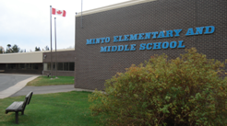
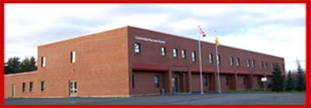
CAMBRIDGE-NARROWS COMMUNITY SCHOOL
PSSC Meeting Notes
2019-2020
C – Community N – Nurturing C- Creative S – Supportive
The C-NCS community will strive to be Honourable and United in Strength. Knowledgeable, Inclusive and Engaged in being Successful.

Date | November 20 2019 | In Attendance
Time | 6:35 |  | Bethany Kennedy, Patricia Dykeman
Location | CNCS Room 218 |  | Victoria Allen, Paige Mason
Chair | Anita Lawton |  | Crystal Whitlock-Upshaw, Emily Mercer
Recorder | Emily Mercer |  | Jennifer Thomas, Anita Lawton, Ms. Bruijns
Regrets | Ashley Lavoie, Faith Kennedy |  | Ms. Bishop, Sabrina McFarlane
 | Trish Bennet, Alexandra Torcatt |  | Gina Dunnett

DISCUSSIONS
Items | Issues Addressed/Points of Discussion/Action | Person Responsible  / Date
Call to Order | Vicky Allen, Bethany Kennedy
Approval of the Minutes | Vicky Allen, Patricia Dykeman
Business arising from the minutes | Moving Green Paper conversation to next meeting
New Business | - Education about PSSC  Gina Dunnett  Support for new members of the PSSC  Went over the ASDW website in regards to PSSC  Powerpoint  Spoke about what the PSSC can and cannot do.  Spoke about article in magazine about CNCS and recognition given  - Green paper  Gina spoke briefly about the green paper. More will be covered on this in December as we weren’t prepared for this discussion.  - Student/teacher feedback about the scheduling pilot  Ms. Bishop went over the graphs. Much discussion was had about the data. Ms. Bishop went over all of the changes that have happened in the school because of the feedback. Such as the 2-minute break becoming longer and PACK being taken away.  Some parents were concerned that high schoolers will not be ready for what comes after (university, college, etc).  - School perception survey  Ms. Bishop went over the CNCS ourschool survey data 2017-2019.  We discussed the happiness level of the students at CNCS and the male students in particular and how to get them to love school.  - Transportation meeting with Superintendent David McTimoney November 27th  - Ms. Bishop invited everyone to her supper meeting at CNCS about vaping and asked everyone to invite anyone interested – November 27  - Reminder to encourage parents to pay school fees  - Next meeting date December 4
Meeting adjourned | Vicky Allen, Jennifer Allen

