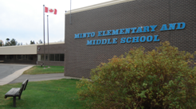
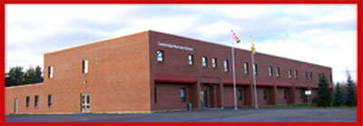
CAMBRIDGE-NARROWS COMMUNITY SCHOOL
PSSC Meeting Notes
2019-2020
C – Community N – Nurturing C- Creative S – Supportive
The C-NCS community will strive to be Honourable and United in Strength. Knowledgeable, Inclusive and Engaged in being Successful.

Date | October 16, 2019 | In Attendance
Time | 6:30 |  | Vicky Allen, Ashley Lavoie,
Location | Art Room |  | Mrs. Brujins, Paige Mason, Ms Bishop
Chair | Anita Lawton |  | Sabrina McFarlan, Crystal Upshaw
Recorder | Amber Bishop |  | Emily Mercer, Trish Bennett,
Regrets | Faith Kennedy, Crystal Upshaw |  | Patricia Dykeman, Jennifer Thomas
 | Victoria Allen

DISCUSSIONS
Items | Issues Addressed/Points of Discussion/Action | Person Responsible  / Date
Call to Order | Jennifer Thomas  Emily Mercer
Approval of the Minutes | Sabrina McFarlane, Jennifer Thomas
Business arising from the minutes | No PPT tonight  We will have it in November – Anita will contact Gina
Officers positions | Chair -  Vice Chair -  Secretary – Emily Mercer (nomination Anita, 2nd Leanda)
S.I.P | No questions came forward  A copy was given to Jennifer Thomas, Anita Lawton
New Business | New Schedule  - Survey results are in but have not been processed but data will be presented in the November meeting. Paige – expressed that students do not like the 2 min break  Student Fees  - 38 students at C-NCS are not properly vaccinated. Parents have been contacted who need to update the school records.72 students who have not paid student fees, 40 are 6-12, 32 are K-5. So the school is out $1440.00 due to the fact that we busy the student school supplies.  Green Paper  - Handed out to members, will email Anita the link for absent members. We will have a round table next month.  Grad/SRC Fundraiser  - Paige shared about the cards 30 cards (all occasions) for $30. The receive 50% 200 boxes were ordered buy 100 and we got 200. Grad class has sold about 40. SRC has sold about 6. If all are sold it is a $4200 profit fundraiser.  Holiday Extravaganza  - Student concert, holiday platters for sale, cake auction, turkey dinner to auction off. All funds will go to refurbishing the Culinary Tech room | Amber
Correspondents | None
Meeting Adjourned | Jennifer motioned  Emily 2nd  7:17 pm

