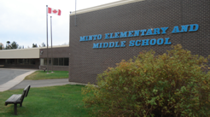
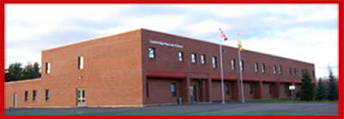
CAMBRIDGE-NARROWS COMMUNITY SCHOOL
PSSC Meeting Notes
2019-2020
C – Community N – Nurturing C- Creative S – Supportive
The C-NCS community will strive to be Honourable and United in Strength. Knowledgeable, Inclusive and Engaged in being Successful.

Date | September 25, 2019 | In Attendance
Time | 6:30 |  | Vicky Allen, Ashley Lavoie,
Location | BBT Room |  | Mrs. Bruijins, Paige Mason, Ms Bishop
Chair | Bethany Kenneys |  | Sabrina McFarlan, Crystal Upshaw
Recorder | Ashely Lavoie |  | Emily Mercer, Trish Bennett,
Regrets | Faith Kennedy, Anita Lawton |  | Patrica Dykeman
 | Jennifer Thomas

DISCUSSIONS
Items | Issues Addressed/Points of Discussion/Action | Person Responsible  / Date
Call to Order | Meeting called to order at 6:37pm  Vickky Motioned to approve the agenda with the change that there is no presentation From Gina it will be postponed until next month. Crystal seconded. Motion carried.
Meeting Dates set | Welcome of new members, website was updated to include new members.  \Date Selection for all meetings:  October 16th  November 20th  December 4th  January storm date if needed  February 5th  March 25th  April 22nd  May 27th  time for all meetings will still be at 6:30. Trish motioned to approve all date and times for meetings, Vickky seconded. Motion carried.
Correspondents | Marcy emailed to ask if the PSSC could help to cover the cost of the news letter fee. Vickky motions to spend $150 dollars for the news letter fee, Trish seconded. Motion carried.
Expression of Officer | This year the position of Secretary and vice chair will both be up. Mrs Bishop gives a brief summary of what a vice chair role is.
SIP | Mrs Bishop hands out the SIP And goes over it with the Pssc. The Graphs for the SIP did not print out and will be handed out at the next meeting.
Meeting Adjourned | Crystal motions to adjourn the meeting, Emily seconded. Motion carried.

