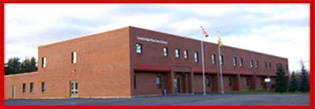
CAMBRIDGE-NARROWS COMMUNITY SCHOOL
PSSC Meeting Notes
2020-2021
C – Community N – Nurturing C- Creative S – Supportive
The C-NCS community will strive to be Honourable and United in Strength. Knowledgeable, Inclusive and Engaged in being Successful.

Date | September 21, 2020 | In Attendance
Time | 6:00 | Emily Mercer (absent),  Leanda Brujins, Heather Doherty,  Sabrina McFarlane, Ashley Lavoie,  Bethany Kennedy, James Mills,  Stephanie Crouch, Sheila Black
Location | Cafeteria
Chair | TBD
Recorder | Leanda Bruijns
Regrets | Ashley Lavoie

DISCUSSIONS
Items | Issues Addressed/Points of Discussion/Action | Person Responsible  / Date
Call to Order | 6:08 pm
Approval of the Agenda | Motion 1st – Stephanie, 2nd – Sabrina
Elections | Chair – Nomination – Ashley Lavoie, Bethany if Ashley not interested.  Co-Chair – Nomination Sabrina McFarlane if Ashley becomes Chair.  Secretary – Bethany Kennedy, Emily Mercer Nominated if Bethany changes positions.  Leanda still looking for a student Rep. (must be HS)  Message to be sent home looking for new members.
Confirmation of Meeting Dates and Times | Members will meet on Tuesday’s at 6:00 pm via Teams.  October 19  November 16  January 25  February 22  March 22  April 19  May 17
Meeting Adjourned | 6:44 pm
Next Meeting | Tuesday, October 19th

