Literacy:

Thank you to all parents for your continued support and patience. I even had a few parents and children deliver May baskets to my door. This week for Literacy I’ll be sending your child a fairytale story to read from EPIC. Beginning next week we will be working on writing fairytales so please try to read as many as you can. This week for writing I’ll be sending your child a personal letter by email to see how they are doing. I would love for them to write back. This can be done a number of ways such as a handwritten letter that you take a picture of and send me or they can even type an email or have a parent type it after it is written. Try to be creative and I hope to hear from everyone. Continue practicing sight words and when your child is reading begin working on spelling the words as well. Reading for 20 minutes a day is to continue as well. Their literacy books and dictionaries are all bagged up and ready to pick up Monday!
Have a great week!
Mrs. Fitzpatrick

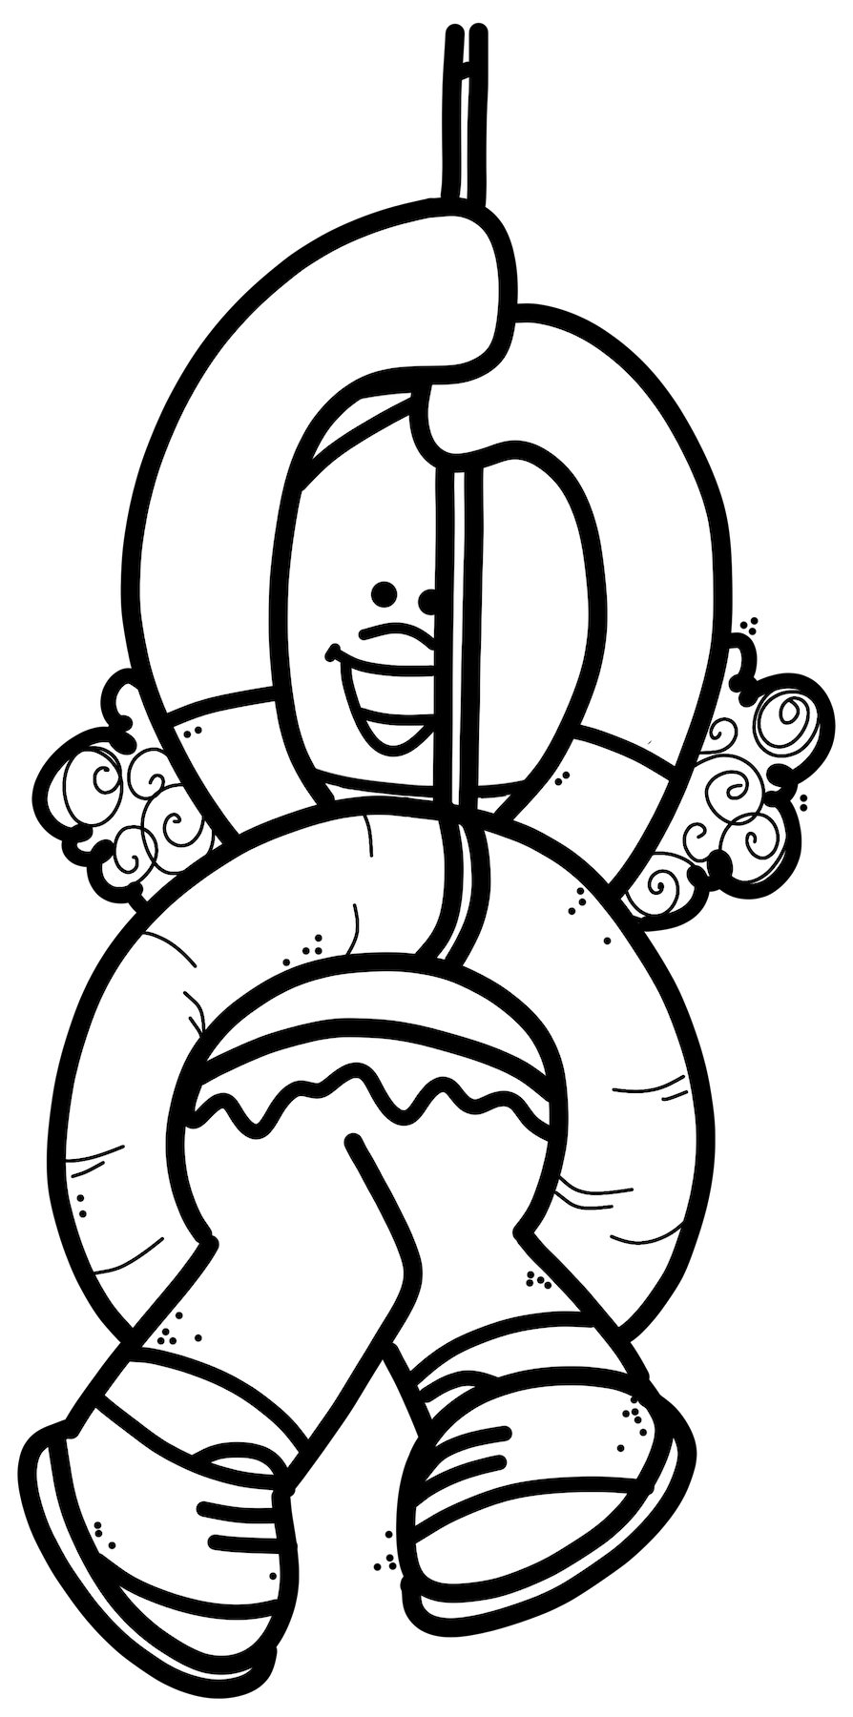
Reading Comprehension #1

At The Park

I see a lot of things when I go to the park.
I see trees at the park.
I see a squirrel at the park. The squirrel runs up a tree.
I see birds at the park. The birds are in the sky,
I see swings at the park. There are people on the swings.
I see people at the park.
I see young and old people. The people see me.
We are all having fun at the park!

- What does she see at the park?
- Where is the squirrel?
- Where are the birds?
- Who sees her?
- What else could you see at the park?
- Draw the park.

Reading Comprehension #2

Giraffes

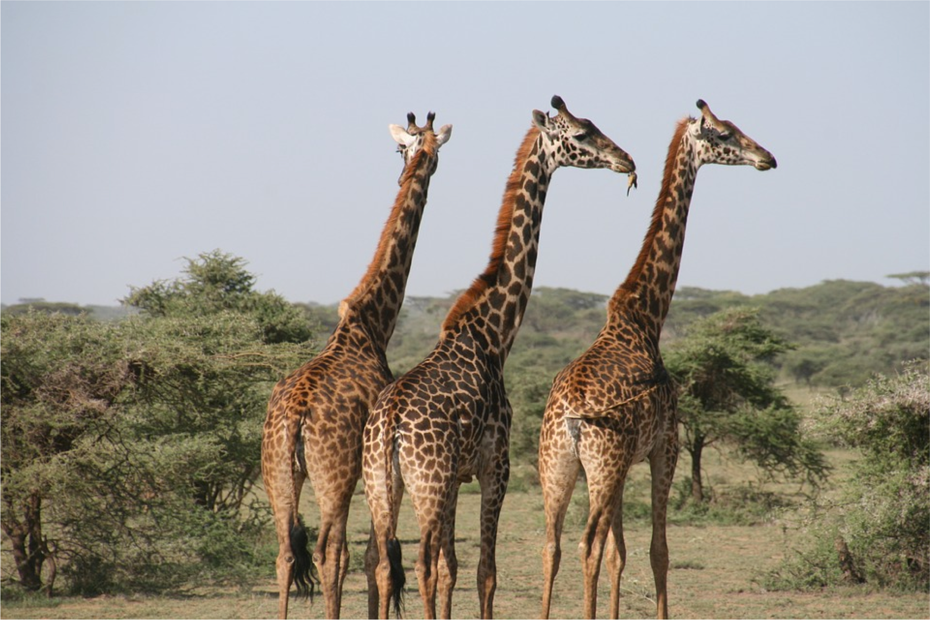

Giraffes are the tallest animal in the world.
Giraffes only sleep for up to two hours a day.
Giraffes use their large tongues to eat leaves.
Giraffes can run really fast!

- Who is the tallest animal in the world?
- How long do giraffes sleep for?
- What does a giraffe use to eat leaves?
- How quickly can a giraffe run?
- What does a giraffe look like?

Sight word practice

Sight Word Hide And Seek
Write the sight words your child is currently practicing on colorful pieces of paper and hide them all around your backyard or in your house. Then, give them a master list of the words to find and have them check them off as they locate each one.

Shoot The Sight Words With Nerf Darts
Write the words on paper (rectangle shape or use recipe cards) Tape them up around the house and either say a word and they shoot it with a nerf gun or have them shoot 1 and they tell you the word.

Soapy Spelling
Mix a little bit of dish soap with water, in a bowl. Then head outside to the sidewalk, pour the mixture out, and practice writing sight words.

Math:
I hope everyone is able to pick up their items at the school tomorrow, Monday, May 4th. I have included a few supplies and a wipe off 100 chart. In addition, I have included copies of games for students to practice their mental math. They will know what area they are working on and what strategy to work on after mastering the one they are at. Lastly, please do not feel you have to print this material and you can email me or message me whenever your child is wanting to show off their work. I have set up challenges on Sumdog for them to complete as well.
Order the numbers least to greatest
(write numbers on squares of paper, on popsicle sticks, or just on paper)

- 16, 35, 3, 18, 9, 18
- 32, 14, 51, 15, 41
- 28, 12, 22, 23, 25

Order the numbers greatest to least

- 22, 14, 13, 45, 88
- 45, 35, 25, 15, 5
- 18, 19, 26, 52, 43

Estimate how many spoonfulls it will take to finish a bowl of cereal or a bowl of Kraft dinner or soup. Count each spoonful as you eat. Were you close to your estimation?

Keep track of the weather starting today. On May 10th answer the following: How many sunny days? Rainy days? Cloudy days? How many more sunny days than rainy days?

 | MON. | TUES. | WED. | THURS. | FRI. | SAT. | SUN.
RAINY

CLOUDY

SUNNY

TOTAL

Fill in or say the missing numbers.
0 | 1 | 2 |  | 4 | 5 |  | 7 | 8 | 9
10 | 11 |  | 13 | 14 |  | 16 |  | 18 | 19
 | 21 | 22 |  | 24 | 25 |  | 27 |  | 29
30 |  | 32 | 33 |  | 35 | 36 |  | 38
 | 41 | 42 |  | 44 | 45 |  | 47 | 48 | 49
50 | 51 |  | 53 | 54 |  | 56 | 57 |  | 59
60 |  | 62 | 63 |  | 65 | 66 |  | 68 | 69
 | 71 | 72 |  | 74 | 75 |  | 77 | 78

Start at 16 and count to 23. Fill in the squares or say it out loud.
16

Start at 32 and count to 39.
39

Start at 56 and count to 63.
56

Start at 15 and count to 22.
22

Start at 50 and count to 79.

50

Start at 26 and count backwards to 19. Fill in the squares or say it out loud.
26

Start at 32 and count backwards to 25.
32 |  |  |  |  |  |  | 25

Start at 56 and count backwards to 49.
56

Start at 29 and count backwards to 22.
29

Start at 50 and count backwards to 21.

50

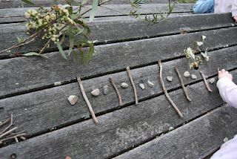
Sticks and Stones

Patterning
Use sticks and stones to create repeating, increasing or decreasing patterns.
Have someone at home guess your pattern rule and tell them the core (part that repeats). Have someone at home create their own pattern and you state their pattern rule/identify the core.
Make as many different types of patterns as you can.
Don’t forget to repeat your pattern at least 3 times!
Kindergarten | Grade 1 | Grade 2
Pattern examples:  AB:  -stick, stone, stick, stone, stick, stone  -short stick, long stick, short stick, long stick, short stick, long stick  -light stone, dark stone, repeat two more times  -big stone, little stone and repeat  AAB:  -stick, stone, stone, repeat two more times  -long, long, short and repeat  -big, big, little, and repeat  ABB:  Stick, stone, stone, repeat  ABC: Short stick, medium stick, long stick, repeat | Grade one student can practice making patterns the same as Kindergarten, but they can add in one more element (part)  Examples:  AABC:  Small stone, small stone, big stone, stick, repeat.  ABBC: small stone, medium stone, medium stone, big stone, repeat.  ABCC: stone, stick, leaf, leaf, repeat.  ABCD: stone, stick, leaf, grass, repeat. | See Kindergarten and Grade 1 but practice patterns with up to 5 elements (parts):  Examples:  AAABC  AABBC  ABCDE  Increasing patterns:  -1 rock, then 2 rocks, then 3 rocks, and so on.  -I rock then 3 rocks then 5 rocks and so on  -2 sticks then 4 sticks then 8 sticks then…  -I rock, 1 stick, then 1 rock, two sticks, then 1 rock, three sticks then…  How does your pattern grow?  Decreasing patterns: start big and take items away each time.

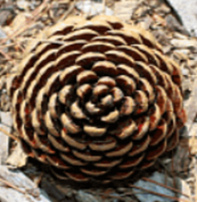
Can you find a pinecone outside? What type of pattern do you see? What do you notice?

Today’s Number

Today’s Number is

18

- How many ways can you show 18?

- Write a story problem to go with one of your ways to show 18.

(Sample Responses)

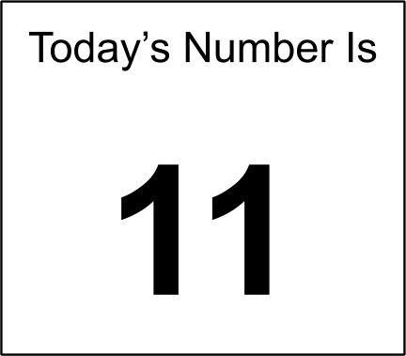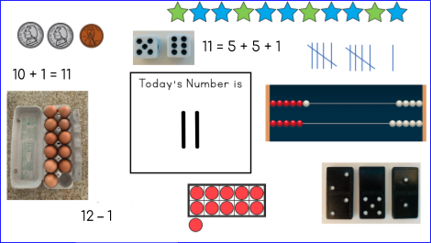

- How many ways can you show 11?
There are many ways to show 11. These are just a few.

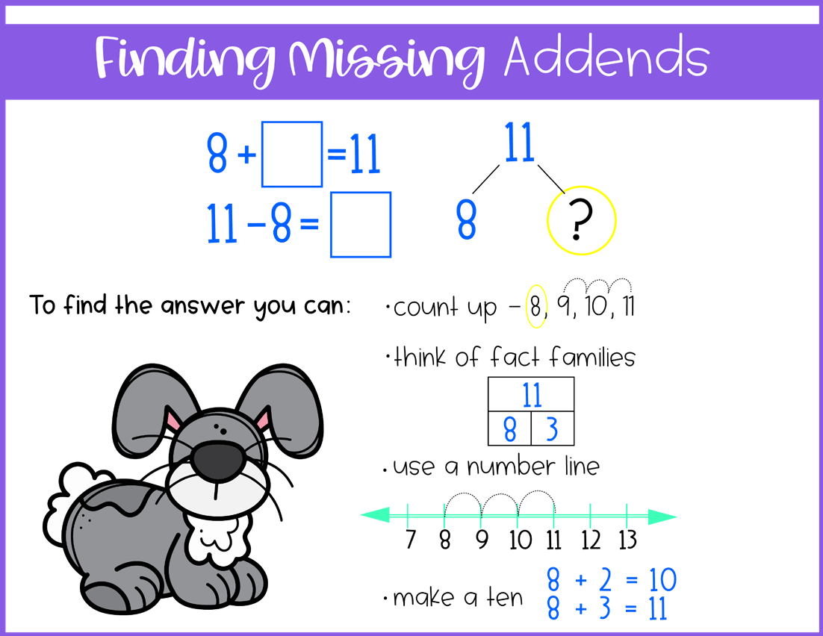

Find the missing addends….write the answers or just say them
+ 7 = 15 | 9+ = 1= 14
12 + = =19 | + 12 = 20
+ 5 = 13 | 7+ = 14
+ 9 = 15 | 4 + = 15
10+ = = 19 | + 11 = 20
+ 8 = 16 | 10 + = 17
+ 11= 12 | 7+ = =11
Create your own | Create your own

K-5 Target Toss (Addition)
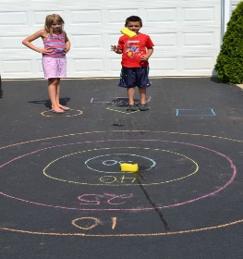
Materials needed: stick, foot or sidewalk chalk to make a target, a dirt or paved driveway, paper and writing tool to keep track of the score.
Directions:
- Using sidewalk chalk or a stick in the dirt, create a large target like the ones shown here:
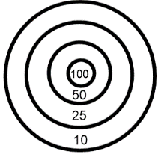
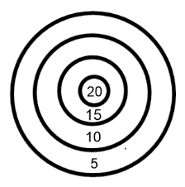
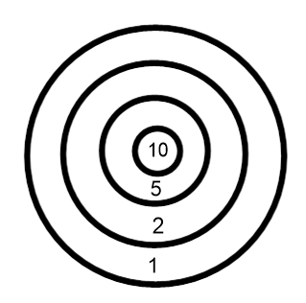
- Decide what the value of each ring will be. This will depend on the age and ability of the student. The larger ring will have the lesser value with the middle ring having the greatest value. Show the value with chalk or write the value on paper and place it in the rings.

- Decide how many rounds you will play before you get started. Consider 5-10 rounds.

- Decide how many rocks each player will throw. Consider 2-4 rocks depending on the level of the child. Stand at the same spot each time you throw.

- Each player will take turns throwing the rocks and adding up their total based on where the rocks have landed.

- Once all rounds have been played there are two ways to win:

- total up the score of all the rounds for each player. The player with the most points wins.

- For each round that is played, the player who scores the highest points gets one point for the round. After all rounds have been played, the player with the most points wins the game.

Teddy Bear Roll

Materials
2 Dice, Teddy Bear Outline, Crayons

Directions
- Roll two dice.
- Find the sum.
- Match the sum in the table below.
- Follow the direction for the sum you rolled.
- Be the first player to draw all parts of your teddy bear.

SUM | DIRECTIONS
2 | Draw the eyes.
3 | Draw the inside of the ears.
4 | Draw the nose.
5 | Draw the mouth.
6 | Skip a turn.
7 | Draw the shirt.
8 | Draw an accessory such as a bowtie, eyeglasses, or shoes.
9 | Draw a belly button
10 | Draw a 2nd accessory
11 | Write the name of your teddy bear on your paper.
12 | Draw some eyebrows

Teddy Bear Roll
My teddy bear’s name is

