Literacy:

Thank you to all parents for your continued support and patience. I even had a few parents and children deliver May baskets to my door. This week for Literacy I’ll be sending your child a fairytale story to read from EPIC. Beginning next week we will be working on writing fairytales so please try to read as many as you can. This week for writing I’ll be sending your child a personal letter by email to see how they are doing. I would love for them to write back. This can be done a number of ways such as a handwritten letter that you take a picture of and send me or they can even type an email or have a parent type it after it is written. Try to be creative and I hope to hear from everyone. Continue practicing sight words and when your child is reading begin working on spelling the words as well. Reading for 20 minutes a day is to continue as well. When you pick up your child’s belongings at the school on Monday the complete set of reading comprehension activities are included in a duotang. You will no longer have to print them off at home each week.
Have a great week!
Mrs. Fitzpatrick

Sight word practice ideas

Sight Word Hide And Seek
Write the sight words your child is currently practicing on colorful pieces of paper and hide them all around your backyard or in your house. Then, give them a master list of the words to find and have them check them off as they locate each one.

Shoot The Sight Words With Nerf Darts
Write the words on paper (rectangle shape or use recipe cards) Tape them up around the house and either say a word and they shoot it with a nerf gun or have them shoot 1 and they tell you the word.

Soapy Spelling
Mix a little bit of dish soap with water, in a bowl. Then head outside to the sidewalk, pour the mixture out, and practice writing sight words.

Math:
I hope everyone is able to pick up their items at the school tomorrow, Monday, May 4th. I have included a few supplies and a wipe off 100 chart. In addition, I have included copies of games for students to practice their mental math. They will know what area they are working on and what strategy to work on after mastering the one they are at. Lastly, please do not feel you have to print this material and you can email me or message me whenever your child is wanting to show off their work. I have set up challenges on Sumdog for them to complete as well.
Order the numbers least to greatest
(write numbers on squares of paper, on popsicle sticks, or just on paper)

- 86, 35, 53, 18, 9, 88
- 32, 14, 51, 15, 41
- 28, 62, 82, 93, 45

Order the numbers greatest to least

- 72, 54, 13, 45, 88
- 55, 35, 95, 15, 5
- 78, 19, 36, 72, 3

Estimate how many spoonfulls it will take to finish a bowl of cereal or a bowl of Kraft dinner or soup. Count each spoonful as you eat. Were you close to your estimation?

Keep track of the weather starting today. On May 10th answer the following: How many sunny days? Rainy days? Cloudy days? How many more sunny days than rainy days?

 | MON. | TUES. | WED. | THURS. | FRI. | SAT. | SUN.
RAINY

CLOUDY

SUNNY

TOTAL

Fill in or say the missing numbers.
0 | 1 | 2 |  | 4 | 5 |  | 7 | 8 | 9
10 | 11 |  | 13 | 14 |  | 16 |  | 18 | 19
 | 21 | 22 |  | 24 | 25 |  | 27 |  | 29
30 |  | 32 | 33 |  | 35 | 36 |  | 38
 | 41 | 42 |  | 44 | 45 |  | 47 | 48 | 49
50 | 51 |  | 53 | 54 |  | 56 | 57 |  | 59
60 |  | 62 | 63 |  | 65 | 66 |  | 68 | 69
 | 71 | 72 |  | 74 | 75 |  | 77 | 78
80 | 81 |  | 83 | 84 |  | 86 | 87 |  | 89
90 |  | 92 | 93 |  | 95 | 96 |  | 98 | 99
 | 101 | 102 |  | 104 | 105 |  | 107 | 108

Start at 16 and count to 23. Fill in the squares or say it out loud.
16

Start at 32 and count to 39.
39

Start at 56 and count to 63.
56

Start at 85 and count to 92.
92

Start at 50 and count to 99.

70

Start at 26 and count backwards to 19. Fill in the squares or say it out loud.
26

Start at 32 and count backwards to 25.
32 |  |  |  |  |  |  | 25

Start at 66 and count backwards to 59.
66

Start at 99 and count backwards to 92.
99

Start at 80 and count backwards to 51.

80

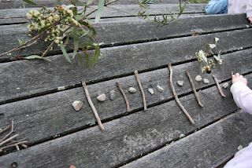
Sticks and Stones

Patterning
Use sticks and stones to create repeating, increasing or decreasing patterns.
Have someone at home guess your pattern rule and tell them the core (part that repeats). Have someone at home create their own pattern and you state their pattern rule/identify the core.
Make as many different types of patterns as you can.
Don’t forget to repeat your pattern at least 3 times!
Kindergarten | Grade 1 | Grade 2
Pattern examples:  AB:  -stick, stone, stick, stone, stick, stone  -short stick, long stick, short stick, long stick, short stick, long stick  -light stone, dark stone, repeat two more times  -big stone, little stone and repeat  AAB:  -stick, stone, stone, repeat two more times  -long, long, short and repeat  -big, big, little, and repeat  ABB:  Stick, stone, stone, repeat  ABC: Short stick, medium stick, long stick, repeat | Grade one student can practice making patterns the same as Kindergarten, but they can add in one more element (part)  Examples:  AABC:  Small stone, small stone, big stone, stick, repeat.  ABBC: small stone, medium stone, medium stone, big stone, repeat.  ABCC: stone, stick, leaf, leaf, repeat.  ABCD: stone, stick, leaf, grass, repeat. | See Kindergarten and Grade 1 but practice patterns with up to 5 elements (parts):  Examples:  AAABC  AABBC  ABCDE  Increasing patterns:  -1 rock, then 2 rocks, then 3 rocks, and so on.  -I rock then 3 rocks then 5 rocks and so on  -2 sticks then 4 sticks then 8 sticks then…  -I rock, 1 stick, then 1 rock, two sticks, then 1 rock, three sticks then…  How does your pattern grow?  Decreasing patterns: start big and take items away each time.

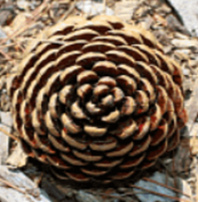
Can you find a pinecone outside? What type of pattern do you see? What do you notice?

Today’s Number

Today’s Number is

19

- How many ways can you show 19?

- Write a story problem to go with one of your ways to show 19.

(Sample Responses)

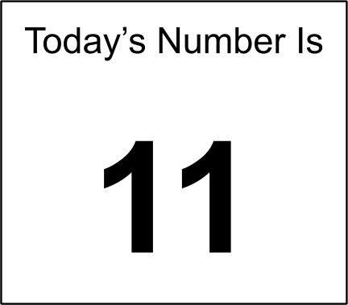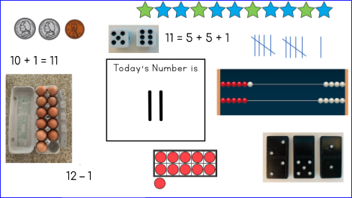

- How many ways can you show 11?
There are many ways to show 11. These are just a few.

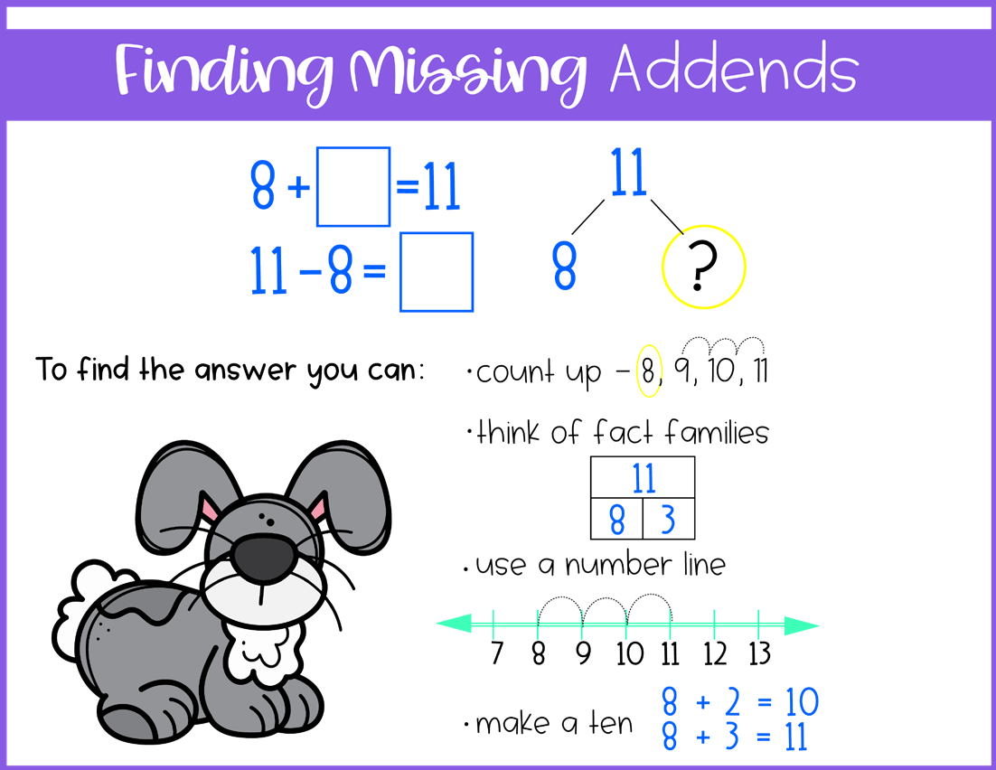

Find the missing addends….write the answers or just say them
+ 7 = 15 | 9+ = 1= 14
12 + = =19 | + 12 = 20
+ 5 = 13 | 7+ = 14
+ 9 = 15 | 4 + = 15
10+ = = 19 | + 11 = 20
+ 8 = 16 | 10 + = 17
+ 11= 12 | 7+ = =11
Create your own | Create your own
K-5 Target Toss (Addition)
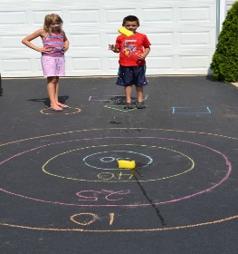
Materials needed: stick, foot or sidewalk chalk to make a target, a dirt or paved driveway, paper and writing tool to keep track of the score.
Directions:
- Using sidewalk chalk or a stick in the dirt, create a large target like the ones shown here:
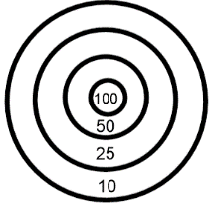
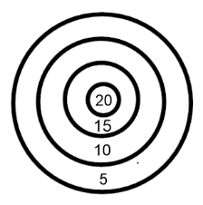
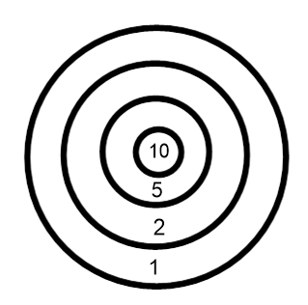
- Decide what the value of each ring will be. This will depend on the age and ability of the student. The larger ring will have the lesser value with the middle ring having the greatest value. Show the value with chalk or write the value on paper and place it in the rings.

- Decide how many rounds you will play before you get started. Consider 5-10 rounds.

- Decide how many rocks each player will throw. Consider 2-4 rocks depending on the level of the child. Stand at the same spot each time you throw.

- Each player will take turns throwing the rocks and adding up their total based on where the rocks have landed.

- Once all rounds have been played there are two ways to win:

- total up the score of all the rounds for each player. The player with the most points wins.

- For each round that is played, the player who scores the highest points gets one point for the round. After all rounds have been played, the player with the most points wins the game.

2D Shape Art
To complete the activity students must cut out the shapes and glue them into the box or draw their own to create a picture. After coloring in the picture they then must identify what their picture is, and how many of each different shape was used. They don’t have to use them all.

My picture is a .
It has
- rectangles
- circles,
- squares,
- ovals,
- rhombuses,
- pentagons,
- hexagons, &
- triangles.

