Grade 1 & 2 Choice Board- Week of May 11th-15th
Create an animal using only 2D shapes. Then, describe how to draw your animal to someone. See if they can draw it without looking at the picture. |  | Listen to a song. Describe how the music makes you feel. List your feelings. Tell a family member or friend why you love this song. | Explore coins (nickels, dimes, quarters, loonies, and toonies) Create a menu for a restaurant with at least 10 items and their price. Then, show different combinations of meals you can purchase, with the total cost of the meals.  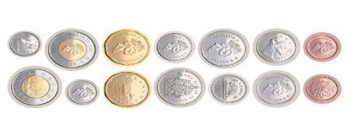
Make a list of your favorite fruits and vegetables. Use food flyers or magazines to cut out pictures and label. |  | Create a board game to practice addition and subtraction facts. Be sure to include rules for your game!  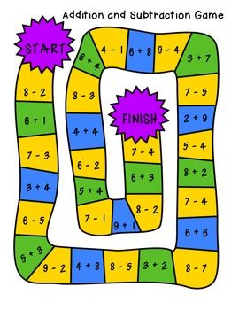 | Write about something you are looking forward to and why?
Use the following recipe, or your own, to make play dough. Use the play dough to practice making letters, numbers, or even sight words!  Play Dough Ingredients: 1 cup Flour ½ cup Salt ½ cup Water Food colouring for colour Step 1: Combine salt and flour Step 2: In a small bowl mix water and food colouring Step 3: Mix together *Allow your play dough to sit for an hour so it can form, then it will be ready for play! *Store in the fridge for up to four weeks.  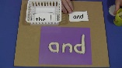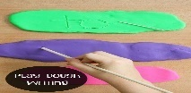 |  | Create an obstacle course in your yard. Use things you have at home.  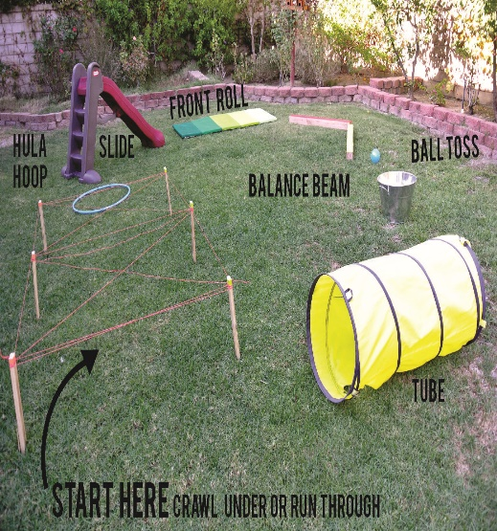 | Using a die, roll 3 numbers. How many different numbers can you create? Put them in order from least to greatest. Do this 2 times.  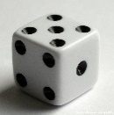ex. 3/6/4  -36, 34, 63, 64, 43, 46, 364, 346, 463, 436, 634, 643…….  Least to greatest  -34, 36, 43, 46, 63, 64, 346, 364, 436, 463, 634, 643
 | Remember to visit at least once a week. www.sumdog.com
 | Remember to visit to read the story Mrs. Fitzpatrick assigned to you. www.getepic.com

What are Choice Boards?
Choice boards are graphic organizers that comprise of different amounts of squares. Each square is an activity. The activities help students learn or practice a primary concept, while allowing them a choice. Students can be instructed to choose one or more of these activities to complete. They can progress from one activity to another either in an organized or random order.

Benefits of using Choice Boards
Choice Boards provide students with the power to choose “how” to learn a particular subject or concept. This freedom encourages them to be more responsible, accountable and independent in their learning. It also allows them to work on the activities at their own pace.

Have your child chose the order they would like to complete a square. If they print the board, they can shade in or check off the squares as they complete them. The goal is to complete every activity on the board throughout the week.

We hope you have a great week!

Mrs.Fitzpatrick & Mrs. Higgins

