Gr 3-4 Choice Board
Magic Math Trick  1. Think of a whole number 1 through 10  2. Double it!  3. Add 4  4. Divide by 2  5. Subtract the original number  Is the numeral 2?!  Begin with a different number do you get the same answer, why?  Try a number greater than 10. Can you still see the magic? | Time for Change  Think of a favorite story you have read….  If you could remove one character from this story, who would it be and why? Draw a picture of how the story would be different and explain in writing how it would change the story. | WHICH ONE DOESN'T BELONG?  Find a reason why each one does not belong.  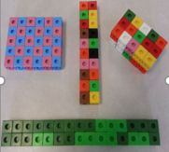
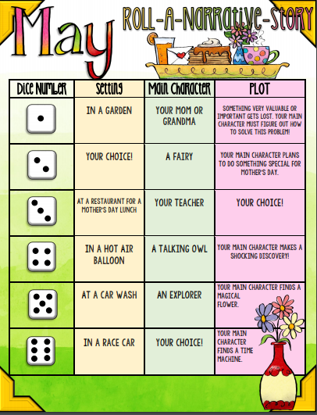 | Table Talk Math  If the zookeeper had 100 pairs of animals in her zoo and if two pairs of babies are born for each and every one of the original animals, and then sadly 23 animal don’t survive, how many animals do you have left in total? | Snack Time  Using paper, tape, and string, build and test a device that warns you when someone has opened a cabinet in your kitchen.
Make 25 with 5  Players are dealt five cards each and the remaining cards are stacked face down in a pile in the middle of the table. Players must use all five cards to create a sum of exactly 25. Players go around in a circle and on each turn, they pick up a new card either from the face-down pile or from the discard pile. Players discard one card per turn. First player to create a sum of 25 wins.  Change it up: Make the game more challenging by changing the rules to include, or even exclude, certain operations. You can start by allowing subtraction, then bringing in multiplication and division.  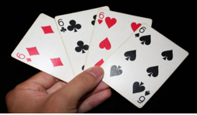 | The Night Before Summer Vacation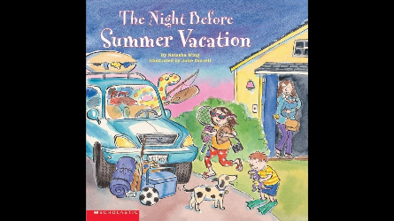This story may sound familiar, but it has a new twist!!  Click here to listen to the book! This book is about all the preparations required to get ready to go for a summer vacation. Research places in NB to visit and create a list of items that you would need to go on your pretend vacation. | Fly Catcher!  Watch the following video and conduct a mini science experiment at your house to answer the question...Which sweet liquid catches the most flies?  Click here for video!  