Kindergarten Choice Board
Fewer / More  Using a deck of cards remove the face cards and ace equals 1. Place 10 cards face down in a pile to draw from. The remaining cards are scattered face up. Turn over a card from the draw pile and find a partner card that is 1 fewer. Continue until draw pile is finished.  Next game, determine the partner card that is 1 more than draw card.  Challenge: Find the partner card that is 2 fewer or 2 more than your draw card.  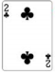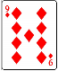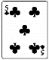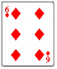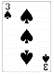  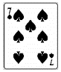 | Rainy Day Fun  Click on the following link and discover how water can travel.  Walking Water Experiment  If you have the materials at home give it a try. | Create a story using some of your toys.
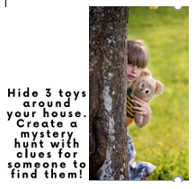 | Break Apart!  Choose a number from a deck of cards (A-10)  Find that many objects at your home inside or outside.  Show your objects in two groups saying how many in each group.  Show all of the part/part/whole ways you can show your number.  Choose a new number…. | Fort Reading  Build a fort inside or outside and read in it! An easy way to do this is use a blanket over the table or a large cardboard box. Invite your favorite stuffie or dollies to join you! Mrs. Deschenes would love to see a picture of this one!!!  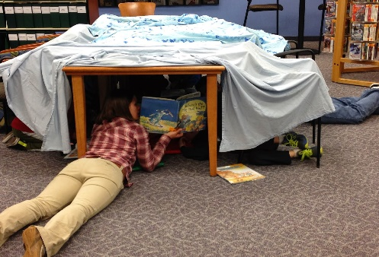
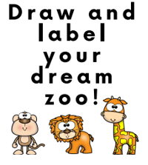 | Count Between  Pick 2 cards. Count backwards starting at the highest number down to the lowest number...  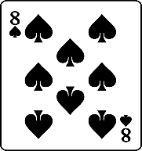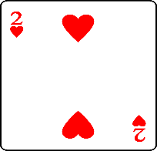 | 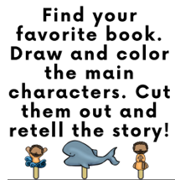

Family Guide to Kindergarten Choice Board
Fewer / More  This game is to build number sense. Have your child tell you the number they have found. Ex: I have 7 and I choose 6 because 6 is 1 fewer than 7. After playing this game a number of times with different focuses your child will soon be able to tell you the number that is more or fewer than a given number before choosing from the scattered cards. Have the child make the statement to match their cards. For example, “4 is fewer than 5” or “8 is more than 7”. | Rainy Day Fun  The link will take you to a simple science experiment that shows how water can move through paper towel much like it does in plants.  Have fun and enjoy other clips by Ryan | Story Creation  Have your child double check their No-Excuse words to make sure they are spelled correctly. Encourage them to add another sentence when they “think” they are done. After they have reread their story to you, think out loud and say, “Hmm, I wondered what happened after that?”, or “I wonder what the cat(whatever character they used) looked like?”
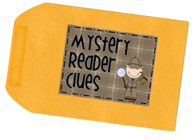Your child may write out the clues or draw pictures with labels and tell you their clues. | Break Apart  This activity will help reinforce the idea that numbers can be broken down or seen in many ways.  After completing this activity, a number of times have your child choose a number and before they break the number apart ask them about a specific part. Ex: You have 8 if a part is 3, how many in the other part? The goal eventually is they will tell you without needing to actually break the group apart. | 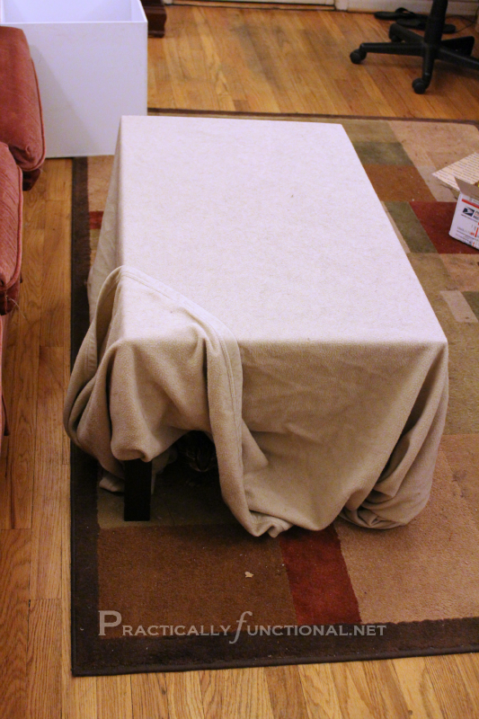
My Zoo  Have your child draw their zoo with animals. They can label their animals and other parts of their zoo.  Encourage your child to stretch their words carefully to hear and record all the sounds they hear. | Count Between  You can use a deck of regular playing cards with the face cards removed or you can help your child make a set of cards using any empty box from your cupboards. Take the box apart and use a marker or pen and make a grid on the back side. Allow your child to form the numbers 0-10. One in each box. Have them cut them out and place in a baggie for future use! | Story Retell  After your child has drawn and cut their characters if you can attach them to a stick or a piece of cardboard, they are much easier to handle while they move them around to retell the story.

