Literacy
Writing this week will consist of a Covid 19 Time Capsule. There is still a number of parents who have not yet signed up for getepic.com. Please take the time to check your last week’s email and click on the link as it has many levelled books for your child. There will be a book and an assignment for each student this week that I will be sending you from the website. There are many suggestions that you can use to help learn sight words this week as well. May 1st marks May Basket day. I have included instructions on how to make them. It might be a nice gesture to hang one on someone’s door to brighten their day.
Mrs. Fitzpatrick

Reading Comprehension#1
Apple Orchard

I went apple picking with my mom.
We went to the apple orchard.
It was so big!
First, we walked through all of the apple trees.
Next, we each picked six apples.
Then, we put the apples in our baskets.
Finally, we went home and made apple pie.
I ate two pieces. It was so yummy!

- What did they do first?
- How many apples did the girl pick?
- What did they do last?
- What did they use the apples for?

Cut out the events and put them in order. (If you don’t want to print, just have your child point)
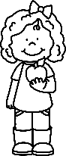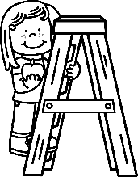 | 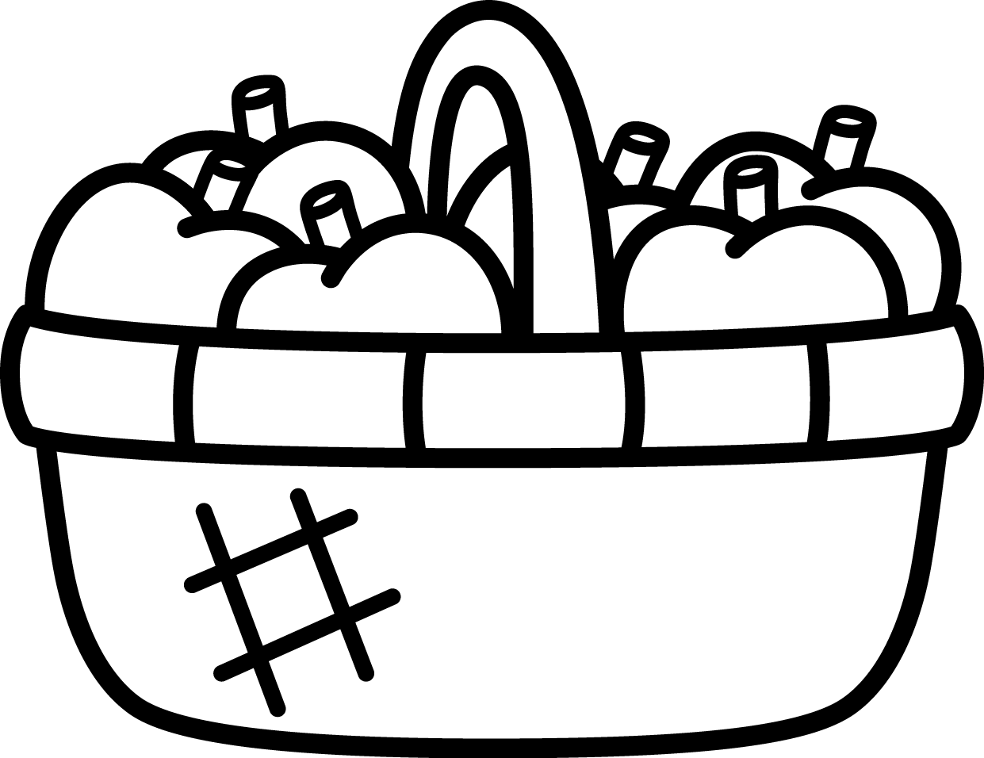 |  | 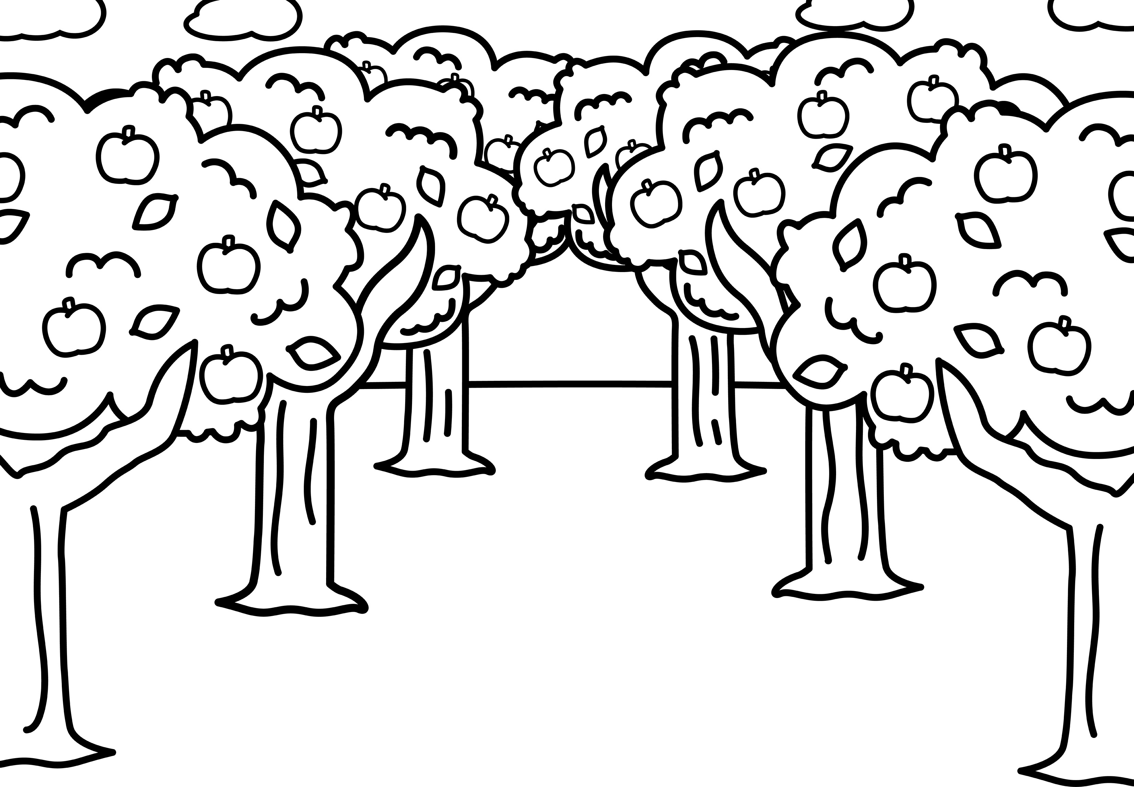

Reading Comprehension #2
A Trip to the Nurse

Tony’s class was playing kickball for recess.
He was having so much fun!
When the ball went flying into the air, he quickly ran to catch it.
Instead of catching the ball, the ball hit Tony’s head.
Tony fell to the ground.
“My head really hurts,” he told his teacher.
Tony’s teacher walked him to the school nurse.
She gave Tony an ice pack for his head.
Soon, his head began to feel better.

What was Tony playing?

How did Tony hurt his head?

What did Tony get for his head?

Draw a picture about this story.

Writing for the week: Complete the following Time Capsule. (If you don’t have a printer, you can write it on paper)
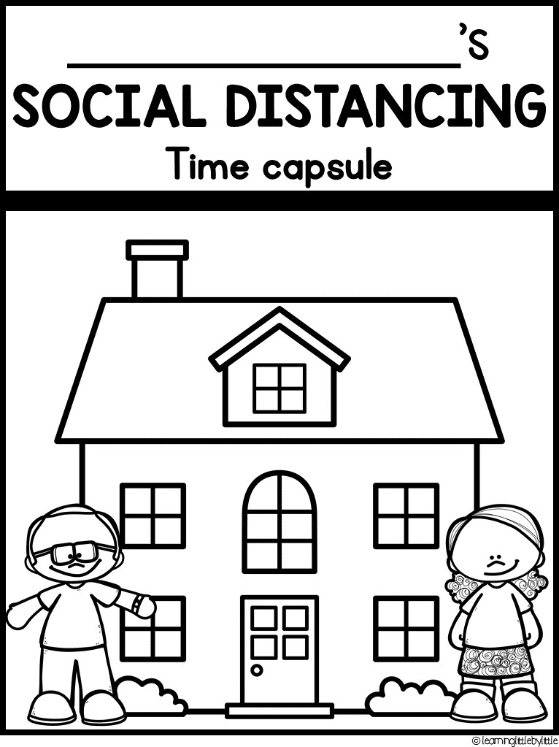

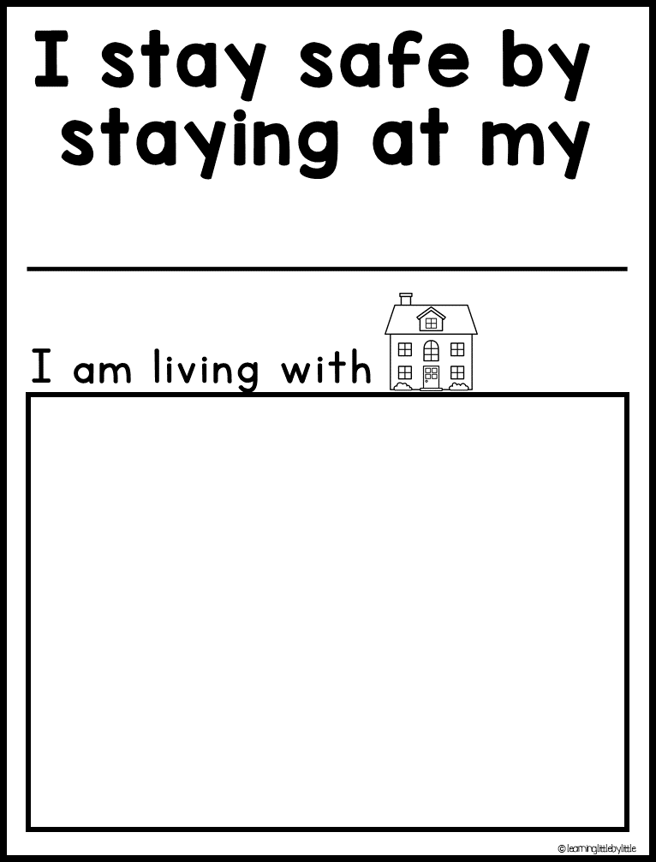

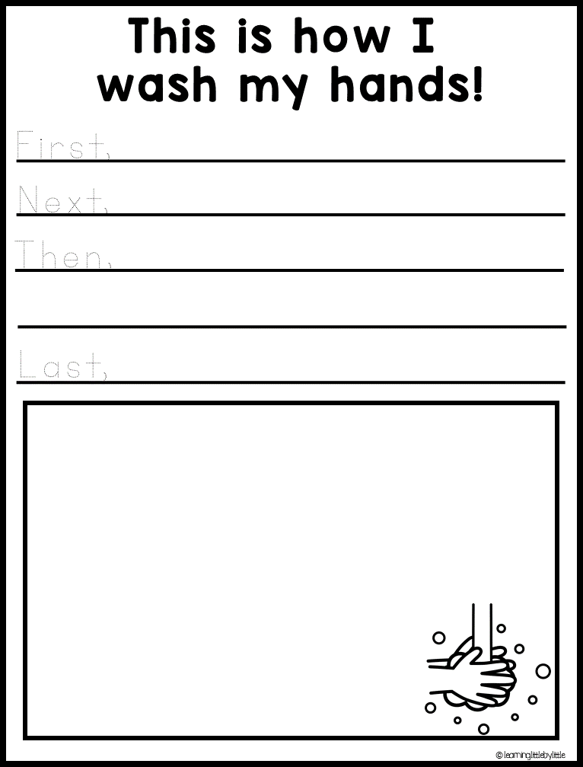

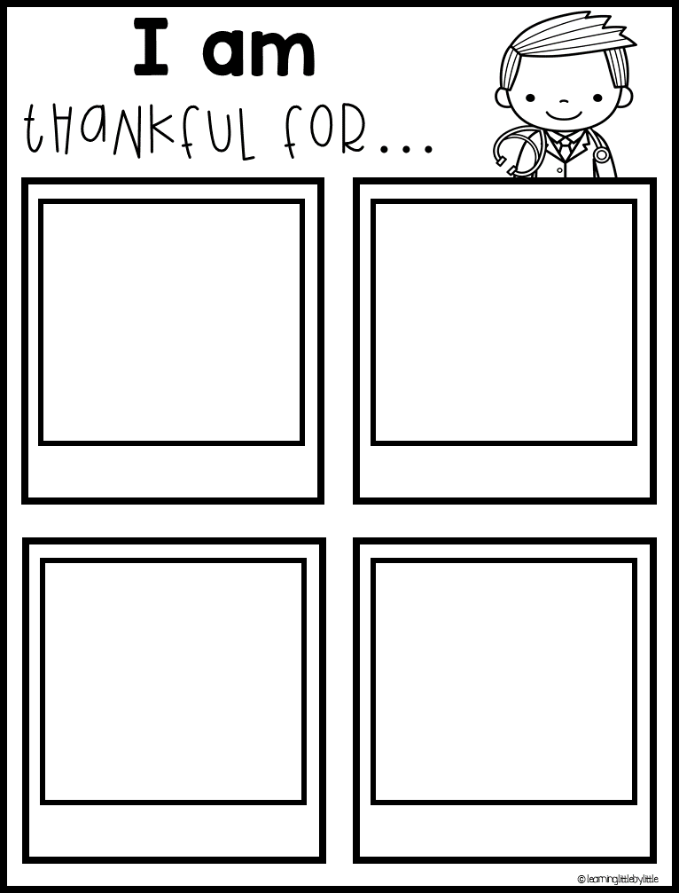

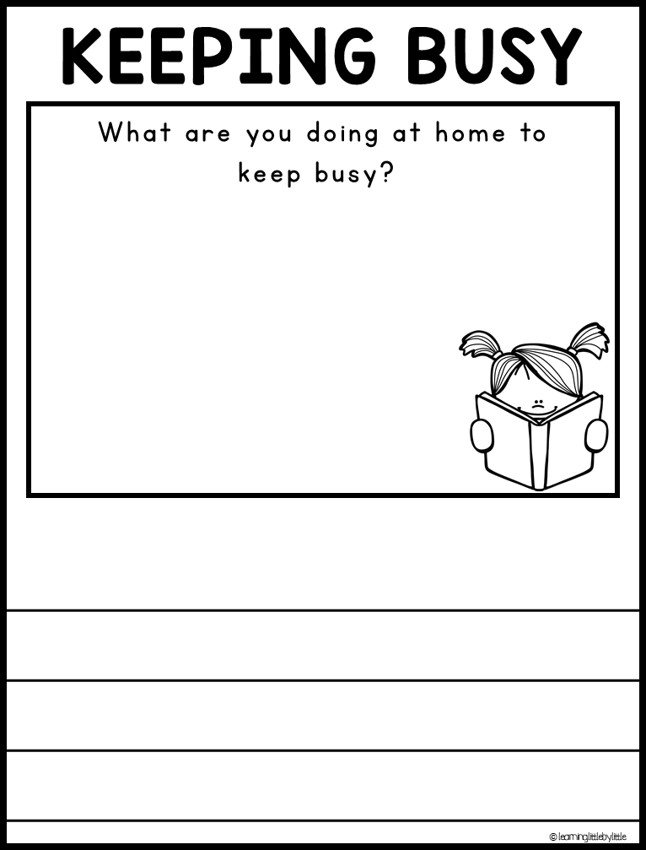

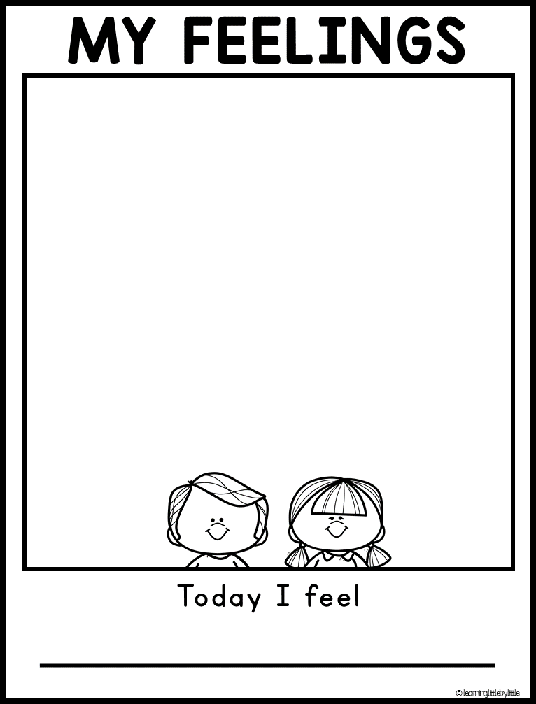

Sight words: Try one of the following activities with words your child is working on
1. Note of the Day: Each day write your child a short note (1-3 sentences). Include the words they are practicing. Ask them to circle those words in crayon(bonus points for letting them use their favorite color).

2. Make a sight word parking lot and get toy cars to drive to certain words
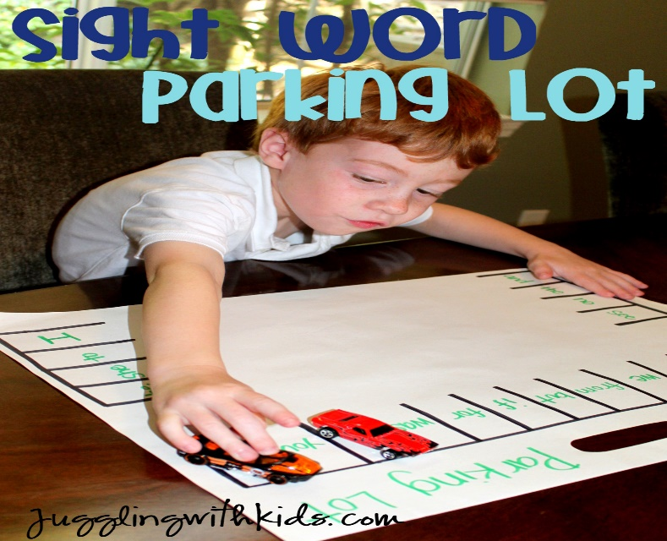

3. Put letters onto a set of legos and BUILD the words.

4. Shaving Cream: Spread shaving cream onto a plastic tray and write the words with your finger

5.Tic Tac Toe: Play tic tac toe (using two sight words instead of x and o).

Instructions on how to make a hanging May basket

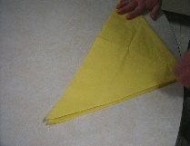
Step 1 - Begin with an absolutely square sheet of tissue paper. Fold in half diagonally

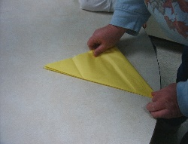
Step 2 - Fold the far right corner over to meet the far left corner.

Step 3 - Repeat Step 2.
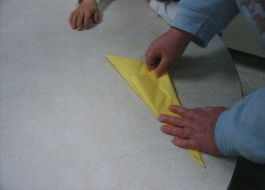
Step 4: Follow the photograph, bringing one edge of the folded triangle, over the longest edge.
Step 5: Time to begin cutting.
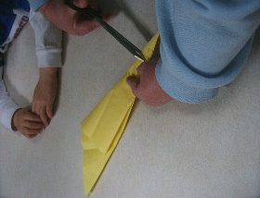
Step 6: Make small alternating horizontal cuts partway through your folded basket; begin from the bottom, cutting first from one side, then from the other. Make your cuts about a third to half an inch apart - too close, and your maybasket won't hold its shape; too far apart, and it won't have the feathery quality of a well-made maybasket.

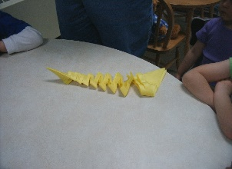
Step 7: Cutting complete. Now it is time to carefully unfold your maybasket, bringing two of the edges together at the top, and putting a small weight in the bottom to hold it down. Fashion a handle from scraps of tissue paper, either by folding, twisting or braiding, and secure to the top with tape or a staple.

Step 8: Don't forget to hang your maybasket!!
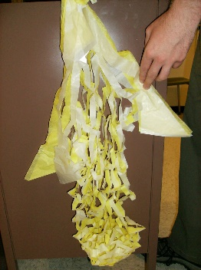

Math: I have created a Math Challenge for students to try on Sumdog. Please refer to the e-mail I sent 2 weeks ago for login information or feel free to contact me. I am attaching 2 photos of what you will see when your child log’s in. On the left side of the screen after they enter their username, password, and school code, they will see “Math Challenge” they can click that and then hit start. When the next screen appears, they need to click start again. Have a great week! (Mrs. Higgins)
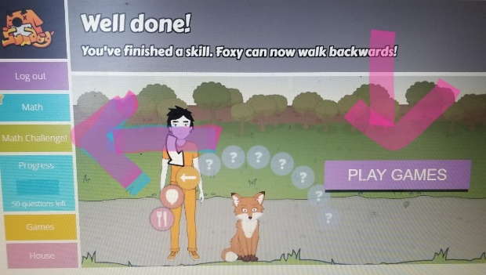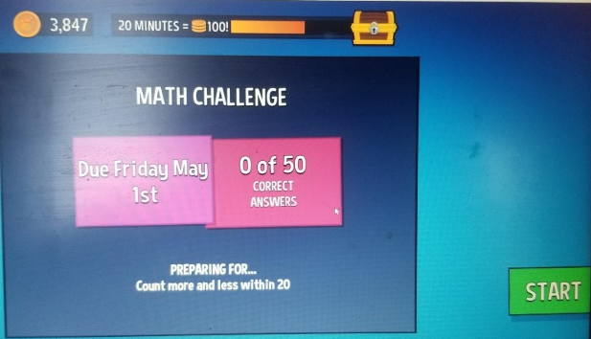
Card game for the week:
Salute
-Remove face cards
-Sit in a circle and take turns being the judge.
-When the judge says, “Salute!” the players put their card on their forehead without looking at it.
-The judge announces the sum of the two cards.
-Players try to guess the amount on their card based on the card the other player is holding.

Other games/Activities:

Add 2
One person picks a number to begin this game (To keep it simple, make the starting number between 1-9). The next person adds two to that number and says the sum out loud. (Be sure to use the word sum–math vocabulary is essential!)
The next person has to add 2 and say the sum out loud.
Continue, until you reach a designated number (we like 100).
Skip counting is a precursor to multiplication, and this game makes it enjoyable.
You can easily change it up. Next round, add 3. Or start with a big number and subtract 2.

-using a deck of cards turn over the top card and count on from that number to 30

-turn over card say what would be 1 more, 1 less, 2 more, 2 less

-find 6 objects and order them from shortest to longest

-find 6 objects and compare using heavier and lighter

-find 6 objects and compare a different way

The following 100 chart can be printed if you wish. If you do not have access to a printer, simply bring it up on the computer and ask the questions or draw a 100 chart on paper, having your child fill in all the numbers or some. For some, counting to 100 may be difficult so use it to your discretion, maybe only go to 50, 75, etc..to where your child is comfortable at. The next page includes ideas as to what you can ask.

One Hundred chart

1 | 2 | 3 | 4 | 5 | 6 | 7 | 8 | 9 | 10
11 | 12 | 13 | 14 | 15 | 16 | 17 | 18 | 19 | 20
21 | 22 | 23 | 24 | 25 | 26 | 27 | 28 | 29 | 30
31 | 32 | 33 | 34 | 35 | 36 | 37 | 38 | 39 | 40
41 | 42 | 43 | 44 | 45 | 46 | 47 | 48 | 49 | 50
51 | 52 | 53 | 54 | 55 | 56 | 57 | 58 | 59 | 60
61 | 62 | 63 | 64 | 65 | 66 | 67 | 68 | 69 | 70
71 | 72 | 73 | 74 | 75 | 76 | 77 | 78 | 79 | 80
81 | 82 | 83 | 84 | 85 | 86 | 87 | 88 | 89 | 90
91 | 92 | 93 | 94 | 95 | 96 | 97 | 98 | 99 | 100

Below are a few games to play with your child on the attached 100 Chart!
*Skip Counting: mark it or count by 10’s, 5’s, or 2’s...all the way to 100!

*Mystery number game: Give your child clues like – “I’m thinking of a # that is between 34 and 36” or “I’m thinking of a number that has a 7 in the ten’s place & a 2 in the one’s place.” or “I’m thinking of a number that is 2 more than 56!”…and then your child gets to guess the mystery number & color it in! They love this game!

*Random Number I.D.
drop a piece of cereal on the 100 chart. Ask your child to identify the number the cereal is covering!

*Puzzle – Cut out all the squares of one copy of the 100 chart & scramble them up! Then see if your child can glue the pieces to an additional copy of the 100 chart. By completing this activity, students become VERY familiar with the numbers & how to find them quickly on the 100 chart!

simply give them a number and have them point to it. You can ask tell me 1 number more than a certain #, 1 less or fewer than, 2 more/2 fewer than.

* Race to 100 - Take turns rolling one or two dice and moving that many spaces on the hundreds chart. If you correctly predict your landing place before you move (without counting squares!), then you can go one extra space as a bonus. The first person to reach or pass 100 wins the game!

*Even or Odd – Color in a number on the chart & ask your child if it the # is even or odd! Then let your child color in a number and ask you the same! The child needs to let you know if you guessed correctly!

*Special numbers: Place five to ten markers (cereal pieces, chocolate chips, marshmallows, etc.) on numbers that are very special to you.
Go through each # & tell your child why it is important to you. Examples of special numbers may include:
-Your age
-The date you were born
-The # of people in your family
-The number of pets you have
-Your favorite or “lucky” number
-your shoe size
-The # of relatives you have
-Your favorite sport’s player’s team jersey number
-The # of years you’ve been married
-The age you started driving a car
(Then let your child pick some of their own special #s & explain them to you!)

Shape Search

Directions: Look around the house and find objects that match the 2D shape names. Draw a picture or write the name of the object you find under the correct shape.

Circle | Square
Rectangle | Triangle

3D Shape Search

Directions: Look around the house and find objects that match the 2D shape names. Draw a picture or write the name of the object you find under the correct shape.

Sphere | Rectangular Prism
Cube | Cylinder

Math Scavenger Hunt Bingo
Explore the math in your environment by finding and crossing out the items below. Only one item may be crossed out for each find. See if you can get 5-in-a-row horizontally, diagonally or vertically. Challenge: Find all the items.

Something square | A circle | Something shorter than you | The number  5 | A double-digit odd number  21, 23, 25,  27, 29…
A coin | Something that comes in twos (pairs) | A rectangular prism | An even number  0, 2, 4, 6, 8… | A pattern
Something twice as long as your  foot | Something taller than you | Something spherical | Something that tells time  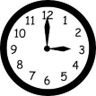 | Something rectangular
Something that is heavier than you | Something longer than a box of cereal | A number in the teens  13,14,15,  16,17,1 | Something that is lighter than you | Something that has more legs than you
A number greater than 20 but less than 50  >20 <50 | Something that has days of the week on it | Something triangular | Something that is about the size of your hand | A number whose tens place is even  Ex. 21

Math in Our World: Sorting Blocks

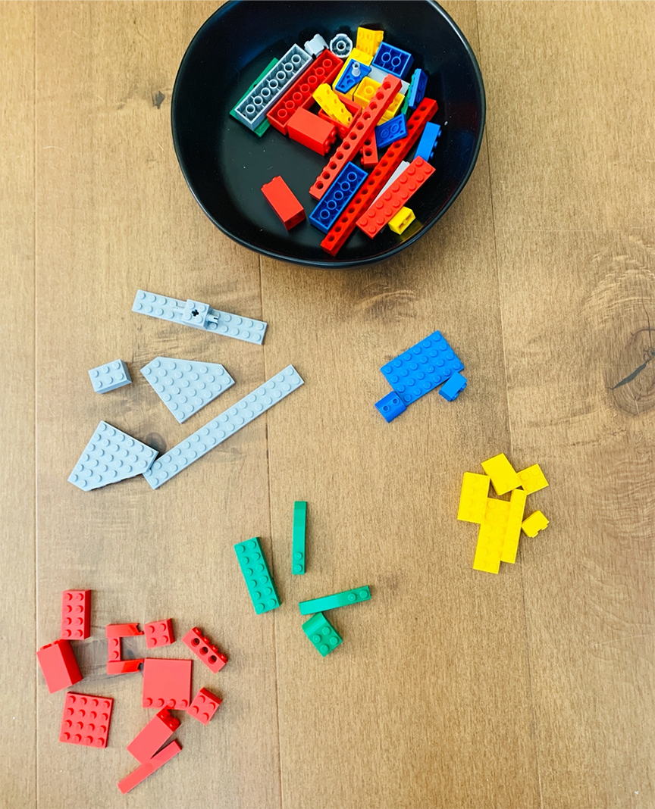
Hayden loves building with blocks. Sometimes it’s hard for him to find the color he needs in a big bin. He’s sorting his blocks to help him find what he needs.
- What do you notice? What do you wonder?

- Show or tell what is happening using pictures, numbers, or words.

- What math questions can you ask about the picture? Answer the questions you can!

- How many groups of blocks are there? How many in each group?

- What numbers or words could you use to describe the blocks?

- What could you build with this many blocks? Draw a picture or use toys of your own.

