8470 Main Street, Florenceville, NB E7L 4J8 Tel: (506) 392-5109 Fax: (506) 392-5122 Principal: Sarah Mahar Vice-Principal: Bridget Nugent
Florenceville Elementary School

Florenceville Elementary School Newsletter
February 2020

It is hard to believe it is February already! The days are beginning to get longer and spring will be here before we know it!
Safety on the Bus
As mentioned previously, safety on the bus is vitally important. Winter road conditions make it even more difficult for the drivers, so please remind your children to follow the bus rules and make good choices.
Dressing for Outside
Please ensure your children are dressed properly to go outside each day. Fresh air and vitamin D are very important, so unless it is very cold and icy, students go outside each day. Students need a hat, mittens, ski pants and boots every day. It is also a great idea to pack extra socks.
French Immersion Registration
Online registration for French Immersion is open. The link is http://web1.nbed.nb.ca/sites/asd-w/Pages/default.aspx.
French Immersion entry points are Grade 1 and Grade 6.
Fox Dens
We are continuing to remind students how to regulate their emotions using the Take 5 approach. In February and March, we will be focusing on recognizing our “Strengths” and “Smarts”.
In Fox Dens, students are learning about different “Smarts”:
- Word Smart
- People Smart
- Self Smart
- Nature Smart
- Picture Smart
- Music Smart
- Body Smart
- Logic Smart
Ask your child to tell you about their individual “Smarts”!
Drama Club
Drama club is held on Tuesday afterschool. This year’s production is “Frozen Junior”. Stay tuned for details on dates for DramaFest and school performances.
Weekly Wednesday Lunches
Wednesday lunches have been running smoothly. A monthly order form will be sent home for planning purposes, rather than weekly forms.
Sustainability Study Meeting #3
The final Sustainability Study Meeting will be held on Thursday, March 19th at 6:30 at Carleton North High School.
Family Literacy Activities
Thanks to all the families that participated in the Family Literacy Activities. There was such a variety of different student submissions such as:
- Decorated cookies and read recipe to Mom
- Made a grocery list and went grocery shopping
- Practiced drama script
- Wrote Valentines to Grandma and Grandpa
- Played board games
- Went for a walk in the woods
- Read bedtime stories
- Read to pets at bedtime
- Built a house with lego
- Ordered at a restaurant
- Went sliding
- Dressed up as character in bedtime story
Physical Activity Week
The week of February 24-28 will be Physical Activity Week. Students will participate in some activities related to physical activity such as Drop Everything and Dance as well as a school wide activity afternoon. Theme days will also be happening throughout the week as well.

Intramural Noon-time Curling
All students had an introduction to curling on January 22nd. Grades 4 and 5 students have the opportunity to participate in Tuesday noonhour curling, thanks to Megan Crandlemire of the Florenceville-Bristol Recreation Department.
Home and School Updates
Thanks to our Home and School for purchasing a class set of small-sized snowshoes. Our students have already been getting lots of use out of them! Thanks also to Jessica Sipperell, a Pampered Chef consultant and Home and School member, who coordinated a fundraising event. She donated the profits of this event to our school kitchen in Pampered Chef product. It was a very generous gesture and helps our breakfast program.
Art Club
In January, several students participated in 3D felting with Jacqueline Dunn. There will be another group beginning soon.
Gymnastics
Once again this year, all students from FES will be traveling to River Valley Gymnastics studio for an hour of gymnastics instruction/exploration.
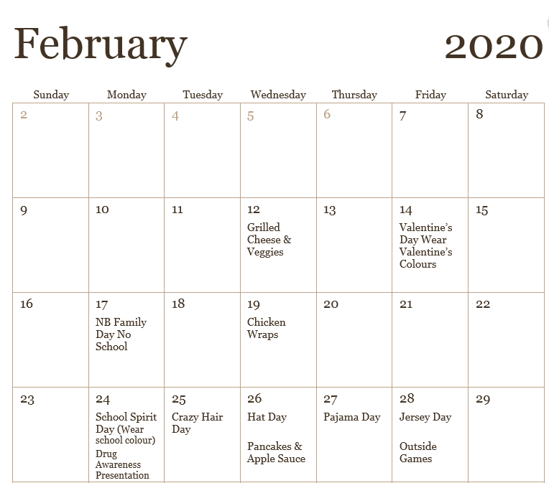
Pre-K Roll Out the Bag
Any student registered in kindergarten for the 2020-2021 school year is invited to attend the school for activities. The date is March 11, from 4:45-5:45.

RCMP Drug Awareness Presentation
On February 24, students in grade 4 and 5 will have a presentation from the RCMP on drug awareness.

