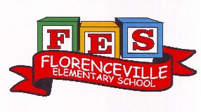
8470 Main Street, Florenceville, NB E7L 4J8 Tel: (506) 392-5109 Fax: (506) 392-5122 Principal: Sarah Mahar Vice-Principal: Bridget Nugent
Florenceville Elementary School

Florenceville Elementary School Newsletter
January 2021

Happy New Year to all of our FES families!
We feel so fortunate to be able to spend our days with your children. We understand the additional stresses that families have this year, and we appreciate your support as we have worked through the pandemic together. We often say to each other, “We Can Do Hard Things!” Please take care of yourselves and your family during this time and reach out to the school if you need assistance, or if you have questions or concerns.

Orange Level
At the present time, the province of New Brunswick is in the Orange level in the COVID Recovery Phase. At schools, this means increased mask usage. Students will need to have several clean masks with them each day, as they are required to wear them outside and they often become wet after playing outside. Please make sure to pack extra masks each day. Thanks for your support with this important safety measure.
Thank you to our PSSC (Parent School Support Committee) for purchasing personalized FES masks for all students.

This month we are talking about the character trait of Gratitude!

For the month of January we are focusing on the character trait of Gratitude at FES. The definition we are using is:
Choosing to notice and appreciate things in our life, things in others and things in the world.

We will be sharing with students that Gratitude is: 1) a choice that we get to make over and over again on where we put our focus and 2) doesn’t always have to be about something positive.
We can feel grateful even for tough or challenging things in our life! There is plenty of research that shows a strong connection between Gratitude and reduced anxiety, increased happiness, and better relationships. Over the course of the month, we will talk about amazing people who demonstrate Gratitude in various ways. We will talk about what we are grateful for in ourselves and in others. And we will even find Gratitude in some things we would not expect to be thankful for!

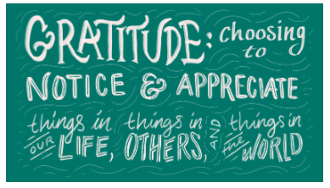

Home Link for talking about Gratitude:

Activity

Start a Family Joy Journal where you keep an ongoing list of gifts (people, places, things) that you are grateful for and how you showed your Gratitude for that thing. Try to write in it each day for 30 days. Write as many things as you can think of for that day as possible. How many days until you reach 100? How about 1000?
Feeding the Foxes- Free Bagged Lunches
This was our first week of our free, weekly bagged lunch program for all interested students. It is a new partnership with Carleton North High School’s Nutrition class. It will be adjusted as necessary and the menu will change based on feedback. Please contact the school if you are interested in taking part, but have not notified the school.
Dressing for Outside
The snowy and cold weather has arrived and it is important that students are prepared for outside play. Hats, mittens, boots, jackets and snow pants are necessary. It is also helpful to tuck an extra pair of socks in your child’s bookbag.
FES School Environmental Monthly Challenges!

FES strives to become a greener school year after year! This year, we will be having monthly challenges happening every first Wednesday of each month!

January 6th- GOOS Day (Good On Other Side)
On this day students will learn about being mindful of using both sides of paper, if possible. At FES, we recycle paper, but it important to be mindful of reusing materials as well.

February 3rd- Recyclable Art-
Students will participate in art activities using recycled materials. They may even want to try some of these activities at home after!

Celebrating Literacy
Family Literacy Day is celebrated annually on January 27th. We would like to celebrate with our students with various activities.
On Thursday, January 28th, students are invited to wear their PJs, and bring a favourite book to read and share.
On Friday, January 29th, it is Book Character Dress Up Day! Students can dress as their favourite book characters. This is always a fun activity and is enjoyed by students and staff.
During the week of January 25th-January 29th, we encourage all families to engage in family literacy activities together. We will have prize draws for students who return forms outlining the various activities they have done together (ie. baking, playing outside, board games, etc). We will send more information about the challenge this month. Have fun!

Coming up in January/February
January 15th- Hat Day- we invite all interested students to wear a favourite hat
January 28th- PJ/Picture Book Day- students can wear their cozy pjs and bring a favourite picture book to read and share. Don’t forget a flashlight for reading time!
January 29th- Book Character Dress-Up Day- dress as your favourite book character
February 15th- Family Day- no school
February 26th- Last day of school before March Break (March 1-5)

