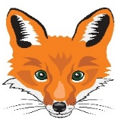
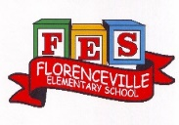
FLORENCEVILLE ELEMENTARY SCHOOL
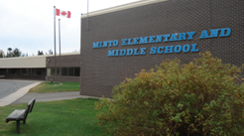
At FES our vision is to be a community where everyone is empowered to be lifelong learners.
HOME LEARNING PLAN
May 25-29, 2020

Class | 5B
Teena Bishop | teena.bishop@nbed.nb.ca
Sarah Mahar  Bridget Nugent | Principal: sarah.mahar@nbed.nb.ca;  Vice-Principal: bridget.nugent@nbed.nb.ca
Cindy Crowhurst | Resource: cynthia.crowhurst@nbed.nb.ca
Dianne Lord | Guidance: dianne.lord@nbed.nb.ca
School | florencevilleelementary@nbed.nb.ca

In accordance with the communication sent from our Minister of Education, Dominic Cardy, on April 2, 2020 Home learning opportunities to support literacy and numeracy outcomes will be made available online weekly by Teachers.

Families are encouraged to:
-Support their children to complete the options below for an average of one hour per day.
-Read aloud with their children daily; and
-consider daily physical activity and free play as an important part of their child’s mental health and skill development.

Subjects | Description of Learning Activities
Literacy
Oral Language- Listening to music and shows in French is a great way to review and develop your oral language. Here are some suggestions of things that you can listen to and watch. (You can slow the speed of videos down when you are watching YouTube.)  Listen to these songs:  Au petit déjeuner  https://www.youtube.com/watch?v=d5U4kDDBCVA  C’est le printemps:  https://www.youtube.com/watch?v=yKKWNJ8qsss  Dans mon jardin:  https://www.youtube.com/watch?v=BsuodT8iAMQ  Savez-vous planter les choux  https://www.youtube.com/watch?v=iAGV2pcLaAg  Sème, sème dans le jardin  https://www.youtube.com/watch?v=OpSxyCG5LE8  Quel temps fait-il aujourd’hui?  https://www.youtube.com/watch?v=eBvJVOuBPXI  La chanson des légumes:  https://www.youtube.com/watch?v=NTPQJUugCJM&  list=PLPpLiNCESKpV28I-Zd5KTSil8p56oTDMp&index=2  How to make a pizza video:  Telmo et Tula - Recettes populaires: pizzas et crêpes  https://www.youtube.com/watch?v=pxeRnzvu1R8  Here is a French book that you can listen to on YouTube called; Le Petit Bonhomme en Pain d’épices  https://www.youtube.com/watch?v=QWAy3fUdVvw  & Le GROS navet  https://www.youtube.com/watch?v=ywJmq0ZYssQ  Défi littératie : Trouve les mots des aliments dans la grille de mots mêlés. Pour un défi encore plus amusant, tu peux créer ta propre grille de mots mêlés et demande a un membre de ta famille de trouver les mots qui sont caché!  (Full size version of the crossword is with other attachments below). | Reading – (Students are encouraged to read in both French and English throughout the week). Talk about books that you read (or movies that you watch) by discussing some of the following questions:  Avant la lecture:  - Quel est le titre de ce livre?  - Qui est l’auteur de ce livre?  - Qui est l’illustrateur?  - Est-ce un texte informatif ou fictif?  - Pose une question que tu aimerais répondre pendant la lecture.  Pendant la lecture:  - Où se déroule l’histoire?  - Quel est le problème de l’histoire?  - Est-ce que cette partie de l’histoire te fait penser à quelque chose de similaire qui t’est arrivé?  Après la lecture:  - Quelle question poserais-tu à l’auteur?  - Aurais-tu préféré une différente fin? Aimerais-tu lire un autre livre par cet auteur?  While reading your book, try to make as many connections as you can with books you have read, movies you have seen, or events that has happened to you in the past.  See what you will come up with, even if it sounds a little bizarre!  If you do not have French books at home, there are websites that you can access French books. Explore these and read (or listen to) French books that are a “good fit” for you (not too hard, not too easy). https://boukili.ca/fr  https://www.readinga-z.com/worldlanguages/french/leveled-books/
Word Work:  - Utilise le lien ci-dessous pour jouer un jeu sur ‘’l’ordre alphabétique’’des mots! https://micetf.fr/ruche-mots/  - Using any word list of your choice (gardening list below, food list above, words from older lesson plans, words from the game ‘’L’ordre alphabétique’’)  - Decorate or illustrate your words.  S ’amuser avec les mots  1 Écris le mot 3 fois. 2 Écris le mot avec des lettres bizarres. 3 Écris le mot en images  4 Écris le mot avec les voyelles en rouge et les consonnes en bleu. 5 Écris le mot avec des points sur les lettres. 6 Écris le mot avec des lettres MAJUSCULES.  7 Écris le mot avec des lettres minuscules. 8 Écris le mot avec une régularité AB de couleur. 9 Écris le mot en écriture cursive. | Writing – Here are a few writing ideas for this week.  You can choose one to work on throughout the week or a different one each day. If you want to go back to last week’s ideas, please do so. Don’t forget to make sure that you use capital letters and punctuation where they belong. Think about who will enjoy (or learn from) reading your writing after you are finished.  - En utilisant le guide alimentaire, planifie une journée de repas sains (déjeuner, diner, collation, souper). Écrit une liste de tous les ingrédients que tu as besoin.  - Créer trois recettes avec des ingrédients que tu peux trouver dans le guide alimentaire. (A recipe card can be found with attachments below to help guide your writing).  - Tu es chef dans un restaurent bien connu. Invente une histoire de ce qui s'est passée quand une personne vedette est venu manger dans ton restaurent.  - Créer un nouveau mot croisé en utilisant les mots des aliments qu’il y a sur la feuille du guide alimentaire.  - Répond aux questions de la lecture (en haut) écrit ta réponse en français.  - Écrit une fin différente que tu aurais préféré de ton livre.  - D’écrit qu’est-ce qui se passe avec les graines que tu as plantées.  Une Devinette  Quel est le dessert préféré des araignées ?

Numeracy  Material needed for this project:  Grocery store flyers.  Scissors.  Glue. | At the grocery store …  - Make a shopping list.  - Place checks or tallies next to each item to indicate the number needed (this will help you with your collection of data).  - How much milk or juice do you think you will need for a week. Use estimations to help you decide how much of everything you might need.  - You might decide to estimate using cups or liters or other measurement tools. See how they compare to each other.  - Using flyers, find the grocery items that you have on your list.  - Cut out the items from the flyers and estimate how much your grocery will cost you if you buy all the items you have cut out.  - You can practice your mental math by estimating how much one item might cost if you must buy more than one.  Example:  - On Monday I want to make grilled chicken on the barbecue with a baked potato and a side of fiddle heads for dinner. I will check the flyers for the items I might need. These would be; chicken, potatoes and fiddle heads.  - Then I will cut out the items from the flyers. Estimate how much it will cost me.  - Check many different flyers to see if you can find the best prices available.  - Should I buy the chicken breast at 2.99 per pound of the chicken thighs at 3.49 per pound? Which is the best price?  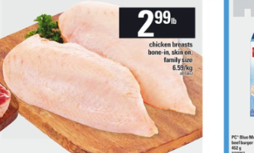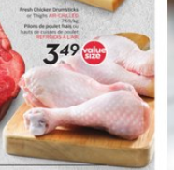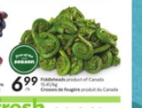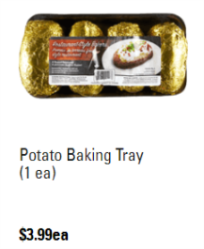
 | Math Games | Math Challenges  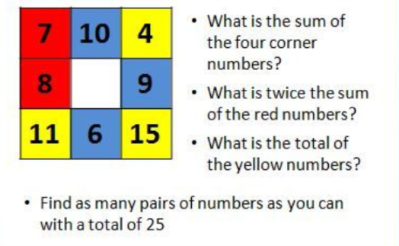  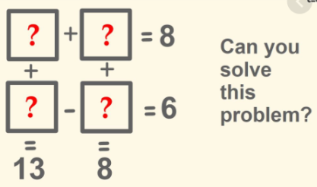  Check out the FREE app Prodigy Kids Math Games or you can play this fun game online https://www.prodigygame.com
 | 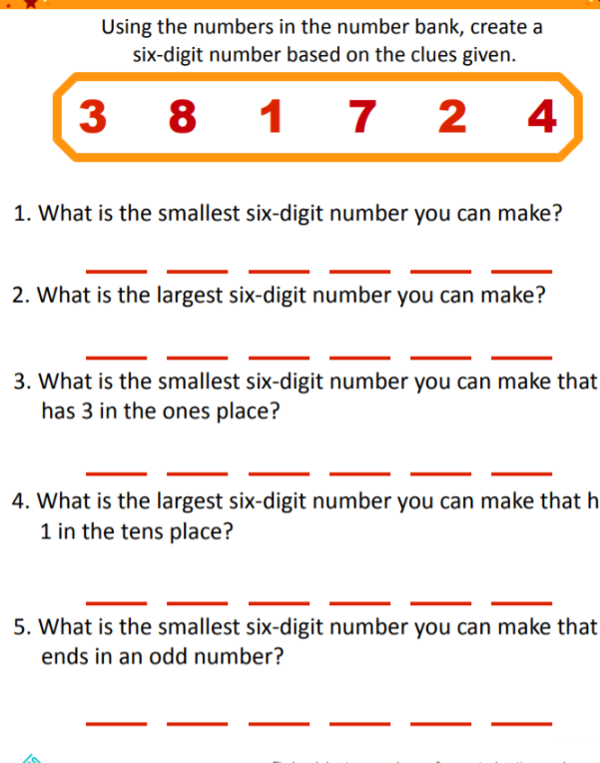
Other areas of interest/learning experiences  Science & Art & Mindfulness | Here are some activities that you can choose from this coming week. Try doing at least one from each column.  Create a gratitude journal. Try to write three things each day that you are thankful for. Use pictures, words, or both. Explore the Canada’s Food Guide online (or copy at the end of this document). What are some foods that you have tried, what are some food you would like to try? https://food-guide.canada.ca/en/food-guide-snapshot/ https://www.aboutkidshealth.ca/Article?contentid=1436&language=English&hub=nutrition Collect rocks and paint them with inspirational pictures or messages. Leave these messages around your community to brighten someone’s day. Thank you Rylynn for these examples. 😊  Go outside and lay quietly on the grass and look at the sky. What do you notice? Do this at different times of the day, what is the same, what is different? Check out one of these videos to learn more about the food guide suggestions. https://www.youtube.com/watch?v=CsvBBfRDjbg https://www.youtube.com/watch?v=Gmh_xMMJ2Pw https://www.youtube.com/watch?v=pZL2BBU7Dyk Make a card to express gratitude for someone working as an essential worker right now.  Tell each person in your family one thing that you really like about them. You can tell them with words or write a little note. Plan and prepare a meal for your family this week. How have you used the New Canada’s Food Guide to help you plan your meal? Why not create art that you can eat. Using food items create an art piece. Don’t forget to take a picture before you eat it!
English Language Arts | Here are some English Language Arts activities for you to choose from over the next three weeks (May 25th - June 12th). Try to choose 2-3 to do each week.  Find a nice cozy place to read in the sun. What do you want next year’s teacher to know about you?Create something that we can pass along to that teacher to let them know a little about you. You could write, draw, make a video...the opportunities are endless. Learn how to draw Snug from DOG MAN by watching this video. https://www.youtube.com/watchlist=PLtCDOmMCDvaq8ZvzN6eVRgFZJZGpvvzvT&time_continue=2&v=6jZHKkHNR0A&feature=emb_logo  What is a book that you have read lately that you would recommend to others? Create something to share with others about that book. Some ideas: a video clip, a poster, a write up, a comic. Read some news on https://www.cbc.ca/kidsnews/ Snuggle up and read with your cat, dog or stuffed animal.  Select a favourite recipe to follow and cook supper foryour family.You could even create place cards so they will know where to sit! Create a skit/play to perform in front of your family. Have your siblings or stuffed animals join in the fun! You could even film your skit and send to others! Create a summer “bucket list” of things you hope to do this summer. They don’t have to be expensive or far away...watch a beautiful sunset, go on a hike, learn to make/do something new...

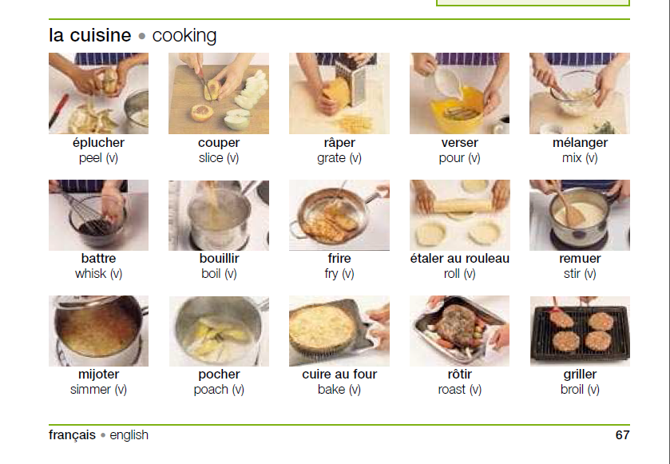

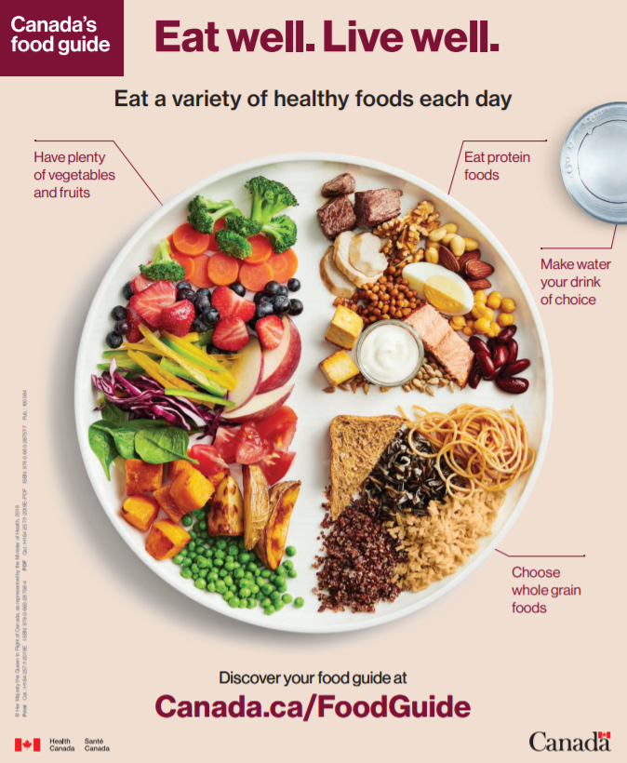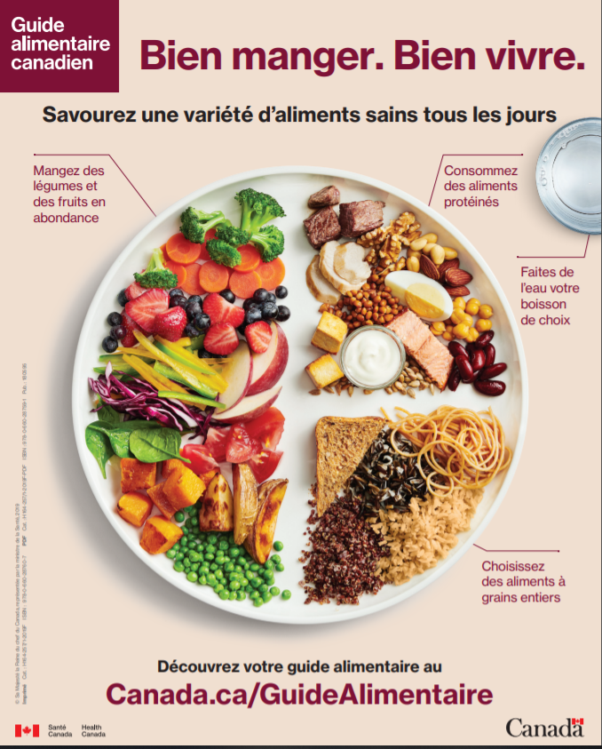
Crossword Puzzle Grid

