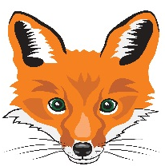
FLORENCEVILLE ELEMENTARY SCHOOL
At FES our vision is to be a community where everyone is empowered to be lifelong learners.
PRIMARY HOME LEARNING PLAN

Grade: | 1/2
TEACHER | Andree Charlebois : andree.charlebois@nbed.nb.ca
Sarah Mahar  Bridget Nugent | Principal: sarah.mahar@nbed.nb.ca; Vice-Principal: bridget.nugent@nbed.nb.ca;
Cindy Crowhurst | Resource: cynthia.crowhurst@nbed.nb.ca
Dianne Lord | Guidance: dianne.lord@nbed.nb.ca
School | florencevilleelementary@nbed.nb.ca

In accordance with the communication sent from our NB Minister of Education, Dominic Cardy, on April 2, 2020 Home learning opportunities to support literacy and numeracy outcomes will be made available online weekly by teachers.

Families are encouraged to:
-support your children to complete the options below for an average of one hour per day
-read aloud with their children daily
-consider daily physical activity and free play as an important part of their child’s mental health and skill development.

Subjects | Description of Learning Activities – Week of May 19th – 22nd
Literacy | Activity 1: Keep doing the Literacy and Math activities from the following websites. I received an email from IXL to tell me that my students have answered 2500 Math questions in just 2 weeks and you worked on over 50 Literacy skills and answered over 500 Literacy questions. Wow!! I’m so impressed!  https://www.getepic.com/  https://www.abcya.com/  https://www.starfall.com/h/  https://ca.ixl.com/  **ENJOY THE NEW RAZ KIDS READING SITE*** www.kidsa-z.com  Please refer to the email I sent all families last week with your child’s password.  Activity 2 Literacy/You and Your World Reading and Writing:  First read this extremely funny read aloud “The Very Impatient Caterpillar” by Ross Burach. We have read this in class but the way these two read it is hilarious!!  https://www.youtube.com/watch?v=h0meslYrZKk  Below are examples of life cycles. In the Winter your child created a poster of their life cycle. If they would like, they can research an animal, insect or bird and create a poster/picture or a model out of playdoh/clay of the life cycle. PLEASE EMAIL ME A PHOTO OF YOUR POSTER/PICTURE/MODEL! I will show them to everyone if that is okay with you!  A good child-friendly website is called “Kiddle” (it’s Google for kids) to help them research. https://www.kiddle.co/  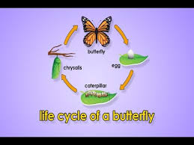  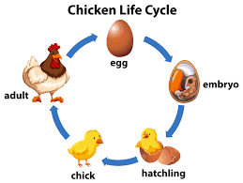  Activity 3:  Gr. 1: “From 3 To 3” Oral Program  https://www.youtube.com/watch?v=77uZvFzNtYw&feature=youtu.be  Gr.2 https://drive.google.com/file/d/1IWC-3OPGVx983Mjipk3yu7kEuZNu7UgV/view  Gr. 2 Read aloud “King Pom and the Fox” https://drive.google.com/file/d/1d1JG2QfCryb8ouNK_oGl8sZIorhXID0W/view  Activity 4: Word Work (sight words)  Please see the attachment “Sight Word Dice Game” on this email.  - Write some sight words (from the list you already have) on some pieces of paper or index cards.  - Roll a die and follow the direction (see the attachment).  - Challenge: when you say the word, spell it on your whiteboard.  - Have fun!  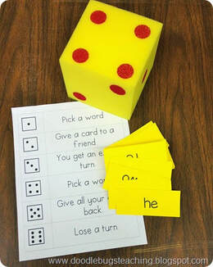  Activity 5: More writing suggestions:  - Set a timer for 5 minutes. Make a list of things that make you happy. Choose some of these to write about over the next week in one of your new notebooks. Name this notebook “My Journal”.  - Create a “Gratitude Jar”: re-use a jar and every day, write on a small piece of paper something you are grateful for! Ex: I am grateful that I can talk with my family a few times a week on our “video calls”. It’s like we are altogether! I am grateful that I am in touch with your parents every week. I am grateful when I receive a letter from you or when you send me a video. I LOVE these!  - Please write me a LETTER! I will write you back!  - Write in your notebooks a personal recount (or personal narrative). Do you remember these? Write about real things you are doing. See below to refresh your memory!  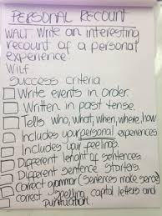  This is an example….more details would make it even better don’t you think?!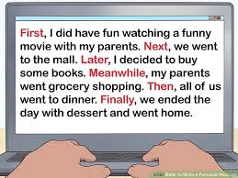
Numeracy | Activity 1: Showing numbers using coins  You can either print the attachment “Showing Numbers in Different Ways” or just use a table or the floor to show the coins then draw them on your whiteboard. Be creative!  Rules of the activity:  - You can use the full deck of cards or as the attachments says, use only 1-5 playing cards (for lower numbers).  - Turn over 2 cards and make a 2-digit number. Ex: if you turn over a 4 and 3, you can make the numbers 43 or 34.  - One partner makes this number using coins. The other partner makes the same number another way using coins. You can put the coins on the sheet only or put them on the sheet and then draw them.  - Challenge: Can you make them 2 more different ways?  - Have fun!  **Remember: when you count coins, start with the highest value first**  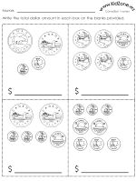  Activity 2: Game “Race to 100” (we played this with Gr. 2 students but if Gr. 1 students can do it, go for it!)  Rules:  - Use the base ten models you made last week (tens/ones).  - Roll 2 dice and add them together.  - Take that many base ten models.  - Remember to “re-group” or “trade” if you have 10 ones, re-group for 1 ten (rod). 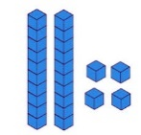  - First person to 100 wins! (But we ALL win don’t we?)  Activity 3:  Create your own Math flower garden! See the picture below as an example. Gr. 1 students can work with number less than 50 or higher if they’d like and Gr. 2 students can work with numbers to 100. Also include coins and base ten models!  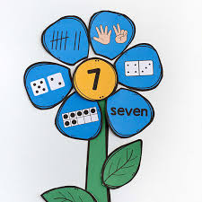  Activity 4: Measurement – Length (how long something is)  Measure length using things you find at home: string or yarn.  Create snakes of different lengths with playdoh or clay.  - Compare them from shortest to longest or longest to shortest.  - With a partner, decide if the longest or shortest snake wins and create a snake (without looking). Then show each other and compare and if you decided that the shortest snake wins, whoever created the shortest snake gets a point! Keep playing and have fun!  - Outside take turns jumping. Measure the distance or length with a string or yarn. Who can jump the farthest?  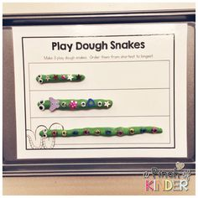  Activity 5: Mental Math  Have fun playing “Tic Tac Toe” Doubles +1 or -1. I have sent this home but print it again (or write it out if you don’t have a printer) – see the attachments. Put it in a plastic pocket and play with 2 different coloured erasable markers. Make sure to tell your partner the strategy then the sum before you put your X or 0!  Strategy example: 5 + 6 =  Think: 5 + 5 = 10  I don’t want to add just 5 to the 5, I want to add 6 which is 1 more so….  10 + 1 = 11  OR  6 + 6 = 12  I don’t want to add 6 to the 6, I only want to add 5 which is 1 less so…..  12 – 1 = 11  Activity 6: Store  Keep playing store (an activity from last week). Either use real coins or money you make (coins or bills). Have fun!!
Other areas of interest/learning experiences | Movement: Count to 100 and dance with Jack Hartmann: https://www.youtube.com/watch?v=cVwjmC-gpBU  Les Mill’s “Born to Move” exercise video! https://www.youtube.com/watch?v=GHCqRsrQwNU  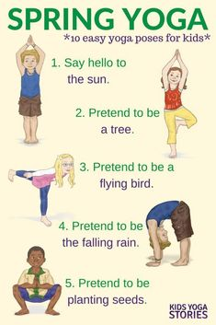  Art: Blow Paint Monsters  Do this outside! Use a straw and blow different coloured paint onto a canvas or piece of paper. Let it dry. Then draw the monster’s arms, legs, face, horns, whatever you’d like. Have fun!  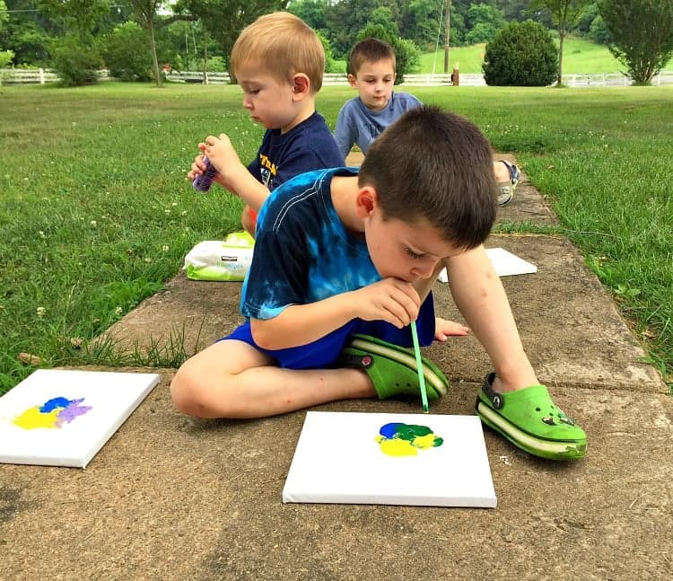  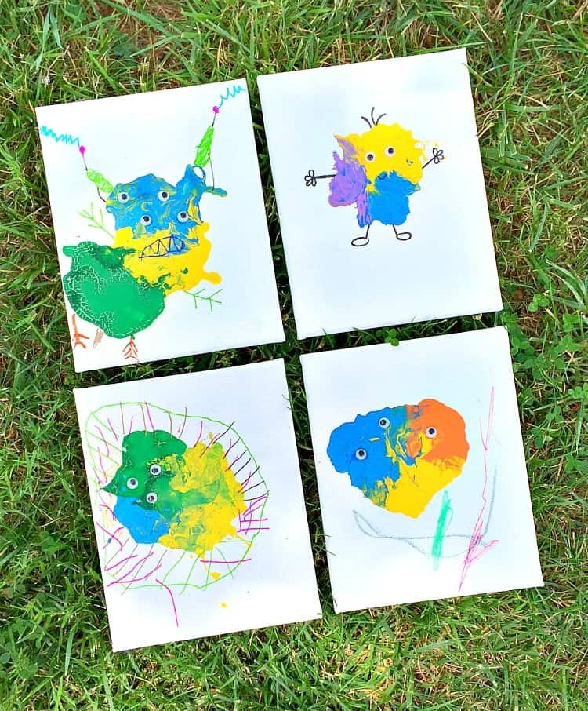  FES FOX MAKERS CHALLENGE!  Please see the attachment!  