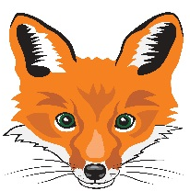
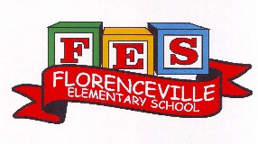
FLORENCEVILLE ELEMENTARY SCHOOL
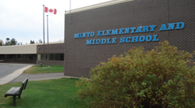
At FES our vision is to be a community where everyone is empowered to be lifelong learners.
PRIMARY HOME LEARNING PLAN

Grade: | 1/2
TEACHER | Andree Charlebois : andree.charlebois@nbed.nb.ca
Sarah Mahar  Bridget Nugent | Principal: sarah.mahar@nbed.nb.ca; Vice-Principal: bridget.nugent@nbed.nb.ca;
Cindy Crowhurst | Resource: cynthia.crowhurst@nbed.nb.ca
Dianne Lord | Guidance: dianne.lord@nbed.nb.ca
School | florencevilleelementary@nbed.nb.ca

In accordance with the communication sent from our NB Minister of Education, Dominic Cardy, on April 2, 2020 Home learning opportunities to support literacy and numeracy outcomes will be made available online weekly by teachers.

Families are encouraged to:
-support your children to complete the options below for an average of one hour per day
-read aloud with their children daily
-consider daily physical activity and free play as an important part of their child’s mental health and skill development.

Subjects | Description of Learning Activities: Week of April 27 – May 1
Literacy | Keep doing the Literacy and Math activities from the following websites:  https://www.getepic.com/  https://www.abcya.com/  https://www.starfall.com/h/  Activity 1: “From 3 To 3” Oral Program: In a separate email, I have sent the links with new Spring rhymes and additional oral stories. Have fun saying the old rhymes and learning the new ones!  *Practice saying the oral story a few times with each other. Have fun with the stories and rhymes!  Activity 2: I hope that everyone received a letter from me (included in the package was a letter from your pen pal).  *I would really love it if you could write me back (some of you have so thank you!) Draw a picture of something you have been doing with your family.  *If you would like to write back to your pen pal, I will be sure to mail it to their teacher.  Activity 3: Follow along with the book “Pete the Cat and His Magic Sunglasses”: https://www.youtube.com/watch?v=tJCG1Ls7a9c  Enjoy this read aloud, listen to the reader’s voice and how it changes with each animal that Pete meets (now that’s reading with expression)!  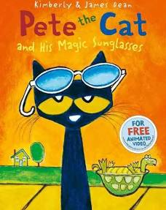  Think about these questions and discuss them with your parents:  - What do you do when you feel blue (or in the blue zone)?  - Do you have a toy or thing that makes you feel better? Would you share it with your friends if you know it will make them feel better?  - What different feelings were in this book? What other feelings can you thing of?  - Why did the owl tell Pete that he does not need his sunglasses to see things in a new way and to remember to look for the good every day? Have you ever tried to see the good in every day?  Activities to go along with this book:  - Make up a new character (or a few characters) for Pete to meet and draw them. Discuss with your family why you think they would be interesting for Pete to meet.  - Draw what happened at the beginning of the story and write 1-2 sentences to explain your thinking. Then draw/write what happened in the middle and at the end.  - Create a new ending for this book. Maybe it’s not the Owl he meets…..  - Write in a journal and finish the following….  *Things that make me feel better include…..  *If I had Pete’s magic sunglasses I would….  5. Draw your favourite style of sunglasses, describe them and  explain why they are so cool.  Activity 4: Word Work “Sight Word Scavenger Hunt”: Write some sight words on pieces of paper and have someone hide them around the house. Say the words when you find them then practice spelling them on your “whiteboard” (plastic pocket/cardstock already at your house). Put these words in sentences.
Numeracy | Activity 1: Addition and Subtraction Facts Practice! Have fun timing yourself! Questions have been sent in one of the attachments to this email.  Gr. 1: In grade 1 you do not need to solve these in 3 minutes but it would be fun to see how long it takes you!  Gr. 2: Your goal is to solve 12 basic fact questions in under 3 minutes. When you have finished these questions, create your own questions. Have fun!  Activity 2: Patterns  Gr. 1: Create some repeating patterns (use 2 and 3 items/elements in each core). Use the attribute chart to help you. Go outside and find things in nature. Describe your pattern to your parents. Have them create patterns too!  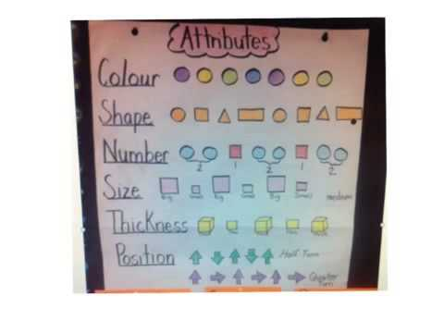  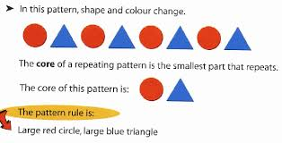  Gr. 2: Go outside and find things in nature to create increasing patterns.  Examples:  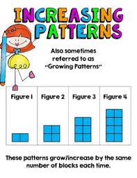Pattern rule for the above: Start at 2 and increase by 2  each time.  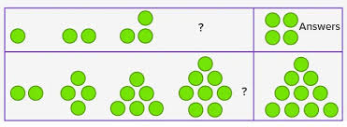  Pattern rule for the 1st pattern: Start at 1 and increase by 1 each time.  Pattern rule for the 2nd pattern: Start at 2 and increase by 2 each time.  Activity 3: Mental Math: Partner Numbers to 10. Have fun watching this website: https://www.youtube.com/watch?v=ch7KzI3n2Zk  Partner Number to 10 Concentration/Memory Game: You need playing cards but don’t use the entire deck (use 2 pairs of: 0+10 (joker + face card), 1+9 (1 = ace), 2+8, 3+7, 4+6, 5+5. Place them in rows and columns. Turn 2 cards over (remember to keep the card in that position and make sure you turn it over all the way so your partner can see them). If they make 10, keep them. If not, turn them back over and leave them in the same place. Have fun!  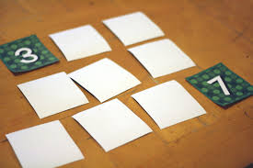  Activity 4:  https://ca.ixl.com/ This is a NEW math website for your child. I have sent all parents their child’s usernames and passwords for the one month free trial in a separate email last week. Discover it together! Use it every day! I have already received an email from them to say my students have answered over 200 questions so far! YAY!  Activity 5: Skip counting by 2s:  Gr. 1: Students count by 2s (forward) to 20 only if they can keep going, great!  Gr. 2: Students count by 2s forward and backward to 100.  We love Jack Hartman videos! Dance/count to these: https://www.youtube.com/watch?v=OCxvNtrcDIs (forward by 2s)  https://www.youtube.com/watch?v=MtN9SSI6qSA (backward by 2s)  Then go outside and throw a ball around (or something else you have from your home) and skip count by 2s! See how high you can count to without dropping your object!  Activity 6: “Spring Counting Collections”: Go outside and collect things from nature (leaves, rocks, twigs) and put them into groups (what is the best way to count them?). How many did you collect? Write this number in tally marks in the dirt (write it with a twig in dirt)?  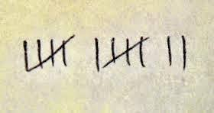
Other areas of interest/learning experiences | Continue to keep moving and having fun dancing to this website: https://family.gonoodle.com/  FES Creativity and Positivity Challenge – please see the poster attachment that I have sent with this email. Have fun with this!  Watch “The Science of Spring” video. Go on another nature walk! I hope you will be able to grow (in a pot) a vegetable or flower.  https://www.youtube.com/watch?v=qaZ2CICGuL8  Look at the attachment “Spring Organize and Count” while you are on your nature walk!  French song we have sung in class: https://www.youtube.com/watch?v=atNkI6QFZ50

