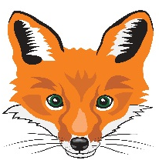
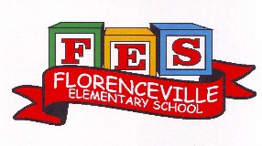
FLORENCEVILLE ELEMENTARY SCHOOL
At FES our vision is to be a community where everyone is empowered to be lifelong learners.
PRIMARY HOME LEARNING PLAN

Grade: | 1/2
TEACHER | Andree Charlebois : andree.charlebois@nbed.nb.ca
Sarah Mahar  Bridget Nugent | Principal: sarah.mahar@nbed.nb.ca; Vice-Principal: bridget.nugent@nbed.nb.ca;
Cindy Crowhurst | Resource: cynthia.crowhurst@nbed.nb.ca
Dianne Lord | Guidance: dianne.lord@nbed.nb.ca
School | florencevilleelementary@nbed.nb.ca

In accordance with the communication sent from our NB Minister of Education, Dominic Cardy, on April 2, 2020 Home learning opportunities to support literacy and numeracy outcomes will be made available online weekly by teachers.

Families are encouraged to:
-support your children to complete the options below for an average of one hour per day
-read aloud with their children daily
-consider daily physical activity and free play as an important part of their child’s mental health and skill development.

Subjects | Description of Learning Activities – Week of May 4th – 8th
Literacy | Activity 1: Keep doing the Literacy and Math activities from the following websites. I received an email from IXL to tell me that my students have answered 1000 Math questions in just a few days! Wow!! I’m so impressed!  https://www.getepic.com/  https://www.abcya.com/  https://www.starfall.com/h/  https://ca.ixl.com/  Activity 2: Sensational Writing! Imagery (visualizing) lets readers develop a mental picture of what they are reading (making a picture in their minds). This involves our five senses: sight, sound, taste, smell and touch and it’s a very important reading comprehension strategy.  - Listen to David Ezra Stein’s picture book “Honey”: click on this link  https://www.youtube.com/watch?v=olLYuwLqXEo  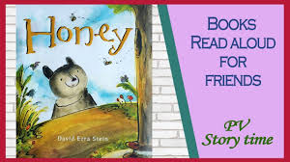  - With your family, discuss what the bear sees, hears, smells, tastes and touches/feels throughout the story.  - With a parent’s help, get yourself a snack. But don’t eat it yet!! You will use this snack in your writing.  - You may choose an apple as your snack for example. The writing challenge is you cannot write the word “apple”.  - On a sheet of paper, write 1-2 sentences related to each of the five senses relating to your snack. Don’t let your family see you do this!  *look at your snack and describe/write what you see  *hold your snack in your hand and describe/write what you feel (texture)  *take a small bite of your snack and describe/write what sound it makes as you chew it  *hold your snack up to your nose and describe/write how it smells  *take a big bite of your snack and describe/write the taste (texture)  6. Have your family read your sentences. Can they guess what your snack is?  Have fun!  Activity 3: Have fun with these new Spring rhymes, oral stories and read alouds! Students can click on any of the links.  Gr. 1: https://www.youtube.com/watch?v=eMW14mdHdyY&feature=youtu.be  Gr. 2: https://drive.google.com/file/d/1zGqYhoO94up_YpGtoum7KHIcGC_1-gXR/view  Gr. 2 Read aloud “The Blizzard’s Robe” https://drive.google.com/file/d/1WRVEpWAyZ--axx0h5utmEUPe6VG-4wQn/view  Activity 4: Word Work (S blends)  On the email I usually send on Sunday evenings, this game will be attached to the email. I hope you are able to print this and play. If you can’t print it, try to play it while looking at it on your computer. Once your child says the word, have them write (on their whiteboard) the first 2 letters of the word or if they want to challenge themselves, write the entire word.  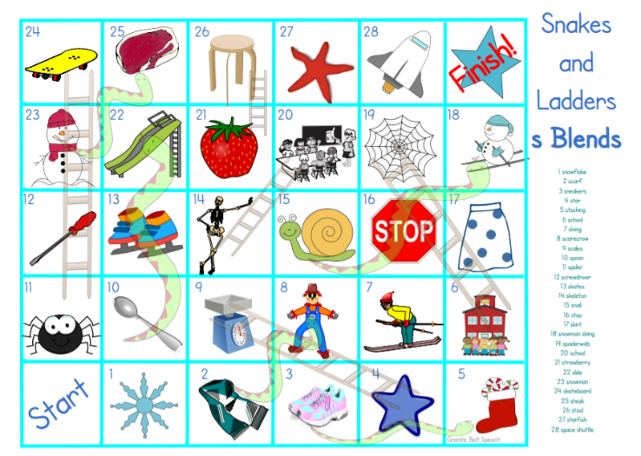  Activity 5: Word Work (“ight” word family)  Have fun with this word search! It will also be an attachment on your email.  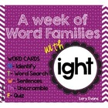
Numeracy | Activity 1:  Showing numbers in different ways! Listen and dance to Jack Hartmann:  https://www.youtube.com/watch?v=lAQ2HTqTl2w  Create a poster to show numbers in different ways. Grade 1: to 20 (or greater than 20 if you can! We have not discussed base ten blocks with this grade). Grade 2: to 100  ***Also use coins!  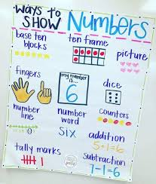  Activity 2:  Create a store in your house! We have played this in class and the students LOVE it!  *Art connection: make your money (you can use only coins – quarters, dimes, nickels and pennies or use loonies, toonies and bills ($1 coin, $2 coin, $5, $10, 20)  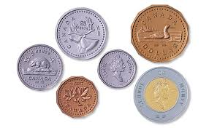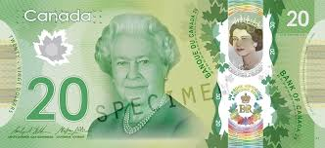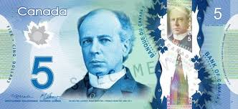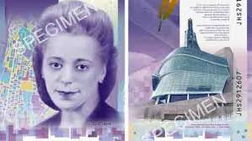  Take items from your house and place them in the “store”. Put prices on them. How will you know what change to get back? Use a 100 chart or use a 10 frame with counters. Decide who will be the cashier (use the calculator from your parents’ phone if you are allowed). REMEMBER: you have to determine the amount you get back first and then you tell the cashier that amount (they check your answer on the calculator).  HAVE FUN!!  Activity 3:  Write some addition and subtraction basic facts to 18 only (on small pieces of paper) and put them in each muffin tin compartment. Don’t stand too close to it. Throw a soft small object and try to get it into one of the muffin compartments. If you do, answer the question – use your mental math strategies (or if you need to, use your 100 chart or number line). Have fun!  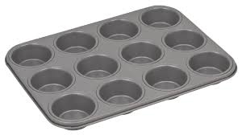  Activity 4:  Outdoor Fun! Replace beanbags with soft items from your home. Write numbers in a plate (Gr. 1: basic facts to 18 or make up your own; Gr. 2: put 10s and 5s, ex: 10 + 5 = 15 then you put it in a 10 so 15 + 10 = 25, then you toss and it’s 5 so 25 + 5 = 30).  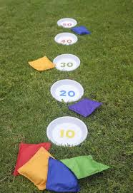  Activity 5: Use real coins or make/create them!  Draw the coins:  - How many ways can you create 18 cents using pennies, nickels and dimes?  - How many ways can you create 29 cents using pennies, nickels, dimes and quarters?  - How many ways can you create 85 cents using pennies, nickels, dimes and quarters?  - Create your own amounts!!
Other areas of interest/learning experiences  (Phys ed/  Art/  Wellness) | 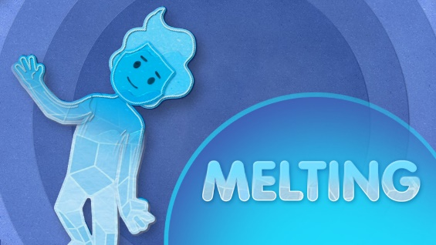  https://family.gonoodle.com/activities/melting  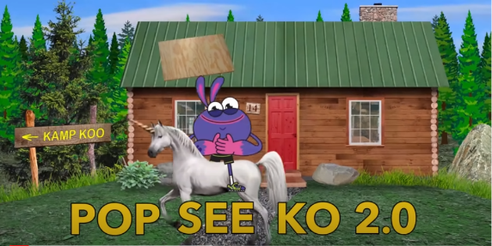  https://www.youtube.com/watch?v=Pwn4beja1QE  Art: As noted above in Math, make your own coins and/or bills for the “Store” activity.  Outdoor Play/Phys ed: “Learning Through Outside Play” document which is attached to the email.

