Florenceville Elementary School

At FES our vision is to be a community where everyone is empowered to be lifelong learners.

HOME LEARNING PLAN

Grade: | 2/3 Antworth
TEACHER | Dianne Antworth: dianne.antworth@nbed.nb.ca
Sarah Mahar  Bridget Nugent | Principal: sarah.mahar@nbed.nb.ca;  Vice-Principal: bridget.nugent@nbed.nb.ca
Cindy Crowhurst | Resource: cynthia.crowhurst@nbed.nb.ca
Dianne Lord | Guidance: dianne.lord@nbed.nb.ca
School | florencevilleelementary@nbed.nb.ca

In accordance with the communication sent from our Minister of Education, Dominic Cardy, on April 2, 2020, Home learning opportunities to support literacy and numeracy outcomes will be made available online weekly by Teachers.
Families are encouraged to:
Support their children to complete the options below for an average of one hour per day.
Read aloud with their children and have them read an additional 30 minutes daily; and
consider daily physical activity, exploration, music, art, creating, free play, as an important part of their child’s mental health and skill development.
Subjects |  | Description of Learning Activities  June 8th – 12th  **PLEASE FEEL FREE TO RE-VISIT ACTIVITIES FROM PREVIOUS WEEKS**
Literacy |  | Summer Reading  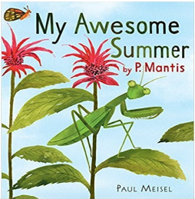  Option #1 My Awesome Summer by P. Mantis  https://www.youtube.com/watch?v=PyOde6GU4r8  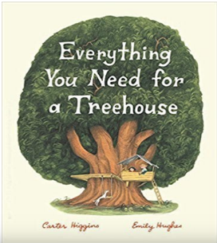  Everything You Need For a Treehouse  by Carter Higgins  https://www.youtube.com/watch?v=8kEGaqPeqXI  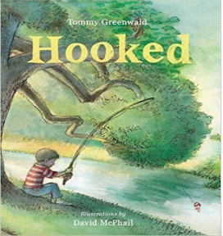  Hooked by Tommy Greenwald  https://www.youtube.com/watch?v=wQUZbTu6Oaw  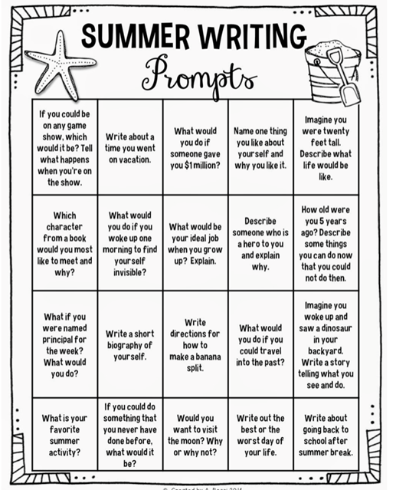  Option #2: Log into your Epic account and begin reading  www.epic.com  Log into your Raz-Kids account and begin reading  www.kidsa-z.com (  Literal response questions (read the lines): Find the page that tells us…..What happened first? Next? Who are the characters? What is the setting?  Inferential response questions (read between the lines): What does this picture tell us about the story? Why did this character say …..? How is this character feeling?  Personal Connections: Has anything like this happened to you? What is your favourite part and why? Does this character and yourself have anything in common?  When you’re reading this week, think about the characters you’ve met. (Suggestions)  - What’s the character (s) like?  - How is the character similar to you?  - How is the character different than you?  - How was the character feeling / acting?  New Spring Riddles / Thought Problems, “From 3 To 3”: Students can feel free to do both if they would like! Discuss the riddle and have them justify their answer (prove it based on the clues in the riddle). Remember the thought problem has a truth and a lie. Discuss what is true and what is not!  Step 1: Discuss it orally.  Step 2: Write about it – first with an illustration then 1-2 sentences.  Rhymes, Oral Story & Thought Problem  Eletelephony  Elephant  Have You Ever Seen?  I Went to the River  Oral Story Retell: The Terrible Leak  The Living Kuan Yin  Riddle  https://drive.google.com/file/d/1cjwh9HIVn1ZgHCdp7XhJM972FkYvl7SS/view?usp=sharing  Read Aloud  Listen to Chapter eight of the novel Seven Day Magic by Edward Eager:  https://drive.google.com/file/d/1Lkl5A1zKv8KvfZBffx8EY4IL8p-5z8bC/view?usp=sharing  Writing Suggestions  - Writing a Comic, using some suggestions from above or your own ideas  - Read, write and draw about the bird or animal you researched that lives in New Brunswick. (Continuation from last week.)  - What do they look like?  - What do they eat?  - What does it need in it’s surrounding to survive? (Habitat)  - Any interesting facts?  - Other information you find.  - Write out your list of similarities and differences between you and one of your characters that you chose from your reading.  - Word Work Idea –  With sidewalk chalk, create a hopscotch. Write some sight words in each square and play!  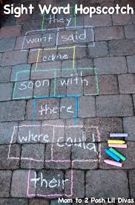
Numeracy |  | Continue with mental math games and log into your sumdog account.  Are you trying the challenges?!?  Review the earlier weeks’ games and activities.  Magic Square  Using the digits from 1-9 only once,  place the numbers on the grid so the sum of each row and  each column equals 15.  Find more magic squares here by scrolling down the page: https://www.math-salamanders.com/magic-square-worksheets.html  Close Call  To play Close Call, each player deals themselves four cards then determines how to arrange them, so they make two two-digit numbers that add up close to 100 without going over. For a subtraction version, work to get as close to zero as possible.  Students (from either grade) can choose any activity from the following  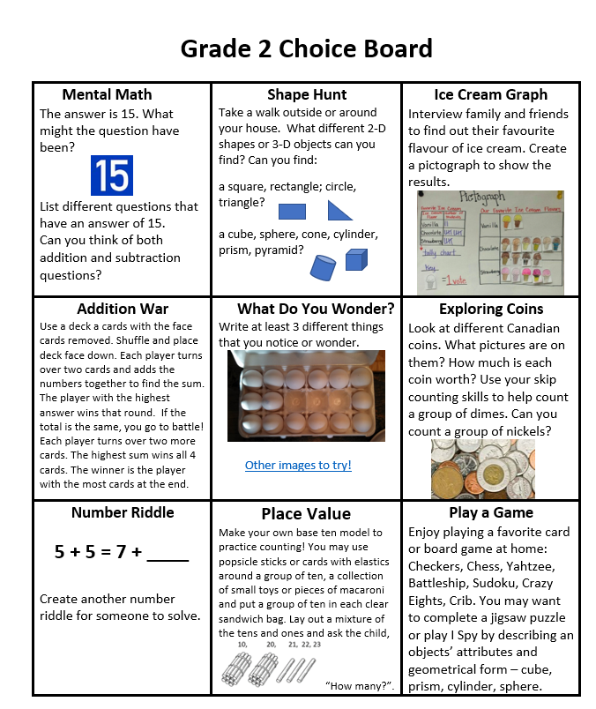  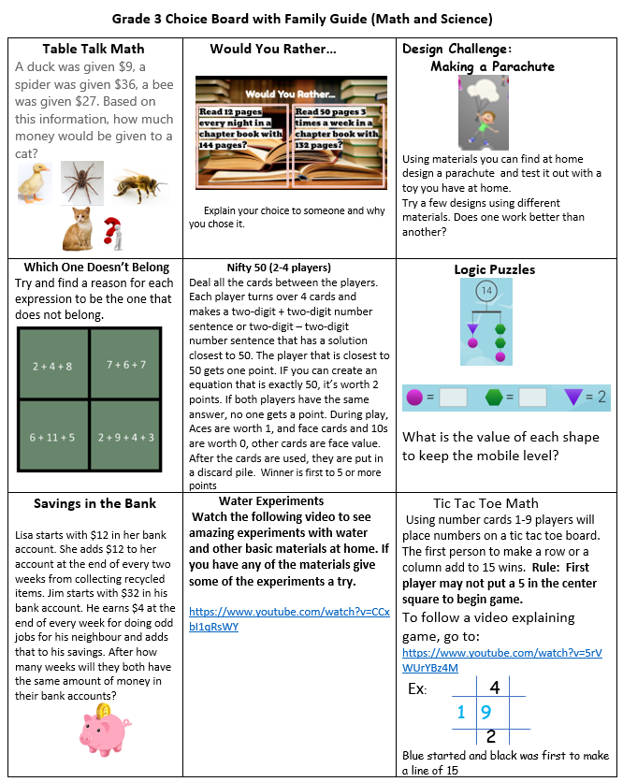
Other areas of interest/learning experiences | 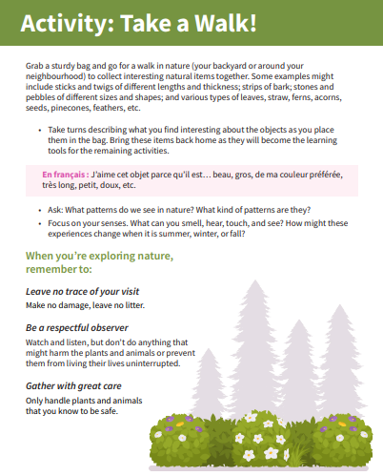  Art / Science / Outside Suggestions with the FAMILY  CHART and ANALYZE like a scientist.  *Record and compare the temperature outside in the early morning and later in the afternoon.  *How many degrees did it change?  *Check it out each day for the whole week.  What do you notice? What do you think the temperature  will be tomorrow?  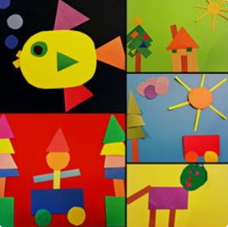  Create a 2-D Shape Picture  Cut out different 2-D shapes and create an animal or design. Describe and name the shapes that you used in your picure.  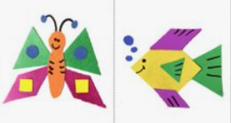  Please visit the FES website for more Phys. Ed, Art and Music Suggestions!!

