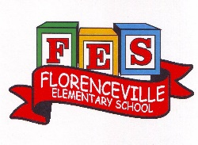
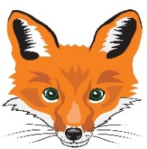
Florenceville Elementary School

At FES our vision is to be a community where everyone is empowered to be lifelong learners.

HOME LEARNING PLAN

Grade: | 2/3 Antworth
TEACHER | Dianne Antworth: dianne.antworth@nbed.nb.ca
Sarah Mahar  Bridget Nugent | Principal: sarah.mahar@nbed.nb.ca;  Vice-Principal: bridget.nugent@nbed.nb.ca
Cindy Crowhurst | Resource: cynthia.crowhurst@nbed.nb.ca
Dianne Lord | Guidance: dianne.lord@nbed.nb.ca
School | florencevilleelementary@nbed.nb.ca

In accordance with the communication sent from our Minister of Education, Dominic Cardy, on April 2, 2020, Home learning opportunities to support literacy and numeracy outcomes will be made available online weekly by Teachers.
Families are encouraged to:
Support their children to complete the options below for an average of one hour per day.
Read aloud with their children and have them read an additional 30 minutes daily; and
consider daily physical activity, exploration, music, art, creating, free play, as an important part of their child’s mental health and skill development.
Subjects | Description of Learning Activities May 11th -15th
Literacy | 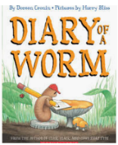  Reading  Option #1: https://www.youtube.com/watch?v=9y6Mtll5b0w  Diary of a Worm by Doreen Cronin  This will lead into our Science activities for the week  Activity Ideas:  Find other books to read that are similar to this. Diary of a …  Begin a personal diary like Worm.  Compare what your diary would be like that to a worm’s. Try using a Venn Diagram, showing how they are the same and different. Remember that if they are the same in any way, they go in the middle under BOTH.  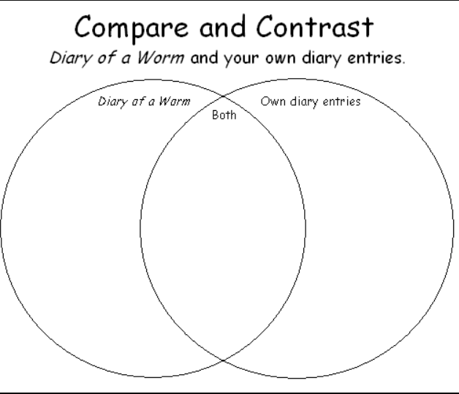  Word Work: use the page below to get started and then make up your own words on cards/pieces of paper!  Compound Words – two words when put together make a new word  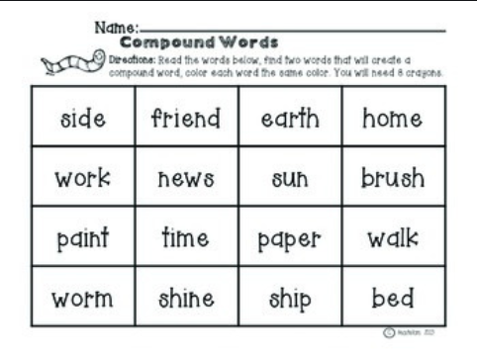  Option #2: Log into your Epic account and begin reading  www.epic.com (Parents have been sent emails. Please let me know if you are still having trouble logging in)  Log into your Raz-Kids account and begin reading  www.kidsa-z.com (All parents should have received an email. Please let me know if you haven’t received it or are having trouble logging in)  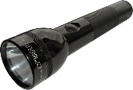  Option #3: Read books that you have at home. Try reading to a parent, sibling, stuffie, or find a quiet place to read to yourself. Get creative! Find a comfy spot outside to read.  Maybe have a FLASHLIGHT day!!  Literal response questions (read the lines): Find the page that tells us…..What happened first? Next? Who are the characters? What is the setting?  Inferential response questions (read between the lines): What does this picture tell us about the story? Why did this character say …..? How is this character feeling?  Personal Connections: Has anything like this happened to you? What is your favourite part and why? Does this character and yourself have anything in common?  When you’re reading this week, think about the characters you’ve met. (Suggestions)  - What’s the character (s) like?  - How is the character similar to you?  - How is the character different than you?  - How was the character feeling / acting?  New Spring Riddles / Thought Problems, “From 3 To 3”: Students can feel free to do both if they would like! Discuss the riddle and have them justify their answer (prove it based on the clues in the riddle). Remember the thought problem has a truth and a lie. Discuss what is true and what is not!  Step 1: Discuss it orally.  Step 2: Write about it – first with an illustration then 1-2 sentences.  Rhymes, Oral Story & Thought Problem  Sad Demise of the Vegetables  There Was An Old Man in a Barge  Help  Humpty Dumpty  Elephant and the Quarrel  Oral Story, The Brahmin, the Tiger, and the Jackal  Thought problem #5  https://drive.google.com/file/d/1n7nxoF2lg_LoB8bq3etDik2z3tcSgkWH/view?usp=sharing  Read Aloud  Listen to Chapter three of the novel Seven Day Magic by Edward Eager:  Part 1:  https://drive.google.com/file/d/1oJLz4XjZKA0tNxc0jfkbk1RrzshPon0Z/view?usp=sharing  Part 2:  https://drive.google.com/file/d/1-rs_Gsy7bRjftMMRndOt32Dq4O51DcXs/view?usp=sharing  Writing Suggestions  - Make a word web for a feelings word or a word web of all the feelings a character had from a story you read.  - Write in your personal journal / begin keeping a diary similar to WORM.  - Write out your list of similarities and differences between you and one of your characters that you chose from your reading.  - Set a timer for 5 minutes. Make a list of things that make you happy. Choose some of these to write about over the next week.  - What other words mean ‘happy’? (joy, joyful, elated) Make a list and see how many times you can use interesting words throughout the week.
Numeracy | Continue with mental math games and log into your sumdog account.  Are you trying the challenges?!?  Classroom Game to Review at HOME  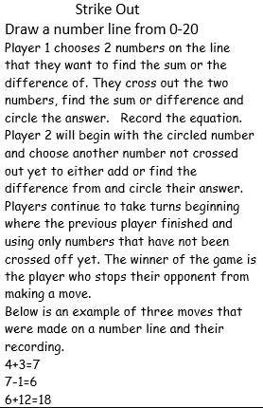  Measuring / Estimation  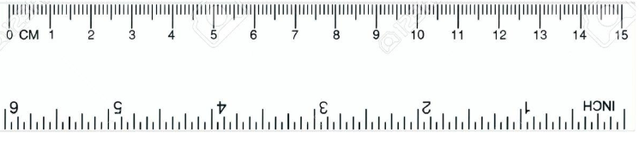  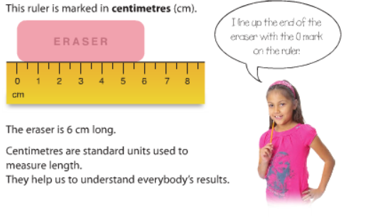  Give it a try! If you don’t have anything to measure with at home, use string, yarn or anything that you can lay o the ruler above. Be creative  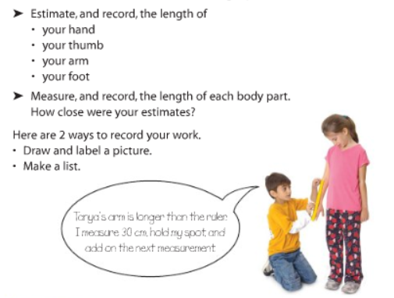  *******REFERENT is the key skill  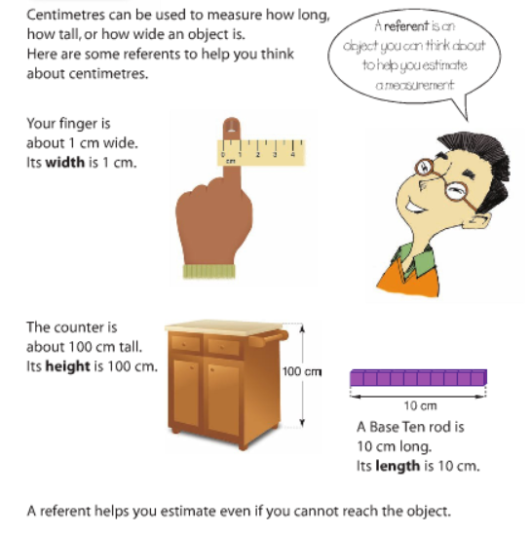  Measuring / Estimation Scavenger Hunt  1) Measure your height.  2) Find an object that is: shorter than you, taller than you and equal to your height.  3) Estimate each object’s height.  4) Measure each object to compare your estimation.  5) Optional: Take a picture of you with your items and send the picture to me. I’d love to see what you found!
Other areas of interest/learning experiences | Art / Science Suggestions  Send pictures of your FES Rainbow!  Drawing to be included with in your Literacy time – 3 TO 3 illustrations and drawing of your characters. REMEMBER to use your techniques taught for sketching and shading from art classes.  Looking at the forecast, with the wet weather, thinking that these friends will be coming out Some of you are possibly digging in the gardens, flowers and getting ready for planting, so have fun listening and learning a bit more about WORMS!  Read aloud: https://www.youtube.com/watch?v=eWjl8mGMLAI

