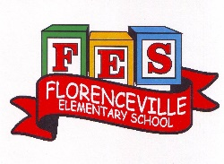
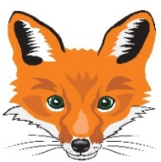
Florenceville Elementary School

At FES our vision is to be a community where everyone is empowered to be lifelong learners.

HOME LEARNING PLAN

Grade: | 2/3 Antworth
TEACHER | Dianne Antworth: dianne.antworth@nbed.nb.ca
Sarah Mahar  Bridget Nugent | Principal: sarah.mahar@nbed.nb.ca;  Vice-Principal: bridget.nugent@nbed.nb.ca
Cindy Crowhurst | Resource: cynthia.crowhurst@nbed.nb.ca
Dianne Lord | Guidance: dianne.lord@nbed.nb.ca
School | florencevilleelementary@nbed.nb.ca

In accordance with the communication sent from our Minister of Education, Dominic Cardy, on April 2, 2020, Home learning opportunities to support literacy and numeracy outcomes will be made available online weekly by Teachers.
Families are encouraged to:
Support their children to complete the options below for an average of one hour per day.
Read aloud with their children and have them read an additional 30 minutes daily; and
consider daily physical activity, exploration, music, art, creating, free play, as an important part of their child’s mental health and skill development.
Subjects |  | Description of Learning Activities June 1st – 5th
Literacy |  | 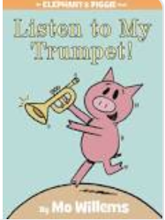  Reading  Option #1: Listen to My Trumpet by Mo Willems  https://www.youtube.com/watch?v=QN4Oo4IqRMU  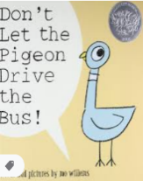  Don’t Let the Pigeon Drive the Bus by Mo Willems  https://www.youtube.com/watch?v=n-dHeNfXtgc  Writing a COMIC  IDEAS  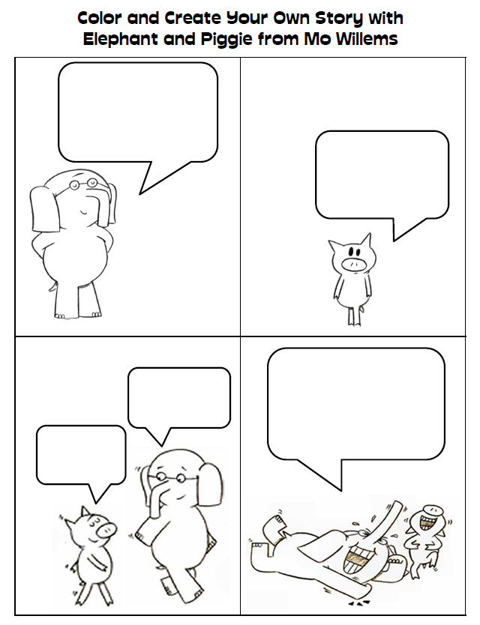  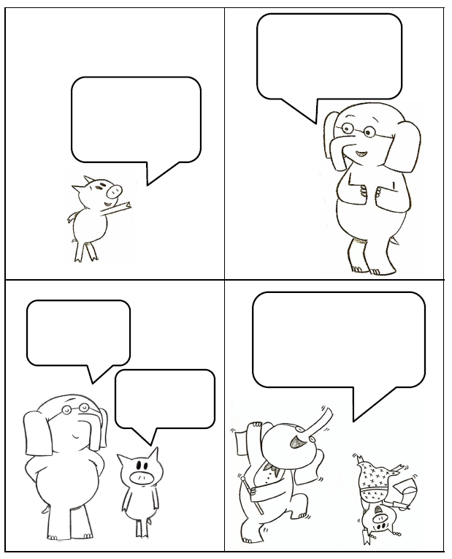  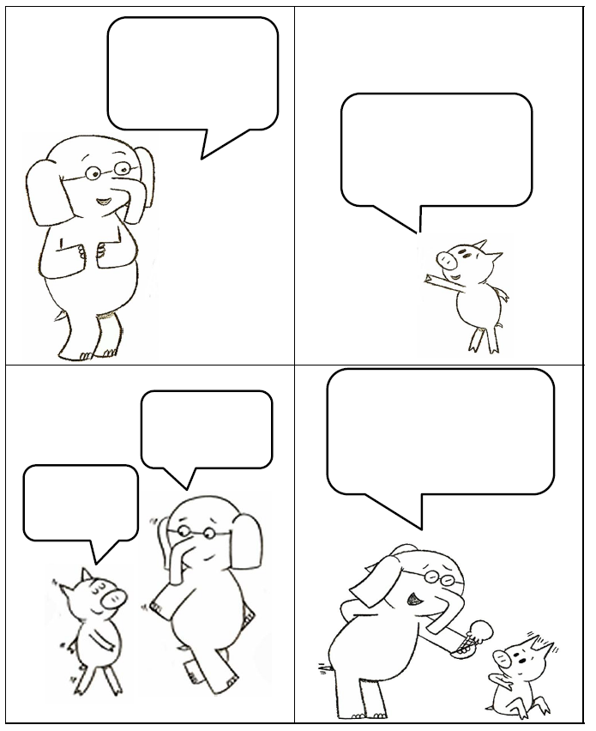  IDEA # 2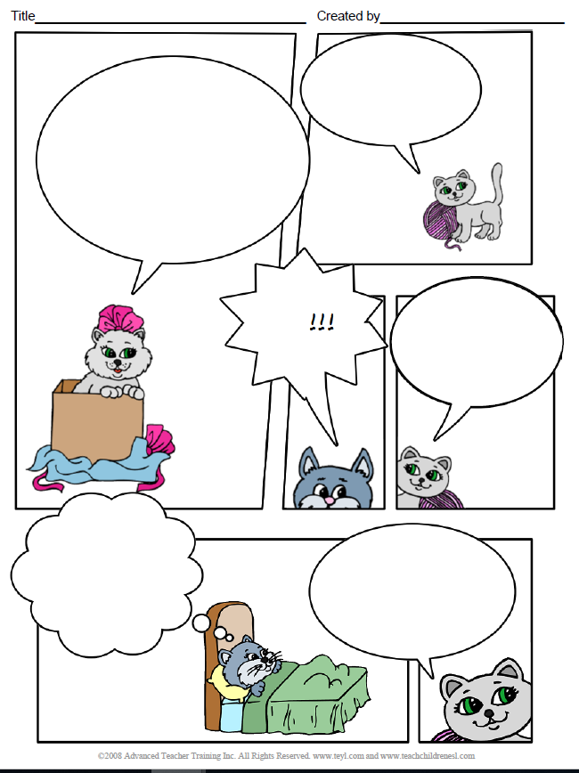  IDEA #3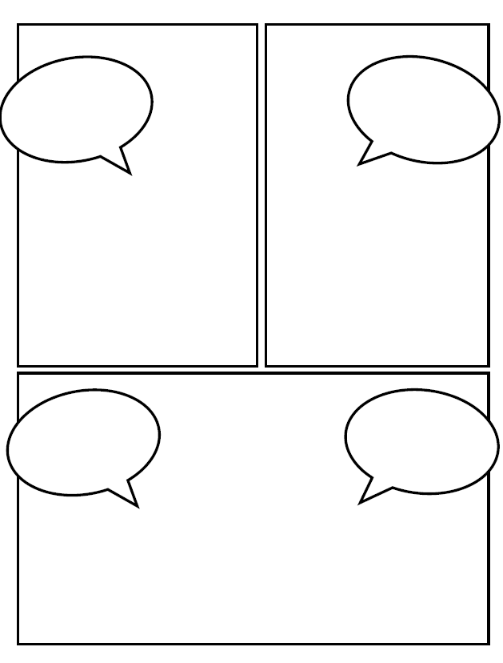  IDEA #4  Option #2: Log into your Epic account and begin reading  www.epic.com  Log into your Raz-Kids account and begin reading  www.kidsa-z.com (  Literal response questions (read the lines): Find the page that tells us…..What happened first? Next? Who are the characters? What is the setting?  Inferential response questions (read between the lines): What does this picture tell us about the story? Why did this character say …..? How is this character feeling?  Personal Connections: Has anything like this happened to you? What is your favourite part and why? Does this character and yourself have anything in common?  When you’re reading this week, think about the characters you’ve met. (Suggestions)  - What’s the character (s) like?  - How is the character similar to you?  - How is the character different than you?  - How was the character feeling / acting?  New Spring Riddles / Thought Problems, “From 3 To 3”: Students can feel free to do both if they would like! Discuss the riddle and have them justify their answer (prove it based on the clues in the riddle). Remember the thought problem has a truth and a lie. Discuss what is true and what is not!  Step 1: Discuss it orally.  Step 2: Write about it – first with an illustration then 1-2 sentences.  Rhymes, Oral Story & Thought Problem  Way Down South  Folk Who Live in Backward Town  Pigeons  The Flattering Flying Fish  Oral Story Retell: The Bag of Trickness  The Magpie with Salt on Her Tail  Thought problem  https://drive.google.com/file/d/1GIWAzwScXmFVdonutfxTvqdrGvq0t0Dw/view?usp=sharing  Read Aloud  Listen to Chapter six of the novel Seven Day Magic by Edward Eager:  https://drive.google.com/file/d/1TDP98m0wi9q2YobFzxtlpHvviyq8N1So/view?usp=sharing  Listen to Chapter seven:  https://drive.google.com/file/d/1YwCMyezmwkW3zTxNoFQ2bAe7LxAs_BpS/view?usp=sharing  Writing Suggestions  - Writing a Comic, using some suggestions from above or your own ideas  - Read, write and draw about the bird or animal you researched that lives in New Brunswick. (Continuation from last week.)  - What do they look like?  - What do they eat?  - What does it need in it’s surrounding to survive? (Habitat)  - Any interesting facts?  - Other information you find.  - Make a word web for a feelings word or a word web of all the feelings a character had from a story you read.  - Write out your list of similarities and differences between you and one of your characters that you chose from your reading.
Numeracy |  | Continue with mental math games and log into your sumdog account.  Are you trying the challenges?!?  SHAPES  Revisit: https://www.youtube.com/watch?v=24Uv8Cl5hvI  3-D Objects game “Name That Shape”: https://www.youtube.com/watch?v=MYoUQyLNUi4  Find 3-D objects around your house. Place them in a brown bag or a container so that you can’t see them. Pick an object from the bag (don’t let the members of your family see it!). They can ask you questions, and you can only answer “yes” or “no” (ex: Are the faces squares? Does it have more than 6 vertices? Does it have a curved surface?)  #! Shape Hunt  Take a walk outside or around your house. What different 2-D shapes or 3-D objects can you find? Can you find:  a square, rectangle; circle, triangle?  a cube, sphere, cone, cylinder, prism, pyramid?  #2 Exploring Shape  Pick a 3-D object or item from home such as a tissue box or soup can. Tell what 2-D shapes you see on the faces of the 3-D object.  It is fun to make your own 2-D shapes and 3-D objects using toothpicks and marshmallows or clay!  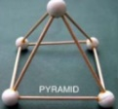  STEM Marshmallow Challenges  #3 Shape Game  You can also create a game with 2D shapes! Draw a 2D shape with chalk and have someone give clues, “Step on a shape that has 3 sides”, “Step on a shape that has 4 vertices” or “Step on a shape that is curved”.  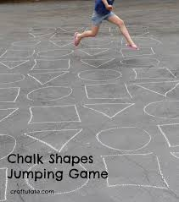  #4 Play a Game  Enjoy playing a favorite card or board game at home: Checkers, Chess, Yahtzee, Battleship, Sudoku, Crazy Eights, Crib. You may want to complete a jigsaw puzzle or play I Spy by describing an objects’ attributes and geometrical form – cube, prism, cylinder, sphere.
Other areas of interest/learning experiences | Art / Science / Outside Suggestions with the FAMILY  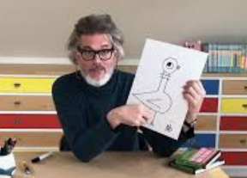  #1 Art Lessons with Mo Willems  Grab your sketch pad / pencil  https://www.youtube.com/playlist?list=PL14hRqd0PELGbKihHuTqx_pbvCLqGbOkF  #2 CHART and ANALYZE like a scientist.  *Record and compare the temperature outside in the early morning and later in the afternoon.  *How many degrees did it change?  *Check it out each day for the whole week.  What do you notice? What do you think the temperature  will be tomorrow?  FES Heart Healthy Week  June 1st – 5th  