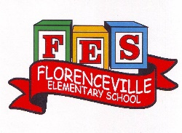
Florenceville Elementary School

At FES our vision is to be a community where everyone is empowered to be lifelong learners.

HOME LEARNING PLAN

Grade: | 2/3 Antworth
TEACHER | Dianne Antworth: dianne.antworth@nbed.nb.ca
Sarah Mahar  Bridget Nugent | Principal: sarah.mahar@nbed.nb.ca;  Vice-Principal: bridget.nugent@nbed.nb.ca
Cindy Crowhurst | Resource: cynthia.crowhurst@nbed.nb.ca
Dianne Lord | Guidance: dianne.lord@nbed.nb.ca
School | florencevilleelementary@nbed.nb.ca

In accordance with the communication sent from our Minister of Education, Dominic Cardy, on April 2, 2020, Home learning opportunities to support literacy and numeracy outcomes will be made available online weekly by Teachers.
Families are encouraged to:
Support their children to complete the options below for an average of one hour per day.
Read aloud with their children and have them read an additional 30 minutes daily; and
consider daily physical activity, exploration, music, art, creating, free play, as an important part of their child’s mental health and skill development.
Subjects | Description of Learning Activities
Literacy | Reading  Option #1: Log into your Epic account and begin reading  www.epic.com (Parents have been sent emails. Please let me know if you are still having trouble logging in)  Log into your Raz-Kids account and begin reading  www.kidsa-z.com (All parents should have received an email. Please let me know if you haven’t received it or are having trouble logging in)  Option #2: Read books that you have at home. Try reading to a parent, sibling, stuffie, or find a quiet place to read to yourself. Get creative! Find a comfy spot outside to read.  Maybe have a FLASHLIGHT day!!  Literal response questions (read the lines): Find the page that tells us…..What happened first? Next? Who are the characters? What is the setting?  Inferential response questions (read between the lines): What does this picture tell us about the story? Why did this character say …..? How is this character feeling?  Personal Connections: Has anything like this happened to you? What is your favourite part and why? Does this character and yourself have anything in common?  When you’re reading this week, make some word lists. (Suggestions)  - Word wall words that you notice  - Describing words – colour, size, etc.,  - Million $ words that caught your attention  - Words that gave you trouble or needed decoding  - Words that you weren’t sure of what they meant  - Feeling words – told us how the character was feeling or maybe how they acted or spoke  New Spring Riddles / Thought Problems, “From 3 To 3”: Students can feel free to do both if they would like! Discuss the riddle and have them justify their answer (prove it based on the clues in the riddle). Remember the thought problem has a truth and a lie. Discuss what is true and what is not!  Step 1: Discuss it orally.  Step 2: Write about it – first with an illustration then 1-2 sentences.  Rhymes & Oral Story  https://drive.google.com/file/d/1mdDdDz5LX7lY4679eYTwyeBdWHdnzNA8/view?usp=sharing  Read Aloud  Listen to Chapter one of the novel Seven Day Magic by Edward Eager:  https://drive.google.com/file/d/1-_958tFNy-n02fYgL4KdfzXEJcX8ujEx/view?usp=sharing  Writing Suggestions  - Finish your poem or song, that you began last week. Remember to read it carefully and check for what ALL good writers do… upper case letters, punctuation, word wall words spelled correctly, describing words.  - Create a “How To….” poster / piece to explain/remind your family the importance of recycling, reusing or your choice within the theme of Earth Day! Remember to use sequencing words “First…. Then….. Next….” Illustrate the picture and put it on display, take a picture and share with friends, if possible send to Miss Antworth😊  - Write out a recipe, a “How To…”, grocery list, wish list, something that you’ve been working on or building with around the house. Maybe a game that you’ve been playing with your family.😊  - Begin a gratitude journal. Write 5 things, each day, that you are grateful, thankful or happy about.
Numeracy | Revisit Mental Math skills Daily  Grade 2 - numbers from 1-100 / Grade 3 – numbers 1-1000  Basis addition/ subtraction facts – use any games that have been sent home or use others that you wish  Focus on counting forward / backward by 10s from any given number.  Please try to Log in to your Sumdog account and attempt the class challenge for the week😊  Continue reviewing and working on last week’s suggestions.  New Game to try😊  RACE TO 100  For this game you will need two dice. The object of the game is to get to 100 or the closet to it, without going over. Each player shakes the dice and makes a number. If you shake a 5 & 3, you could make the number 53 or 35. Write the number on a piece of paper. When it’s your turn again, shake the dice and make a new number. Add the two numbers together. Keep adding the numbers until someone wins. You can also play Race to 0. It’s played the same way but subtracting from 100 instead. If you don’t have dice, you could also make two piles of cards using the ace and number cards 2-6. On your turn you would flip over a card from each pile to create a number.  Representing Numbers  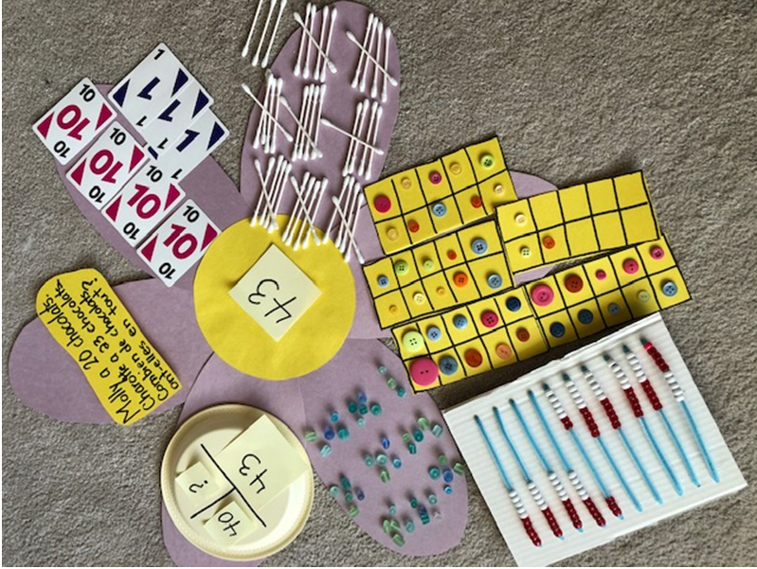  Remembering activities from the class: choose a number / make a number from rolling dice or cards and represent as many ways as possible. How many ways can you represent your number?  Remember, try to be efficient with showing your ways!!!  Always remember😊  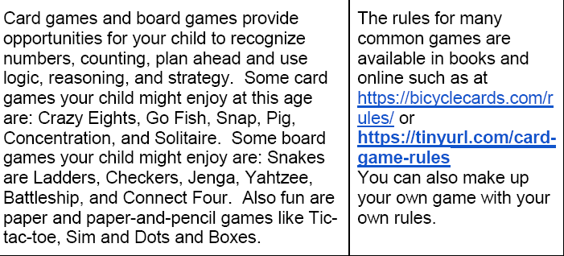
Other areas of interest/learning experiences | Art / Music / Science Suggestions  - Use recycled / household materials to make a musical instrument, which you may wish to use with your song😊  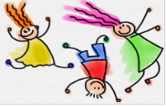  - Illustrate using whatever materials you have at home or act out a 3 To 3 Rhyme.  - Visit this website https://family.gonoodle.com/  Gail Gibbons, “From Seed To Plant” Read Aloud:  https://www.youtube.com/watch?v=Rb7n_B8kzNY  Make a Greenhouse:  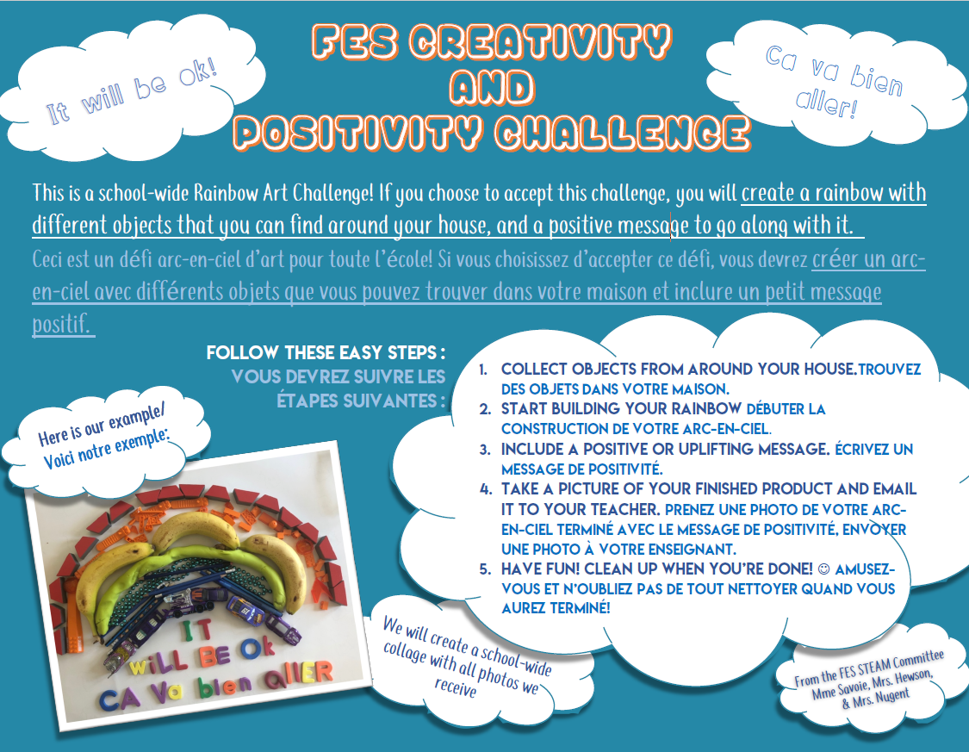  Join the Rainbow Challenge

