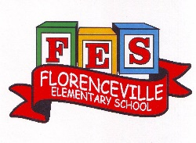
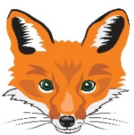
Florenceville Elementary School

At FES our vision is to be a community where everyone is empowered to be lifelong learners.

HOME LEARNING PLAN

Grade: | 2/3 Antworth
TEACHER | Dianne Antworth: dianne.antworth@nbed.nb.ca
Sarah Mahar  Bridget Nugent | Principal: sarah.mahar@nbed.nb.ca;  Vice-Principal: bridget.nugent@nbed.nb.ca
Cindy Crowhurst | Resource: cynthia.crowhurst@nbed.nb.ca
Dianne Lord | Guidance: dianne.lord@nbed.nb.ca
School | florencevilleelementary@nbed.nb.ca

In accordance with the communication sent from our Minister of Education, Dominic Cardy, on April 2, 2020, Home learning opportunities to support literacy and numeracy outcomes will be made available online weekly by Teachers.
Families are encouraged to:
Support their children to complete the options below for an average of one hour per day.
Read aloud with their children and have them read an additional 30 minutes daily; and
consider daily physical activity, exploration, music, art, creating, free play, as an important part of their child’s mental health and skill development.
Subjects | Description of Learning Activities
Literacy | April is POETRY Month  Spend a few minutes to set up Epic Student’s Home account, as most parents should have received an e-mail. If not, please go to the link below and / or send me an email.  https://www.getepic.com/  Look around your home and see if you can find any books that have poems or songs to read.  Remember, all our 3 To 3 Rhymes? Share as you can remember with your family.  When you’re reading this week, make some word lists. (Suggestions)  - Word wall words that you notice  - Describing words – colour, size, etc.,  - Million $ words that caught your attention  - Words that gave you trouble or needed decoding  - Words that you weren’t sure of what they meant  Writing  - Choose a 3 To 3 Rhyme to write  - Finish writing a letter to Miss Antworth  - Think of an idea, theme for a poem or even a song, then begin writing your thoughts
Numeracy | How did you make out with finding the cards and playing a few games?  D0 you need to possibly find some dice from some board games to use in place of the cards?  Continue with these Mental Math Games this week and add Secret Number.  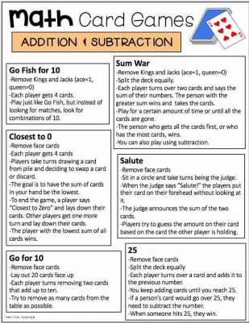  Web site: Sumdog.com  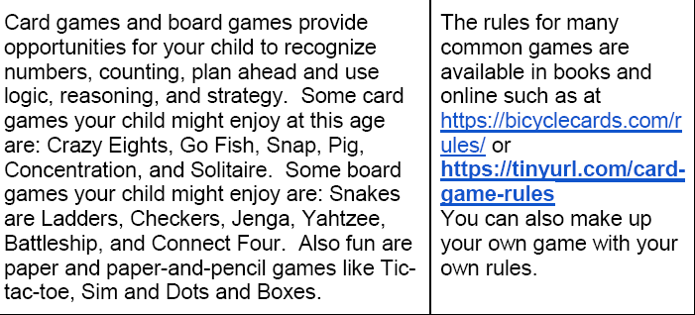
Other areas of interest/learning experiences | Art / Music  - Use recycled / household materials to make a musical instrument, which you may wish to use with your song😊  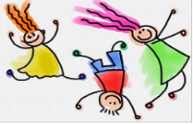  - Illustrate using whatever materials you have at home or act out a 3 To 3 Rhyme  Enjoy the Spring weather that is to come, spend time outside!

