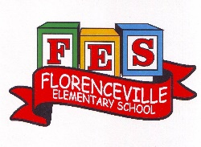
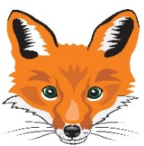
Florenceville Elementary School

At FES our vision is to be a community where everyone is empowered to be lifelong learners.

HOME LEARNING PLAN

Grade: | 2/3 Antworth
TEACHER | Dianne Antworth: dianne.antworth@nbed.nb.ca
Sarah Mahar  Bridget Nugent | Principal: sarah.mahar@nbed.nb.ca;  Vice-Principal: bridget.nugent@nbed.nb.ca
Cindy Crowhurst | Resource: cynthia.crowhurst@nbed.nb.ca
Dianne Lord | Guidance: dianne.lord@nbed.nb.ca
School | florencevilleelementary@nbed.nb.ca

In accordance with the communication sent from our Minister of Education, Dominic Cardy, on April 2, 2020, Home learning opportunities to support literacy and numeracy outcomes will be made available online weekly by Teachers.
Families are encouraged to:
Support their children to complete the options below for an average of one hour per day.
Read aloud with their children and have them read an additional 30 minutes daily; and
consider daily physical activity, exploration, music, art, creating, free play, as an important part of their child’s mental health and skill development.
Subjects | Description of Learning Activities
Literacy | April is POETRY Month  April 22nd EARTH DAY  Todd Parr’s Earth Book  https://www.youtube.com/watch?v=lpEc5nHqO2c  I hope everyone had the opportunity to sign up their child into their “Epic” account. I sent them your email addresses and they should have sent you an invitation to join the program free until June. There are hundreds of books for you and your child to enjoy!  Literal response questions (read the lines): Find the page that tells us…..What happened first? Next? Who are the characters? What is the setting?  Inferential response questions (read between the lines): What does this picture tell us about the story? Why did this character say …..? How is this character feeling?  Personal Connections: Has anything like this happened to you? What is your favourite part and why? Does this character and yourself have anything in common?  Look around your home and find any books that have poems or songs to read.  Remember, all our 3 To 3 Rhymes? Share as you can remember with your family.  When you’re reading this week, make some word lists. (Suggestions)  - Word wall words that you notice  - Describing words – colour, size, etc.,  - Million $ words that caught your attention  - Words that gave you trouble or needed decoding  - Words that you weren’t sure of what they meant  New Spring Riddles / Thought Problems, “From 3 To 3”: Students can feel free to do both if they would like! Discuss the riddle and have them justify their answer (prove it based on the clues in the riddle). Remember the thought problem has a truth and a lie. Discuss what is true and what is not!  Step 1: Discuss it orally.  Step 2: Write about it – first with an illustration then 1-2 sentences.  Riddle  Old Mother Twitchett had but one eye, And a long tail which she let fly; And every time she went over a gap, She left a bit of her tail in a trap.  Thought Problem  Quality Guaranteed  One day a woman who had not a penny to spare sent her son to buy some matches.  “Now, don’t be cheated the way you were last time,” she warned. “Make sure the matches are good before you pay.”  Like every child, he promised to do just what he was told!  But that night when his mother tried to light the fire, she couldn’t get a single match to burn. “What have you done!” she cried. “You’ve been cheated again and I even warned you!”  ‘But I did,” said the son. “I did exactly what you told me to do.”  And he had.  What’s the truth, the whole truth? And where’s the lie?  Here is a link for this week’s Read Aloud ‘Yellow and Pink’.  https://drive.google.com/open?id=1D5QLFDAopScfJrZhLnOSHDDHzCOHcAD5  Writing  - Finish your poem or song, that you began last week. Remember to read it carefully and check for what ALL good writers do… upper case letters, punctuation, word wall words spelled correctly, describing words.  - Create a “How To….” poster to explain/remind your family to wash their hands with soap and water for at least 20 seconds. Remember to use sequencing words “First…. Then….. Next….” Illustrate the picture and put it on the wall next to the sink!  - Create a “How To….” poster / piece to explain/remind your family the importance of recycling, reusing or your choice within the theme of Earth Day! Remember to use sequencing words “First…. Then….. Next….” Illustrate the picture and put it on display, take a picture and share with friends, if possible send to Miss Antworth😊
Numeracy | Revisit mental Math skills  Basis addition/ subtraction facts – use any games that have been sent home or use others that you wish  Focus on counting forward / backward by 10s from any given number.  Grade 2 - numbers from 1-100 / Grade 3 – numbers 1-1000  Earth Week Math  Earth Day, Hooray! (Math Smart Book)  https://www.youtube.com/watch?v=JhhtqHDAIm8  Let’s think about others and the Earth this week, along with Math😊  How could you use recycled, reusable, refundable materials, compost or even litter? (Be safe, but creative😊)  Here’s some suggestions, but we are all independent learners and growing at our own pace!  - Using any materials to make a repeating pattern, identifying the pattern’s core and attributes.  - Have a family member make a pattern and then have you identify the core and attributes.  - Compare the two patterns and discuss how they’re alike and different.  - Estimate various reusable, recyclable, refundable materials. If you don’t have this opportunity, then choose something else around your home.  - Estimate how many times you wash your hands every day / week.  - Before going on a walk, predict how many / much litter you might pick up. Then do some counting / estimating on your return.  - Use your own ideas, be creative as you all are!!  - Take pictures and ask someone to email them to Miss Antworth or put them on the FES home and school site😊  Estimation – thoughtful guess  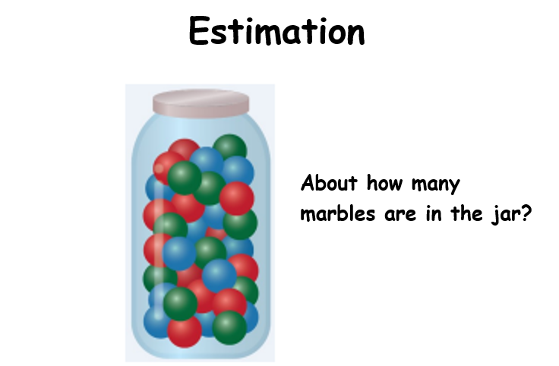  Patterns –  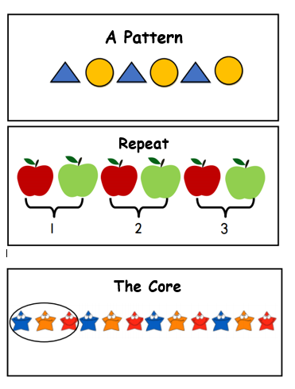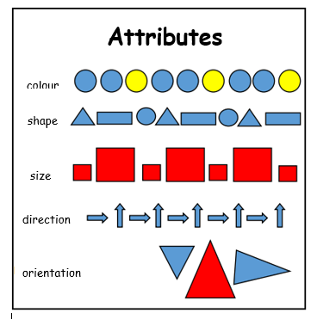
Other areas of interest/learning experiences | Art / Music / Science  www.ecoschools.ca/thegreatgulp  https://earthday.ca/april-22/campaign/earthdayathome/  - Going on daily walks to clean up your yard, neighbourhood, road/ street that walk on.  - Use recycled / household materials to make a musical instrument, which you may wish to use with your song😊  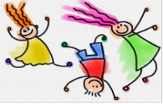  - Illustrate using whatever materials you have at home or act out a 3 To 3 Rhyme.  - Visit this website https://family.gonoodle.com/

