Go to Google : search Thinkscape
It should look like this
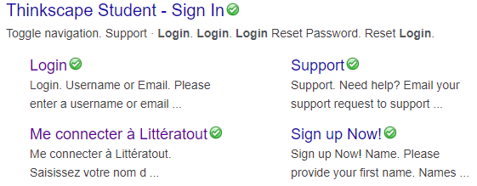
Click on student -sign in (you can also put icon on your home screen)
It will look like this
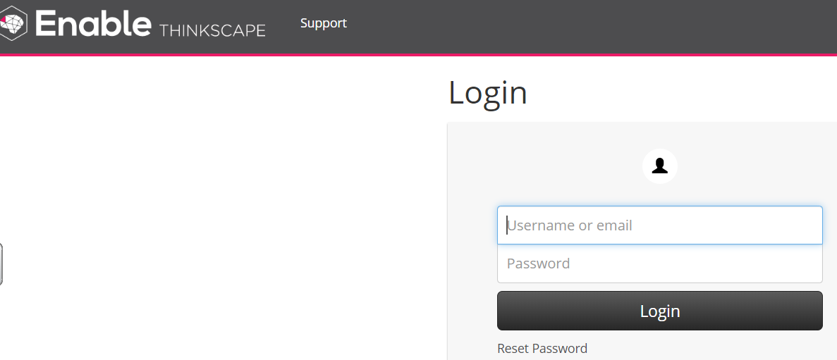
The students have been on this in class and know what to do.
It is interactive and great practice.
All they need is their
Username: ???
Password: ????

We will send you the username and password for your child.
Have fun!

