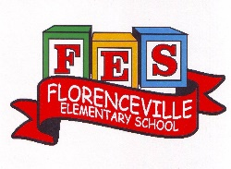
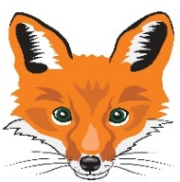
Florenceville Elementary School

At FES our vision is to be a community where everyone is empowered to be lifelong learners.

PRIMARY HOME LEARNING PLAN

Grade: | Grade 2 French Immersion
TEACHER | Molly Kearney: molly.kearney@nbed.nb.ca  Charlotte Dufort: charlotte.dufort@nbed.nb.ca
Sarah Mahar  Bridget Nugent | Principal: sarah.mahar@nbed.nb.ca;  Vice-Principal: bridget.nugent@nbed.nb.ca
Cindy Crowhurst | Resource: cynthia.crowhurst@nbed.nb.ca
Dianne Lord | Guidance: dianne.lord@nbed.nb.ca
School | florencevilleelementary@nbed.nb.ca

In accordance with the communication sent from our Minister of Education, Dominic Cardy, on April 2, 2020, Home learning opportunities to support literacy and numeracy outcomes will be made available online weekly by Teachers.
Families are encouraged to:
-Support their children to complete the options below for an average of one hour per day.
-Read aloud with their children daily; and
-consider daily physical activity and free play as an important part of their child’s mental health and skill development.
Subjects | Description of Learning Activities
Literacy | Week 3: April 20th- 24th  Wednesday, April 22nd is EARTH DAY! This week our focus getting outside to enjoy and appreciate our planet.  Visit blog this week and take time to explore different pages  BLOG: madamekearney.edublogs.org  - Look at page “Les Saisons” to find new 2 French songs/ videos this week!  - Sign word dice game (attached as link) CONTINUED FROM WEEK 2  Instructions:  -Roll the die and say the word, spell the word  -You can also play again and you have to use the word in a sentence.  -Put a check mark or a button every time you get a turn  - La phrase secrete (they know how to play & attached as link)  Instructions:  Print paper or snap shot page.  One person choose a sentence and writes it down without the other one seeing.  Then the player has to try to guess the sentence by using the correct sentence structure.  - Sound work: le son “on”  On the blog:  -Go to the page “Sound Work”  -There will be a video link to play the story of Gaston Cochon, which works on the sound “on”.  -Make a list of the words you hear in the story with the sound “on”. How many did you find?!  -If you have access to a printer, you can print document to work on the sound “on”  -At the bottom of the page, “Les sons (songs)” the song “Gaston Cochon” will be there for students to sing along to.  - Nature walk/ (« Cherche et trouve » document attached)  -Go on a nature walk and make tally marks of what you see!  - Spend 15-20 mins of reading & activities on the Litteratout site  -Students worked on this site earlier in the year  -We will be sending usernames and passwords in emails
Numeracy | - Try these sites. If they do not work for you, do not stress! Try another.  To enter sites, either copy and paste link or press control on your keyboard and click the link!  Addition/ subtraction game:  https://stevewyborney.com/2017/02/splat/  French math site  nlvm.usu.edu/fr/nav/vlibrary.html  French math site:  http://www.lepointdufle.net/maths_savoirs_de_base.htm  - Math Game: (students have played this in class and are familiar with the rules below)  La Carte Secrète  Materials:  -deck of cards (take out Aces,J,Q,K)  -Piece of paper/ whiteboard  -writing utensil  Rules:  -Played with two people  -One person will have a deck of cards, and pull two cards out. They will add the cards together to find the sum and say one of the cards out loud.  Example: (player draws a 7 and a 4)  “The sum of my cards is 11, ONE of my cards is a 4… what is the secret card?”  -The answer would be 7.  -The other player must write the whole numerical equation on the paper/whiteboard ( 4 + 7 = 11 )  - On the blog: Don’t forget to visit the math song page to practice numbers and counting!  Another idea:  Let’s think about others and the Earth this week, along with Math😊  - Estimate how many times you wash your hands every day / week.  - Before going on a walk, predict how many / much litter you might pick up. Then do some counting / estimating on your return.
Other areas of interest/learning experiences | - We completed a unit on helping the environment!  -Ask your child to talk to you about how to reuse, reduce and recycle at home… and don’t forget about composting!  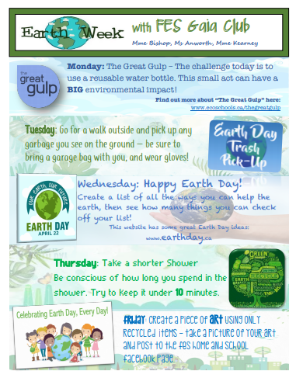  STEAM activities below:  