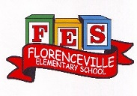
FLORENCEVILLE ELEMENTARY SCHOOL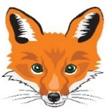
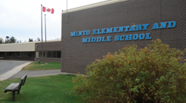
At FES our vision is to be a community where everyone is empowered to be lifelong learners.
HOME LEARNING PLAN
June 8-12, 2020

Laurea Shaw | Laurea.shaw@nbed.nb.ca, (H) 506-375-4779, (C) 506-323-2214
4/5 Shaw | Class blog: https://spoirier.edublogs.org/
Sarah Mahar  Bridget Nugent | Principal: sarah.mahar@nbed.nb.ca;  Vice-Principal: bridget.nugent@nbed.nb.ca
Cindy Crowhurst | Resource: cynthia.crowhurst@nbed.nb.ca
Dianne Lord | Guidance: dianne.lord@nbed.nb.ca
School | florencevilleelementary@nbed.nb.ca
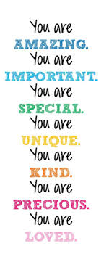
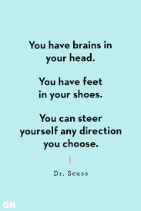
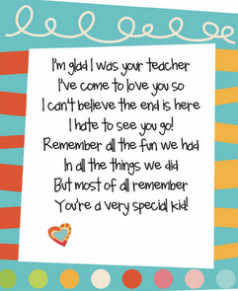

Let’s Celebrate summer!
Here are some ways to celebrate the arrival of summer during our last week of “school.” Please send me pictures of what you have done. I hope we can keep in touch over the summer and in the years to come.

Invente un jeu que tu peux jouer avec tes amis ou ta famille dehors. (Invent a game that you can play with your family.)  Comment pouvons-nous jouer à ce jeu ?  Qu’est-ce qu’on a besoin pour jouer à ce jeu ?  Quels sont les règlements ? | Fais un pic-nique avec ta famille. (Make a picnic for your family.)  Qu’est-ce que vous allez manger ?  Qui va aller à ton pic-nique avec toi ? | Fais une bataille d’eau dehors.  (Have a water fight.)  Tu peux utiliser des ballons remplis d’eau ou de petits instruments qui envoient de l’eau. (N’oublie pas de demander la permission à tes parents/gardiens.)
Trouve un endroit tranquille dans la nature près de chez toi.  (Find a quiet spot in nature near your house to relax.)  Est-ce que tu peux faire un dessin au crayon de ce que tu vois ? | Prends une photo des fleurs ou des plantes qui sont dans ton jardin. (Take a picture of the flowers in your flower garden.)  Sois créatif, utilise des angles différents pour capturer tes images ! | Trouve un endroit paisible dans ton jardin ou autour de ta maison pour lire un livre de ton choix. (Find a quiet spot in your yard to read a book.)  Cela pourrait être dans une cabane dehors ou sur le long de la rivière.
Construis une cabane/fort ou tu peux jouer dehors. (Build a fort outside that you can play in.)  Tu peux utiliser des branches. Tu peux aussi utiliser une tante ou des chaises pour t’aider. | Écris un petit texte qui explique comment tu penses que la dernière journée d’école se serait passée cette année. (Write about how you imagine our last day of school would have been if we were at school.)  Qu’est-ce qu’on aurait fait ?  Où est-ce qu’on serait allé ?  Quelles activités aurais-tu voulu faire avec ta classe ? | Écris une lettre pour ton enseignant(e) de l’année prochaine. (Write a letter to next year’s teacher.)  Explique-lui ce que tu as hâte de faire quand tu retourneras à l’école en septembre.  Qui as-tu hâte de voir ?  Etc.

English Language Arts
Here are some English Language Arts activities for you to choose from over
the next three weeks (May 25th - June 12th). Try to choose 2-3 to do each week.
Find a nice cozy place to read in the sun. | What do you want next year’s teacher to know about you?Create something that we can pass along to that teacher to let them know a little about you. You could write, draw, make a video...the opportunities are  endless. | Learn how to draw Snug from DOG MAN by watching this video.  https://www.youtube.com/watchlist=PLtCDOmMCDvaq8ZvzN6eVRgFZJZGpvvzvT&time_continue=2&v=6jZHKkHNR0A&feature=emb_logo
What is a book that you have read lately that you would recommend to others? Create something to share  with others about that book.  Some ideas: a video clip, a poster, a write up, a comic. | Read some news on  https://www.cbc.ca/kidsnews/ | Snuggle up and read with your  cat, dog or stuffed animal.
Select a favourite recipe to follow and cook supper foryour family.You could even create place cards so they will know where to sit! | Create a skit/play to  perform in front of your family. Have your siblings or stuffed animals join  in the fun! You could even film  your skit and send to others! | Create a summer “bucket list” of things you hope to do this summer. They don’t have to be expensive or far away...watch a beautiful  sunset, go on a hike, learn to make/do  something new...

