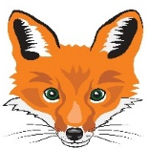
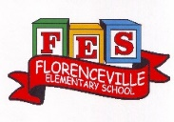
FLORENCEVILLE ELEMENTARY SCHOOL
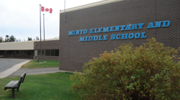
At FES our vision is to be a community where everyone is empowered to be lifelong learners.
HOME LEARNING PLAN
April 13-17, 2020

Grade: | 4/5 Shaw
Laurea Shaw | Laurea.shaw@nbed.nb.ca, (H) 506-375-4779, (C) 506-323-2214
Sarah Mahar  Bridget Nugent | Principal: sarah.mahar@nbed.nb.ca; Vice-Principal: bridget.nugent@nbed.nb.ca ;
Cindy Crowhurst | Resource: cynthia.crowhurst@nbed.nb.ca
Dianne Lord | Guidance: dianne.lord@nbed.nb.ca
School | florencevilleelementary@nbed.nb.ca

In accordance with the communication sent from our Minister of Education, Dominic Cardy, on April 2, 2020 Home learning opportunities to support literacy and numeracy outcomes will be made available online weekly by Teachers.

Families are encouraged to:
-Support their children to complete the options below for an average of one hour per day.
-Read aloud with their children daily; and
-consider daily physical activity and free play as an important part of their child’s mental health and skill development.

Subjects | Description of Learning Activities  L’arrivée du printemps  (Welcome Spring)
Literacy | Oral Language- Listening to music and shows in French is a great way to review and develop your oral language. Here are some suggestions of things that you can listen to and watch:  - Listen to these songs:  1. L’arbre est dans ses feuilles (look it up on YouTube https://www.youtube.com/watch?v=ZE6tuXy4Xfw)  2. Le printemps, Matt Maxwell https://www.youtube.com/watch?v=yKKWNJ8qsss  3. MILLE MILLIARDS D'INSECTES - Les Enfantastiques  https://www.youtube.com/watch?v=JANuY6btBI8 (here is link to the printed lyrics https://www.paroles.net/les-enfantastiques/paroles-mille-milliards-d-insectes)  - Learn to say and spell a few insect names by watching these short videos on YouTube  Apprendre aux enfants les Insectes https://www.youtube.com/watch?v=KNbWsHTwYJo and https://www.youtube.com/watch?v=8n-WwtiGg9k  - Videos/shows to watch: These are some options of shows you can watch:  - La Coccinelle et le Puceron | Ma petite planète chérie  https://www.youtube.com/watch?v=K9HH8Bj2sK4  - Drole de petites betes - https://www.youtube.com/watch?v=efIgdFEp4zc This is a compilation of several episodes of this show where the characters are insects. Watch one or watch them all over the course of the next couple of weeks.  - If you want to stretch yourself, watch this show to learn about ants (les fourmis):  C'est pas sorcier: Les fourmis (This is about 30 minutes long)  https://www.youtube.com/watch?v=4Psgj2AIUcY What did you learn about ants that you didn’t know before?  - Ask your child to tell you some of names of insects that they heard in what they listened to. Ask them what strategies they used to figure out any words that they weren’t sure of.  Reading – (Students are encouraged to read in both French and English throughout the week).  - When you read this week, try to find some non-fiction (information) books, magazines, websites to read and learn more about an insect of your choice. Before reading, write down a question that you are wondering. After you read, ask yourself if you answered the question. Share what you learned with someone.  - If you do not have French books at home, there are websites that you can access French books. Explore these and read (or listen to) French books that are a “good fit” for you (not too hard, not too easy). https://boukili.ca/fr  https://www.readinga-z.com/worldlanguages/french/leveled-books/  Practice reading a book more than once and read with fluency and expression. Record yourself and listen to your fluency and expression. What do you do well? What do you need to work on? Keep a journal of the books that you read.  Writing – Here are a few suggested writing ideas for this week. You can work on one for the week or do a few short ones. Don’t forget to make sure that you use capital letters and punctuation where they belong. Think about who will enjoy (or learn from) reading your writing after you are finished.  - Décris un insecte que tu as trouvé. Utilise toutes tes sens quand tu écris sa description. N’oublie pas d’inclure une illustration de ton insecte. (Describe an insect that you found. Use the 5 senses to help you describe it. Don’t forget a picture.)  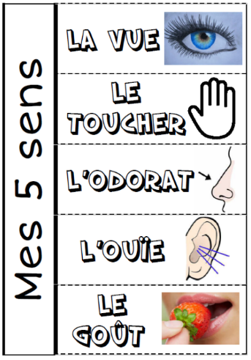  - Imagine que tu es un insecte. Écris une histoire d’une de tes aventures. (Imagine that you are an insect. Write an adventure story about something that happened to you.)  - Après avoir fait de la recherche sur un insecte, écris une petite pièce informative sur ce que tu as appris. (After having researched about an insect of your choice, write an information piece to share your findings with others.)  - Une écriture de ton choix. (Writing of your choice.)
Numeracy  Materiel needed for this project:  -Pen  -Paper  -Appropriate outdoor clothing  -Pencil crayons (optional)  Please answer the questions in French with beautiful complete  sentences.  S’il vous plait répondez les questions en français avec des belles phrases completes. | Diagramme à bandes (Bar Graph)  Think of 5 or more different insects you might see outside now that the warm weather has arrived. Write the name of those insects on a piece of paper and do a tally chart. Go outside and see how many of those insects you can find in 10 or 15 minutes of being out there. Don’t forget to mark it on your tally chart. Do this on 2-3 different days, then do a bar graph of your findings.  This is an example of a tally chart:  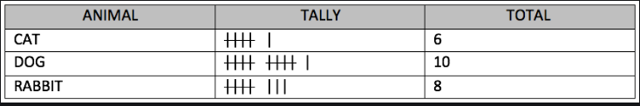  Your bar graph should have a:  - Title  - Horizontal axe (should have a tile and the type of insects)  - Vertical axe (should have a tile and the numbers)  - Have spaces between the bars  - Use a straightedge (ruler) so it will be neat  Here are two examples of a bar graph: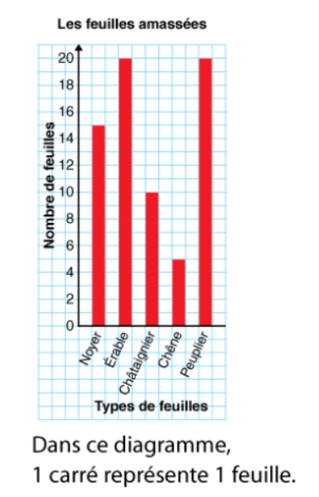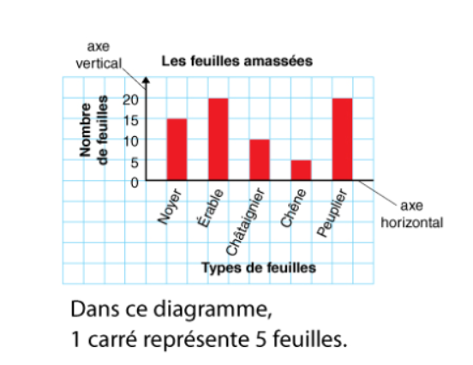  Once you have done your bar graph, answer the following questions:  - How many insects did you see all together?  - Which one is your favorite insect and why?  - Which insect did you find more of?  - Which insect did you find the least of?  - Find two different types of insects that have more than one hundred when added together? If so, which two? (This question might have more than one answer. If so, give all possible answers.)  - Write down your own question that can be answered by looking at your bar graph. Ask a family member, or me (your teacher) to answer your question.  - Combien en as-tu vu en tout?  - Quel insecte est ton favori et pourquoi?  - Quel insecte as-tu trouvé le plus?  - Quel insecte as-tu trouvé le moins?  - Trouve deux types d’insectes qui te donne un nombre plus grand que cent quand tu les additionnes ensemble. (Cette question peut avoir plus qu’une réponse. Donne tout les réponses possible.)  - Ecrit une question qui peut être répondu en regardant ton diagramme à bandes. Demande ta question a quelqu’un dans ta famille, ou à moi, ton enseignante.
Other areas of interest/learning experiences | Sciences: Insect habitats  - What type of habitats do insects live in?  - What type of habitat do we live in?  - Dans quel type d’habitats habitent les insects de ton jardin?  - Dans quel type d’habitat est ce que ta famille habite?  Use the sentences below to help guide your investigation of insects and their habitats.  - What do I think I will see when I lift some rocks/ leaves/ sticks? (prediction)  - I would like to know why this ‘’insect’’ lives here?  - Choose 2 insects that you have observed this week. Compare them. What do you see, colours, size etc. Create a table if you can and make the comparison.  - Think of another habitat (your choice) what type of insects do you think would live there? Why?  - Que penses-tu voir quand tu souleveras les roches/ feuilles/ batons qui sont dans ton jardin. (prédiction)  - Pourquoi est-ce que cet insecte habite ici?  - Choisi 2 insectes que tu as observer cette semaine. Compare les. Que remarques-tu? (couleur, taille etc) Construit un tableau pour voir tes comparaisons.  - Pense à un autre habitat (de ton choix) quel type d’insectes y habiterais? Pourquoi?  Mindfulness:  - Try doing some yoga at home! Below are some Insect inspired yoga poses that you can try at home.  Butterfly pose Sit on your buttocks with a tall spine, bend your legs, place the soles of your feet together, and gently flap your legs like the wings of a butterfly.  Lady bug pose Lie on your back with your chin tucked in, hug your knees into your chest, then grab the outer part of your feet with both of your hands, and rock like a happy baby.  Grasshoppers pose Stand tall in Mountain Pose with your feet hip-width apart, bend your knees, and hop like a grasshopper.  Art: Here are some suggested art activities that you can choose from:  - Using materials that are available to you (including anything natural that you may find outside) create an insect of your choice.  - You could create a butterfly using sticks and leaves that you find in your own backyard or create a caterpillar out of grass and rocks!  - Draw what you see. As you are observing insects for your math assignment, you could take a mental image of your favourite insect and draw what you see.
Looking Ahead | Sometime in the next few weeks, we would like to do some “Spring Planting.” If possible, when you are grocery shopping, could you pick up a packet of seeds or two for your child. DO NOT worry if you don’t, they can be creative and use seeds that they find in their foods or dried on trees and flowers from last summer.
