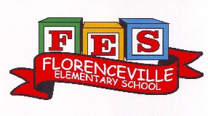
FLORENCEVILLE ELEMENTARY SCHOOL
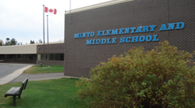
At FES our vision is to be a community where everyone is empowered to be lifelong learners.
PRIMARY HOME LEARNING PLAN

Grade: | 4 Savoie
TEACHER | Marie-Pier.Savoie@nbed.nb.ca /
Sarah Mahar  Bridget Nugent | Principal: sarah.mahar@nbed.nb.ca; Vice-Principal: bridget.nugent@nbed.nb.ca ;
Cindy Crowhurst | Resource: cynthia.crowhurst@nbed.nb.ca
Dianne Lord | Guidance: dianne.lord@nbed.nb.ca
School | florencevilleelementary@nbed.nb.ca

In accordance with the communication sent from our Minister of Education, Dominic Cardy, on April 2, 2020 Home learning opportunities to support literacy and numeracy outcomes will be made available online weekly by Teachers.

Families are encouraged to:
-Support their children to complete the options below for an average of one hour per day.
-Read aloud with their children daily; and
-consider daily physical activity and free play as an important part of their child’s mental health and skill development.

Subjects | Description of Learning Activities
Literacy | Read. Set up a daily reading time. Have your child read their favourite book in English, French, and/or language of their choice. Talk to your child about their reading and ask questions. What do you think this book will be about? Do you like the story so far? Why or why not? Have your child set a goal of how many minutes they will read in a day and record their progress.  Write about what you are reading. Keep a journal or email your teacher with your answers !  (Even if you’re reading a book in English, you should try to answer the questions in both English & French).  - Who is the author?  - Qui est l’auteur du livre ?  - Have you read other books by this author?  - Est-ce que tu as déja lu un livre de cet auteur?
Numeracy | Practice mental math.
Other areas of interest/learning experiences | Art – Draw a new page cover for the book you have been reading.

