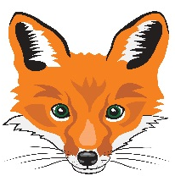
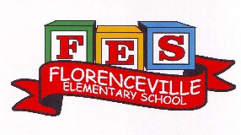
FLORENCEVILLE ELEMENTARY SCHOOL
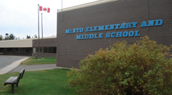
At FES our vision is to be a community where everyone is empowered to be lifelong learners.
HOME LEARNING PLAN
April 20-24, 2020

Grade: | 5B
Teena Bishop | teena.bishop@nbed.nb.ca
Sarah Mahar  Bridget Nugent | Principal: sarah.mahar@nbed.nb.ca; Vice-Principal: bridget.nugent@nbed.nb.ca ;
Cindy Crowhurst | Resource: cynthia.crowhurst@nbed.nb.ca
Dianne Lord | Guidance: dianne.lord@nbed.nb.ca
School | florencevilleelementary@nbed.nb.ca

In accordance with the communication sent from our Minister of Education, Dominic Cardy, on April 2, 2020 Home learning opportunities to support literacy and numeracy outcomes will be made available online weekly by Teachers.

Families are encouraged to:
-Support their children to complete the options below for an average of one hour per day.
-Read aloud with their children daily; and
-consider daily physical activity and free play as an important part of their child’s mental health and skill development.

Subjects | Description of Learning Activities  L’arrivée du printemps  (Welcome Spring)
Literacy | Oral Language- Listening to music and shows in French is a great way to review and develop your oral language. Here are some suggestions of things that you can listen to and watch. (You can slow the speed of videos down when you are watching YouTube.)  Listen to these songs:  - L’arbre est dans ses feuilles (look it up on YouTube https://www.youtube.com/watch?v=ZE6tuXy4Xfw)  - Le printemps, Matt Maxwell https://www.youtube.com/watch?v=yKKWNJ8qsss  - C'EST DE L'EAU - Les Enfantastiques https://www.youtube.com/watch?v=6LxaEGqB7Lg  - Mets du respect dans ton bac – Version NDC  https://www.youtube.com/watch?v=eI0lAoJLwhg  Videos/shows to watch:  - C'est quoi les énergies renouvelables ? - le Professeur Gamberge https://www.youtube.com/watch?v=T2pfO4eJDHw  - Terre: la planète bleue https://www.youtube.com/watch?v=lVevjGI5D0k  - Paxi - Le cycle de l'eau https://www.youtube.com/watch?v=Gq1Y3P8lacw  - La Poubelle magique | Ma petite planète chérie https://www.youtube.com/watch?v=skL_sMXgApg&t=29s  Reading – (Students are encouraged to read in both French and English throughout the week).  - Listen to the book: Sandy’s Incredible Shrinking Footprint on YouTube https://www.youtube.com/watch?v=6FF_MpC3cLc or if you have an EPIC account, read it there. There are also lots of other Earth Day suggestions on Epic that you can read.  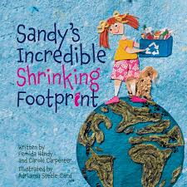  - If you do not have French books at home, there are websites that you can access French books. Explore these and read (or listen to) French books that are a “good fit” for you (not too hard, not too easy). https://boukili.ca/fr  https://www.readinga-z.com/worldlanguages/french/leveled-books/  Practice reading a book more than once and read with fluency and expression. Record yourself and listen to your fluency and expression. What do you do well? What do you need to work on? Keep a journal of the books that you read.  Writing – Here are a few writing ideas for this week. You can choose one to work on throughout the week or a different one each day. If you want to go back to last week’s ideas, please do so. Don’t forget to make sure that you use capital letters and punctuation where they belong. Think about who will enjoy (or learn from) reading your writing after you are finished.  - What is something you could re-use around your house to create something? Write (and illustrate) instructions of how to make something from items that you could find in your recycling bin or around the house. You could also make a video to show the steps of how to make it.  - Create a poster to show people how they can show kindness to our planet. Think: Reduce, Reuse, Recycle and Refuse  - Describe and give examples of what you do to Reduce, Reuse, Recyle or Refuse to make our planet a better place to live.  - Create a character out of recycling materials and then describe your character.  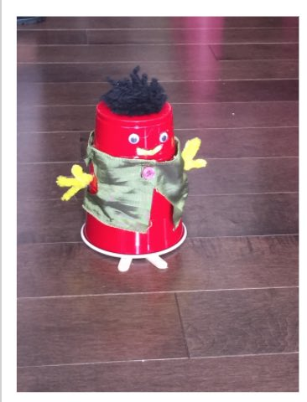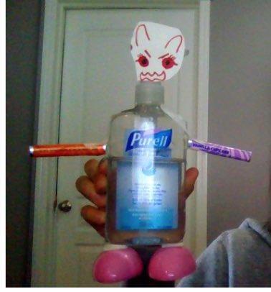  - A Writing of your choice.
Numeracy  Materiel needed for this project:  -Pencil  -Ruler  -recycling material  -scissors  -markers | Jeu de mémoire (memory game)  This week you are going to make your own memory game using recycling materials. You will choose the material and the size of the cards you want.  Here is my example. I used a box of frozen fish and made this.  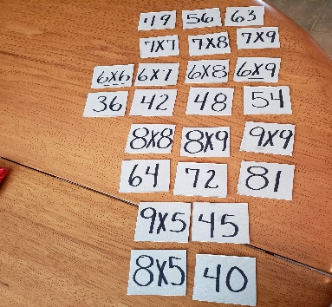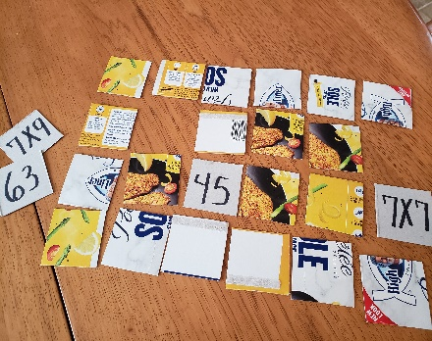  - I opened the box and traced squares with a pencil and ruler on the inside of the box.  - Next, I cut out the squares with scissors.  - I then wrote a multiplication fact on one card and the product on another. I repeated this until I had all the facts from 6X6 up to 9X9.  You can do an addition, subtraction, multiplication or division game. You can also make all four operations so you can challenge yourself at different levels.  Be creative and have fun playing your game during family time!
Other areas of interest/learning experiences | Sciences:  April 22nd is Earth day & the theme this year is Climate Action.  - Think of ways you can help our beautiful planet (turning off the lights when they are not needed.  - What can YOU do to make the Earth feel happy?  - What Actions do you wish your friends and family would take to make the planet feel good?  Follow up on your last experiment / observation activities...  - Go outdoors, use hula hoops to create 3 or 4 different observation stations (these could be done with different items as well; jump ropes, cords, Legos, rocks, sticks etc).  - Number each observation station. Make your observations. What do you see?  - Use very descriptive vocabulary and drawings to describe what you see.  - Don’t forget to write in which observation station you observed these things and the types of habitats you may have encountered.  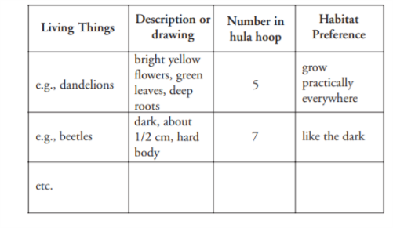  Science based writing prompts:  - A habitat close to my house that I enjoy visiting is … because...  - Un habitat près de ma maison que j’aime visiter est... parce que...  Mindfulness:  - Go for a nature walk around your house. Spot different animals, insects, birds.  - Sit in peace, quiet and calm. What do you hear? What are you thinking of?  - Practice mindfulness/ meditation. Find a quiet corner in your house to sit and relax. How do you feel?  Art: following the science theme of ‘’Climate Action’’ for earth day  - Create an art piece using only recycled materials.  - If you have read ‘’Sandy’s incredible shrinking footprint’’ on epic (linked above in reading category) it will give you lots of ideas.  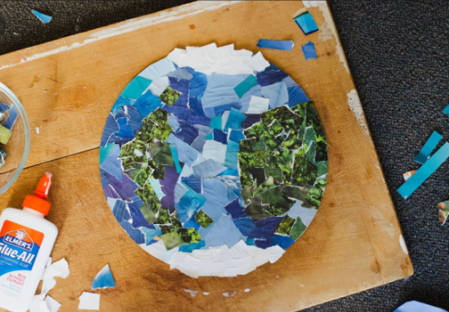  - Create a drawing / picture using natural materials (Use any surface available to you, it does not have to be on a piece of paper).  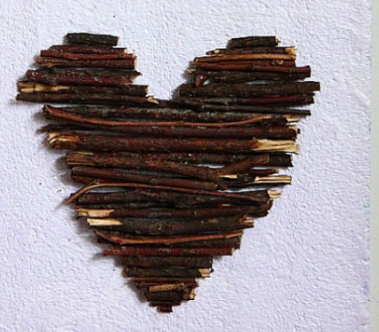
Looking Ahead | In May, we would like to do some “Spring Planting.” If possible, when you are grocery shopping, could you pick up a packet of seeds or two for your child. DO NOT worry if you don’t, they can be creative and use seeds that they find in their foods or dried on trees and flowers from last summer.

