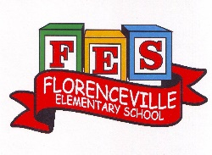
Florenceville Elementary School

At FES our vision is to be a community where everyone is empowered to be lifelong learners.

PRIMARY HOME LEARNING PLAN

Grade: | Grade 2 French Immersion
TEACHER | Molly Kearney: molly.kearney@nbed.nb.ca  Charlotte Dufort: charlotte.dufort@nbed.nb.ca
Sarah Mahar  Bridget Nugent | Principal: sarah.mahar@nbed.nb.ca;  Vice-Principal: bridget.nugent@nbed.nb.ca
Cindy Crowhurst | Resource: cynthia.crowhurst@nbed.nb.ca
Dianne Lord | Guidance: dianne.lord@nbed.nb.ca
School | florencevilleelementary@nbed.nb.ca

In accordance with the communication sent from our Minister of Education, Dominic Cardy, on April 2, 2020, Home learning opportunities to support literacy and numeracy outcomes will be made available online weekly by Teachers.
Families are encouraged to:
-Support their children to complete the options below for an average of one hour per day.
-Read aloud with their children daily; and
-consider daily physical activity and free play as an important part of their child’s mental health and skill development.
Subjects | Description of Learning Activities
Literacy | April 14th- 17th  Visit blog this week and take time to explore different pages  madamekearney.edublogs.org  Words of the week. Spell out words using materials at home (playdough, buttons, macaroni, etc.) Make a sentence orally and/ or written with the words of the week.  - je suis  - voici  - aime  - ami(e)  - arrive  - ma maison  Spend 15-20 mins of reading using following site:
Numeracy | 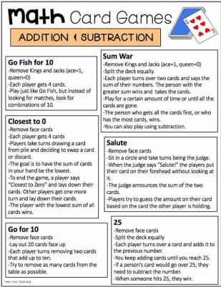
Other areas of interest/learning experiences | Art:  Using only materials found outside, create an Easter egg or Easter bunny!

