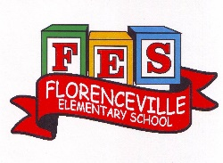
Florenceville Elementary School

At FES our vision is to be a community where everyone is empowered to be lifelong learners.

HOME LEARNING PLAN- WEEK #10

Grade: | 3/4
TEACHER | Marlee Ralston: marlee.ralston@nbed.nb.ca
Sarah Mahar  Bridget Nugent | Principal: sarah.mahar@nbed.nb.ca;  Vice-Principal: bridget.nugent@nbed.nb.ca
Cindy Crowhurst | Resource: cynthia.crowhurst@nbed.nb.ca
Dianne Lord | Guidance: dianne.lord@nbed.nb.ca
School | florencevilleelementary@nbed.nb.ca

In accordance with the communication sent from our Minister of Education, Dominic Cardy, on April 2, 2020, Home learning opportunities to support literacy and numeracy outcomes will be made available online weekly by Teachers.
Families are encouraged to:
-Support their children to complete the options below for an average of one hour per day.
-Read aloud with their children daily; and
-consider daily physical activity and free play as an important part of their child’s mental health and skill development.
Subjects | Description of Learning Activities
Literacy | Reading:  Option #1: Log in to your Raz-Kids account and begin reading  www.kidsa-z.com (All log-in info has been sent to parents. Please let me know if you haven’t received it or are having trouble logging in)  Option #2: Read books that you have at home. Try reading to a parent, sibling or find a quiet place to read to yourself.  Option #3: Check out the rhymes, oral stories and thought problem posed in this week’s From 3 to 3 videos, listed below.  Writing:  Option #1: Write about something that you choose. (Students are encouraged to have choice when writing. If they are working on their own stories or have something different that they would like to write about, that is great! This option is for those students.)  Option #2: Create a summer “bucket list” of things you hope to do this summer. They don’t have to be expensive or far away. Watch a beautiful sunset, go on a hike, learn to make/do something new are all great examples that you could include on your bucket list  Option #3: Create a skit/play to perform in front of your family. Have your siblings or stuffed animals join in the fun! You could even film your skit and send to others!  Option #4: New Spring Riddles / Thought Problems, “From 3 To 3”: Students can feel free to do both if they would like! Discuss the riddle from the video below and have them justify their answer (prove it based on the clues in the riddle). Remember the thought problem has a truth and a lie. Discuss what is true and what is not!  Step 1: Discuss it orally.  Step 2: Write about it – first with an illustration then 1-2 sentences.  From 3 to 3: Watch this week’s From 3 to 3 videos. The answer is provided for last week’s thought problem, along with a riddle  https://drive.google.com/file/d/1cjwh9HIVn1ZgHCdp7XhJM972FkYvl7SS/view?usp=sharing  Listen to chapter seven of the novel Seven Day Magic by Edward Eager:  https://drive.google.com/file/d/1YwCMyezmwkW3zTxNoFQ2bAe7LxAs_BpS/view?usp=sharing
Numeracy | Option #1: Log in to your Sumdog account and review your mental math strategies. All log-in information has been sent to parents. Please let me know if you haven’t received it or are having trouble logging in.  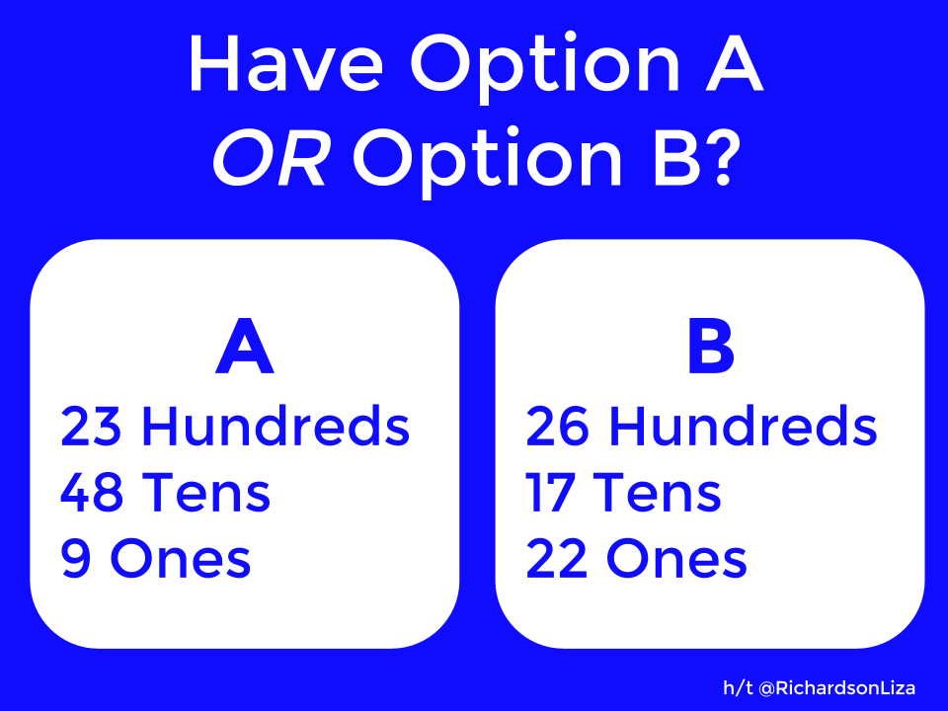  Option #2: Would you rather…? Justify or explain why you chose your answer.  Option #3: Using materials from home, design your own scale like the ones found in the pictures below. Use your scales to explore small objects that are heavier, lighter or about the same mass. YouTube homemade balance scales for ideas.  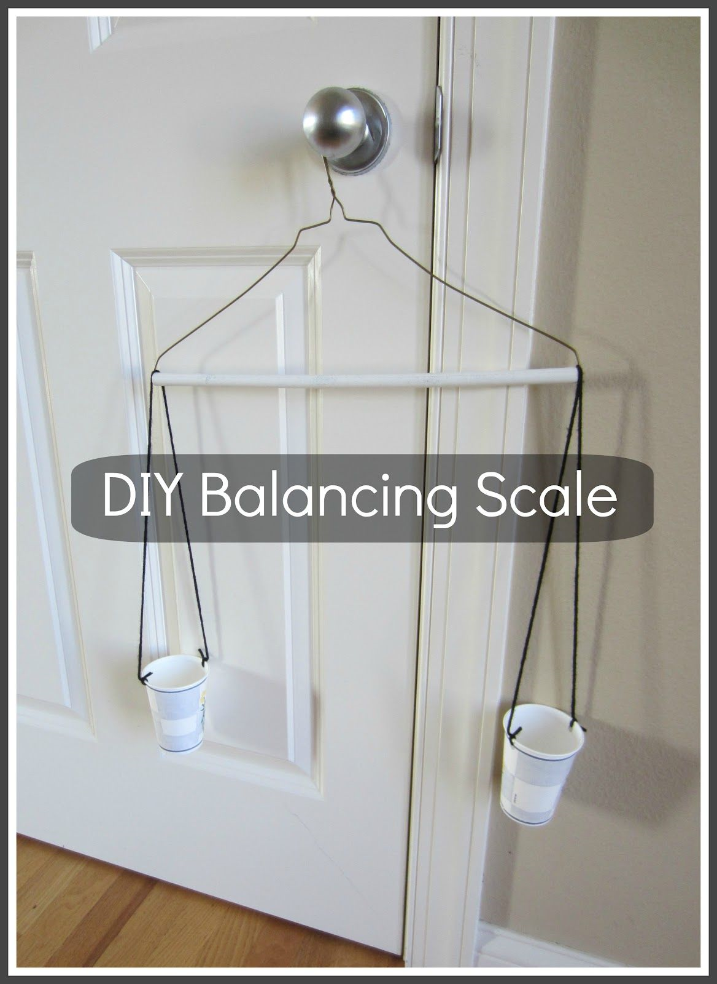  Option #4:  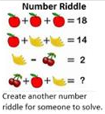
Other areas of interest/learning experiences | Science: Continue to observe your plants growing. What are some observations that you have made?  Check out the virtual NB Museum Exhibit:  https://www.nbm-mnb.ca/virtual-exhibitions/  Check out the Magnificent Rocks Exhibit:  http://magnificentrocks-rochesmagnifique.ca/home-accueil-eng

