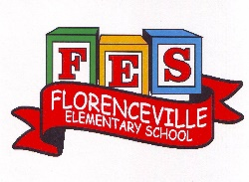
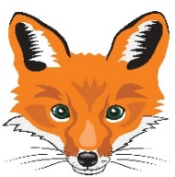
Florenceville Elementary School

At FES our vision is to be a community where everyone is empowered to be lifelong learners.

HOME LEARNING PLAN- WEEK #4

Grade: | 3/4
TEACHER | Marlee Ralston: marlee.ralston@nbed.nb.ca
Sarah Mahar  Bridget Nugent | Principal: sarah.mahar@nbed.nb.ca;  Vice-Principal: bridget.nugent@nbed.nb.ca
Cindy Crowhurst | Resource: cynthia.crowhurst@nbed.nb.ca
Dianne Lord | Guidance: dianne.lord@nbed.nb.ca
School | florencevilleelementary@nbed.nb.ca

In accordance with the communication sent from our Minister of Education, Dominic Cardy, on April 2, 2020, Home learning opportunities to support literacy and numeracy outcomes will be made available online weekly by Teachers.
Families are encouraged to:
-Support their children to complete the options below for an average of one hour per day.
-Read aloud with their children daily; and
-consider daily physical activity and free play as an important part of their child’s mental health and skill development.
Subjects | Description of Learning Activities
Literacy | Reading:  Option #1: Log in to your Raz-Kids account and begin reading  www.kidsa-z.com (All log-in info has been sent to parents. Please let me know if you haven’t received it or are having trouble logging in)  Option #2: Read books that you have at home. Try reading to a parent, sibling or find a quiet place to read to yourself.  Option #3: Check out the rhymes, oral stories and thought problem posed in this week’s From 3 to 3 videos, listed below.  Writing:  Option #1: Write about something that you choose. (Students are encouraged to have choice when writing. If they are working on their own stories or have something different that they would like to write about, that is great! This option is for those students.)  Option #2: Write a letter or make a card for Mrs. Underhill. You can take a picture and send it to me. I will forward it along to her. She misses each and every one of you. I’ve included some very exciting news in my weekly e-mail from her. Go check it out if you haven’t had the chance to yet!  Option #3: Begin a gratitude journal. Write 5 things, each day, that you are grateful, thankful or happy about.  Option #4: Write about the endangered New Brunswick animal or plant that you researched.  Option #5: Help your family write and keep a grocery list for the week.  From 3 to 3: Watch this week’s From 3 to 3 videos. The answer is provided for last week’s thought problem, along with a new thought problem.  https://drive.google.com/file/d/1uwDnlkFa-IBkGOiOmZ2sPUXw5eLpoYIG/view?usp=sharing  Listen to the story and think about the questions asked at the end:  https://drive.google.com/file/d/1DUAeXo6iTFhLxU3_8Z_Wuces1aW1oTl2/view  Listen to chapter one of the novel Seven Day Magic by Edward Eager:  https://drive.google.com/file/d/1-_958tFNy-n02fYgL4KdfzXEJcX8ujEx/view?usp=sharing
Numeracy | Option #1: Log in to your Sumdog account and review your mental math strategies. All log-in information has been sent to parents. Please let me know if you haven’t received it or are having trouble logging in.  Option #2: Would you rather…? Justify or explain why you chose your answer.  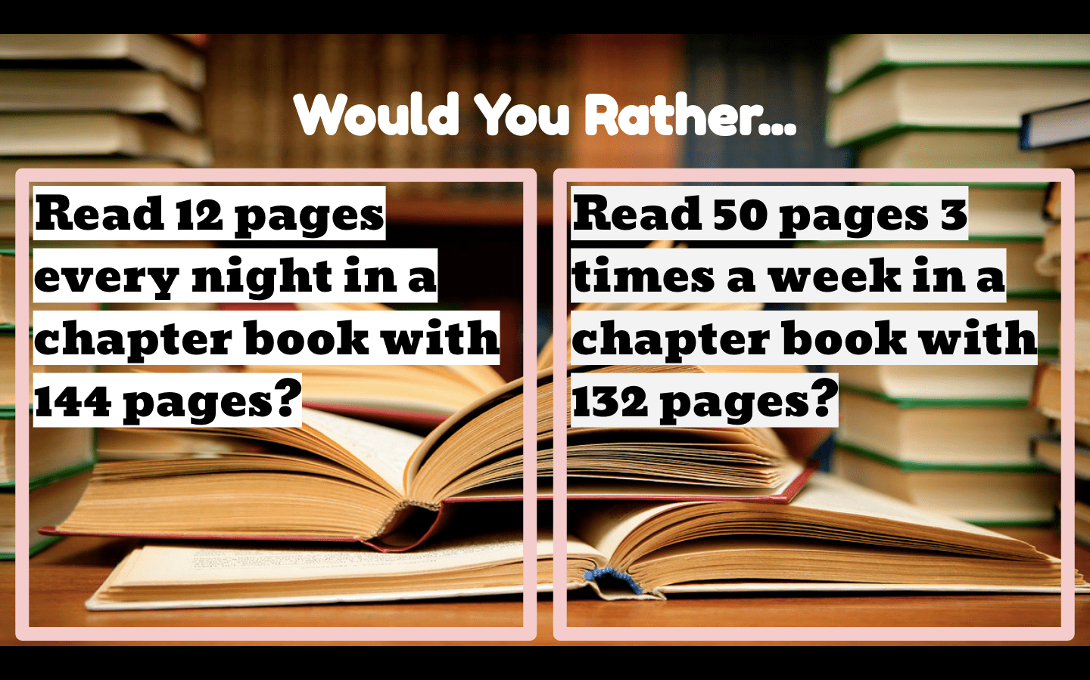  Option #3: Estimation Scavenger Hunt  1) Measure your height.  2) Find an object that is: shorter than you, taller than you and equal to your height.  3) Estimate each object’s height.  4) Measure each object to compare your estimation.  5) Optional: Take a picture of you with your items and send the picture to me. I’d love to see what you found!  Option #4: Choose one of the multiplication songs below to learn this week:  **Please note: Students in Grade 3 can work on multiplication facts to 5x5. Grade 4 students can work on multiplication facts to 9x9  Multiplication Mash-Up (Contains songs for multiplication facts 0-12. Listen to the songs that are relevant for your child):  https://www.youtube.com/watch?v=EgjCLhoI9Mk  Option #5: Practice Math Fact Games (addition, subtraction, multiplication and/or division).  https://www.multiplication.com/games
Other areas of interest/learning experiences | Science: I have provided a few options for science. Do not feel obligated to do them all. Choose which option(s) work best for your family.  Option #1: Explore the endangered species of New Brunswick list. Why are each of these animals and plants endangered?  https://www2.gnb.ca/content/gnb/en/departments/erd/natural_resources/content/wildlife/content/SpeciesAtRisk.html  Option #2: Choose one of the endangered species mentioned above. Think of three or more questions that you have (or want to learn more about) regarding the animal or plant of your choice. A few online websites that you can explore for more information are:  https://kids.nationalgeographic.com/  and  https://kids.britannica.com/kids

