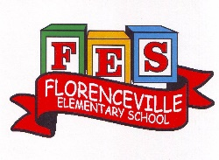
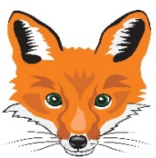
Florenceville Elementary School

At FES our vision is to be a community where everyone is empowered to be lifelong learners.

HOME LEARNING PLAN- WEEK #6

Grade: | 3/4
TEACHER | Marlee Ralston: marlee.ralston@nbed.nb.ca
Sarah Mahar  Bridget Nugent | Principal: sarah.mahar@nbed.nb.ca;  Vice-Principal: bridget.nugent@nbed.nb.ca
Cindy Crowhurst | Resource: cynthia.crowhurst@nbed.nb.ca
Dianne Lord | Guidance: dianne.lord@nbed.nb.ca
School | florencevilleelementary@nbed.nb.ca

In accordance with the communication sent from our Minister of Education, Dominic Cardy, on April 2, 2020, Home learning opportunities to support literacy and numeracy outcomes will be made available online weekly by Teachers.
Families are encouraged to:
-Support their children to complete the options below for an average of one hour per day.
-Read aloud with their children daily; and
-consider daily physical activity and free play as an important part of their child’s mental health and skill development.
Subjects | Description of Learning Activities
Literacy | Reading:  Option #1: Log in to your Raz-Kids account and begin reading  www.kidsa-z.com (All log-in info has been sent to parents. Please let me know if you haven’t received it or are having trouble logging in)  Option #2: Read books that you have at home. Try reading to a parent, sibling or find a quiet place to read to yourself.  Option #3: Check out the rhymes, oral stories and thought problem posed in this week’s From 3 to 3 videos, listed below.  Writing:  Option #1: Write about something that you choose. (Students are encouraged to have choice when writing. If they are working on their own stories or have something different that they would like to write about, that is great! This option is for those students.)  Option #2: Create a wonder list. What do you wonder about? What questions make you curious? Write down your wonderings and explore with your family.  Option #3: Plan your weekly lunch menu. Make a grocery list that includes all the items you would need for the week. Don’t forget to keep Canada’s Food Guide in mind.  Option #4: Create the sequel to a story you have recently read or to a TV show you have watched.  Option #5: Write an information story. Write about something you know a lot about. Some examples: Pokemon, Lego, L.O.L. dolls, dogs, hockey, camping, etc.  Write about different parts of your topic on each page of a booklet. (Folding paper in half works well.)  For example, if your topic is about hockey your booklet might look like this: Page 1: Hockey Gear  Page 2: Types of Equipment  Page 3: NHL Teams  From 3 to 3: Watch this week’s From 3 to 3 videos. The answer is provided for last week’s thought problem, along with a new thought problem.  https://drive.google.com/file/d/1n7nxoF2lg_LoB8bq3etDik2z3tcSgkWH/view?usp=sharing  Listen to chapter three of the novel Seven Day Magic by Edward Eager:  Part One  https://drive.google.com/file/d/1oJLz4XjZKA0tNxc0jfkbk1RrzshPon0Z/view?usp=sharing  Part Two  https://drive.google.com/file/d/1-rs_Gsy7bRjftMMRndOt32Dq4O51DcXs/view?usp=sharing
Numeracy | Option #1: Log in to your Sumdog account and review your mental math strategies. All log-in information has been sent to parents. Please let me know if you haven’t received it or are having trouble logging in.  Option #2: Would you rather…? Justify or explain why you chose your answer.  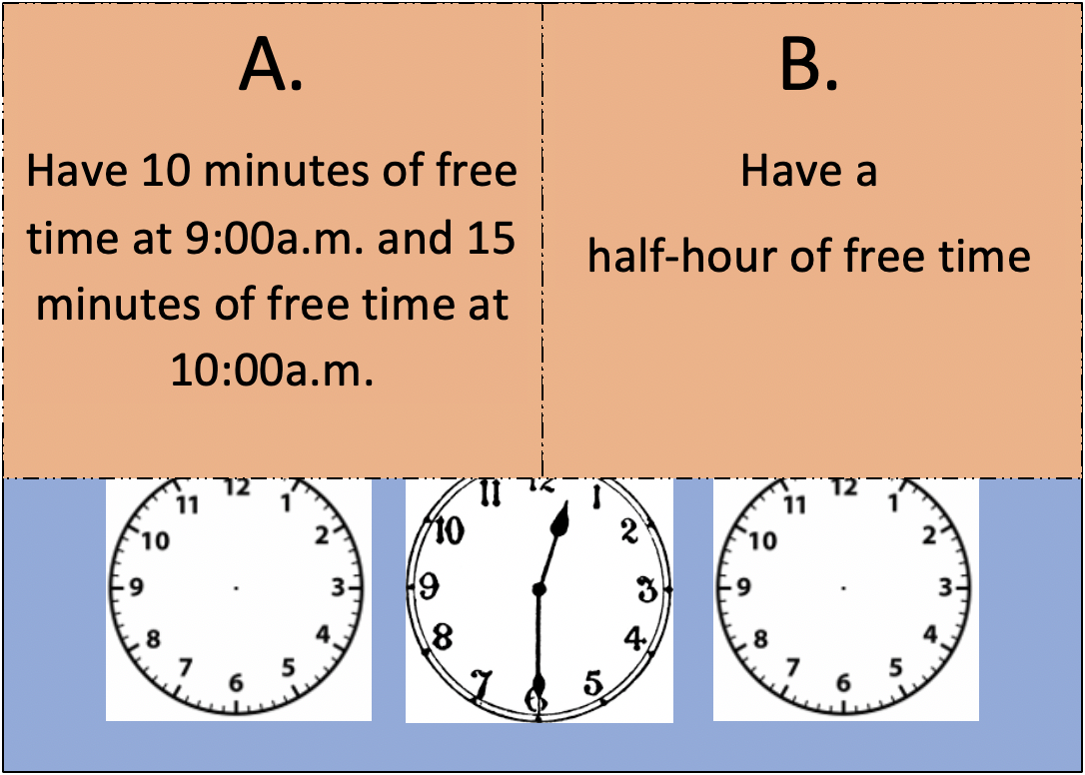  Option #3: Choose a room in your home. Create a list of the shapes you see.  ● Identify if the shape is 2D or 3D  ● List attributes for the shapes  ● Classify the shapes into categories based upon their attributes*  *Attribute=a way to describe a figure/object.  The geometric attributes of 3-D objects are:  - face: a 2-D shape that forms part of a 3-D object. It is a flat surface that can be traced. Both the shape of the face and the number of faces should be considered attributes.  - edge: occurs where two surfaces of a 3-D object meet.  - vertex (vertices): a point where 3 or more edges meet. Note: on a cone, a vertex is the highest point above the base.  - curved surface: is a surface that is not flat, and not typically described as a face. These are found on cylinders, cones, and spheres.  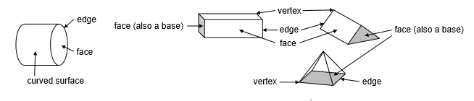  Option #4: Use clay or playdough (you can make dough with 1/2C of lotion or conditioner and 1C of cornstarch) to make some 3D objects (prism, sphere, cylinder). Draw the 2D shapes you see on each one. Create a design that has 1 line of symmetry. Can you make one with 2 lines of symmetry? Colour it and put it in the window.  Option #5: Identify all the symmetrical capital letters. Have your child sort the capital letters according to whether they have one line or two lines of symmetry. For example, C has one horizontal line of symmetry; H has two lines of symmetry, one vertical and the other horizontal.
Other areas of interest/learning experiences | Science: This week students will prepare for seed planting by beginning to observe the world around them and thinking about how certain conditions would affect plant growth.  