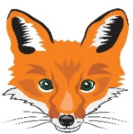
Florenceville Elementary School

At FES our vision is to be a community where everyone is empowered to be lifelong learners.

HOME LEARNING PLAN- WEEK #7

Grade: | 3/4
TEACHER | Marlee Ralston: marlee.ralston@nbed.nb.ca
Sarah Mahar  Bridget Nugent | Principal: sarah.mahar@nbed.nb.ca;  Vice-Principal: bridget.nugent@nbed.nb.ca
Cindy Crowhurst | Resource: cynthia.crowhurst@nbed.nb.ca
Dianne Lord | Guidance: dianne.lord@nbed.nb.ca
School | florencevilleelementary@nbed.nb.ca

In accordance with the communication sent from our Minister of Education, Dominic Cardy, on April 2, 2020, Home learning opportunities to support literacy and numeracy outcomes will be made available online weekly by Teachers.
Families are encouraged to:
-Support their children to complete the options below for an average of one hour per day.
-Read aloud with their children daily; and
-consider daily physical activity and free play as an important part of their child’s mental health and skill development.
Subjects | Description of Learning Activities
Literacy | Reading:  Option #1: Log in to your Raz-Kids account and begin reading  www.kidsa-z.com (All log-in info has been sent to parents. Please let me know if you haven’t received it or are having trouble logging in)  Option #2: Read books that you have at home. Try reading to a parent, sibling or find a quiet place to read to yourself.  Option #3: Check out the rhymes, oral stories and thought problem posed in this week’s From 3 to 3 videos, listed below.  Writing:  Option #1: Write about something that you choose. (Students are encouraged to have choice when writing. If they are working on their own stories or have something different that they would like to write about, that is great! This option is for those students.)  Option #2: Who is the funniest person in your family? What is the funniest memory that you can think of when you think of this person? Why? Write about it!  Option #3: Write about how you are feeling about staying at home right now. What have been your favorite and least favorite moments?  Option #4: New Spring Riddles / Thought Problems, “From 3 To 3”: Students can feel free to do both if they would like! Discuss the riddle from the video below and have them justify their answer (prove it based on the clues in the riddle). Remember the thought problem has a truth and a lie. Discuss what is true and what is not!  Step 1: Discuss it orally.  Step 2: Write about it – first with an illustration then 1-2 sentences.  From 3 to 3: Watch this week’s From 3 to 3 videos. The answer is provided for last week’s thought problem, along with a new thought problem.  https://drive.google.com/file/d/1dfR5fd2Bf3YVwGPALSKmtYJGW4L2VjHc/view?usp=sharing  Listen to chapter four of the novel Seven Day Magic by Edward Eager:  Part One  https://drive.google.com/file/d/17CQVE-Qi1u7171WQV9JP1P0PZi0BE3kb/view?usp=sharing  Part Two  https://drive.google.com/file/d/1IJotNxdoshqTvCmiLdIw8rwVXveXVHU_/view?usp=sharing
Numeracy | Option #1: Log in to your Sumdog account and review your mental math strategies. All log-in information has been sent to parents. Please let me know if you haven’t received it or are having trouble logging in.  Option #2: Would you rather…? Justify or explain why you chose your answer. Bonus option: With a measuring tape, measure both bedrooms outside to better visualize which you would rather have as your own.  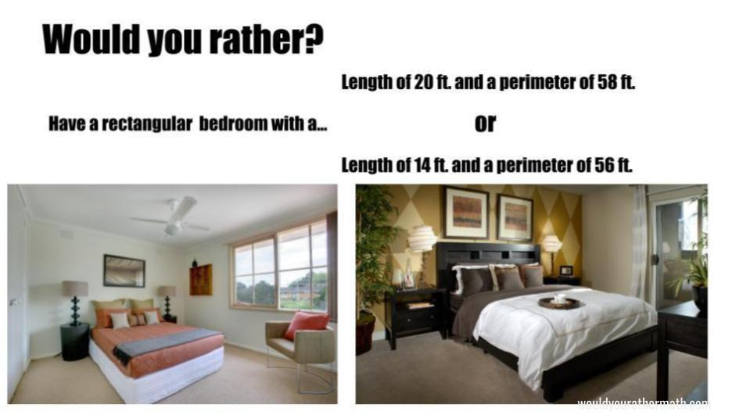  Length of 6 meters and a perimeter of 16 meters  Length of 4 meters and a perimeter of 24 meters  Option #3: Watch the video below on perimeter and area. Explain, to an adult, how perimeter and area are different.  https://www.youtube.com/watch?v=rSVMrPu0__U  Option #4: Get a measuring tape ready and head outside. Measure a square on the ground that has sides that are 1 meter in length. If you wanted to use rope to make your 1 m² shape, how much rope would you need for the perimeter?
Other areas of interest/learning experiences | Science: This week students can begin planting the seeds that they have collected. Continue making observations in your field journal as your seeds grow.  