Florenceville Elementary School

At FES our vision is to be a community where everyone is empowered to be lifelong learners.

HOME LEARNING PLAN- WEEK #8

Grade: | 3/4
TEACHER | Marlee Ralston: marlee.ralston@nbed.nb.ca
Sarah Mahar  Bridget Nugent | Principal: sarah.mahar@nbed.nb.ca;  Vice-Principal: bridget.nugent@nbed.nb.ca
Cindy Crowhurst | Resource: cynthia.crowhurst@nbed.nb.ca
Dianne Lord | Guidance: dianne.lord@nbed.nb.ca
School | florencevilleelementary@nbed.nb.ca

In accordance with the communication sent from our Minister of Education, Dominic Cardy, on April 2, 2020, Home learning opportunities to support literacy and numeracy outcomes will be made available online weekly by Teachers.
Families are encouraged to:
-Support their children to complete the options below for an average of one hour per day.
-Read aloud with their children daily; and
-consider daily physical activity and free play as an important part of their child’s mental health and skill development.
Subjects | Description of Learning Activities
Literacy | Reading:  Option #1: Log in to your Raz-Kids account and begin reading  www.kidsa-z.com (All log-in info has been sent to parents. Please let me know if you haven’t received it or are having trouble logging in)  Option #2: Read books that you have at home. Try reading to a parent, sibling or find a quiet place to read to yourself.  Option #3: Check out the rhymes, oral stories and thought problem posed in this week’s From 3 to 3 videos, listed below.  Writing:  Option #1: Write about something that you choose. (Students are encouraged to have choice when writing. If they are working on their own stories or have something different that they would like to write about, that is great! This option is for those students.)  Option #2: Write about the seeds that you have planted. What kind of seeds did you plant? Why did you choose to plant those kind of seeds? What are you most looking forward to happening with your plants? Do your plants have a use once fully grown?  Option #3: Write about your most favorite summer memory. Who was there? What were you doing? What part of the summer was it? Where did it happen? Why is it your favorite memory? How did/does it make you feel? Try to include your five senses (hear, feel, look, touch, taste).  Option #4: New Spring Riddles / Thought Problems, “From 3 To 3”: Students can feel free to do both if they would like! Discuss the riddle from the video below and have them justify their answer (prove it based on the clues in the riddle). Remember the thought problem has a truth and a lie. Discuss what is true and what is not!  Step 1: Discuss it orally.  Step 2: Write about it – first with an illustration then 1-2 sentences.  From 3 to 3: Watch this week’s From 3 to 3 videos. The answer is provided for last week’s thought problem, along with a new thought problem.  https://drive.google.com/file/d/1as6-Ci6wP47cDwlLROntN5-kRfY4h5jM/view?usp=sharing  Listen to chapter five of the novel Seven Day Magic by Edward Eager:  https://drive.google.com/file/d/1aB4kpQ2wOqI68bL8xerklqdT-lQ4tsRw/view?usp=sharing
Numeracy | Option #1: Log in to your Sumdog account and review your mental math strategies. All log-in information has been sent to parents. Please let me know if you haven’t received it or are having trouble logging in.  Option #2: Would you rather…? Justify or explain why you chose your answer. Bonus: Look around your kitchen, fridge and/or pantry and explore the different sizes of beverages/drinks in your home. If you can find an empty 2L bottle, find a measuring cup and try filling the empty 2L bottle with 250 ml of water, four times. What happens? Did your original answer change?  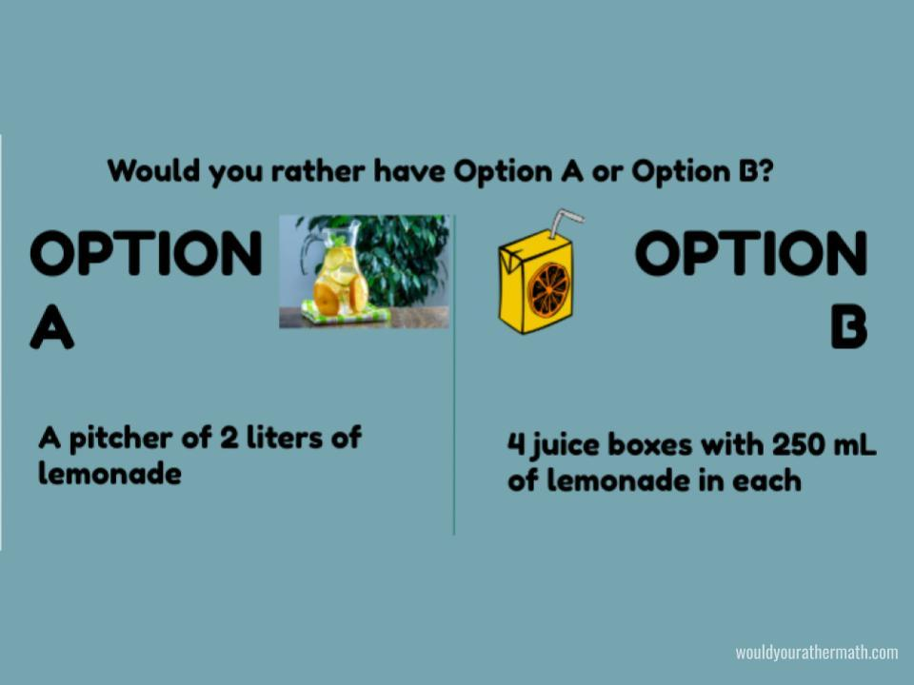  Option #3: Mr. Baker wants to have a garden in his back yard, but he does not know how to plan it. He calls you to plan his garden for him. Can you do the job? He has purchased 36 metres of fencing to use as an outline for his garden. The problem is that he does not know how wide and long to make his garden!  Find all the possible dimensions for Mr. Baker’s garden, given the amount of fencing he has. You should know something else. Mr. Baker wants a rectangular garden. He just hates squares and circles, and do not even get him started about triangles! Draw a picture to represent each possible solution:  • What is the smallest garden that can be created that uses all of his fencing? (Remember to use your math skills to find the area in meters squared [m²].)  • What is the largest garden that can be created that uses all of his fencing?  • Which set of dimensions do you think he should use? Why?  Option #4: Lisa starts with $12 in her bank account. She adds $12 to her account at the end of every two weeks from collecting recycled items. Jim starts with $32 in his bank account. He earns $4 at the end of every week for doing odd jobs for his neighbour, and adds that to his savings. After how many weeks will they both have the same amount of money in their bank accounts?
Other areas of interest/learning experiences | Science: We will begin to explore how soil affects plant growth. This week, collect soil samples from around your home or during a walk with family. See the image below. Put each different type of soil that you find in a small, separate container or one part of an egg carton (to keep it separated from the other soil types).  Use leftover seeds, or seeds that you find in food at home, to plant in these different soils.  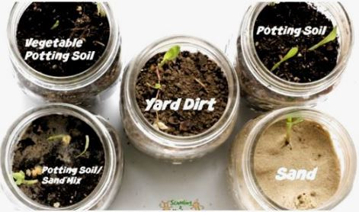  What do you think will happen? Will each seed thrive in the different soils that you have used?

