PRIMARY HOME LEARNING PLAN

Grade: | Kindergarten/Grade 1 Rachel Doucette
TEACHER | Rachel.Doucette@nbed.nb.ca
Sarah Mahar  Bridget Nugent | Principal: sarah.mahar@nbed.nb.ca; Vice-Principal: bridget.nugent@nbed.nb.ca
Cindy Crowhurst | Resource: cynthia.crowhurst@nbed.nb.ca
Dianne Lord | Guidance: dianne.lord@nbed.nb.ca
School | florencevilleelementary@nbed.nb.ca

In accordance with the communication sent from our Minister of Education, Dominic Cardy, on April 2, 2020, Home Learning Opportunities to support literacy & numeracy outcomes will be made available online weekly by Teachers.
Families are encouraged to: -
- Support their children to complete the options below for an average of one hour per day.
- Read aloud with their children daily.
- Consider daily physical activity and free play as an important part of their child’s mental health and skill development.
Subjects | Description of Learning Activities
Literacy | - Have your child listen to you read a book every day. When you finish the book, go back and do a retell of the story from beginning, to middle, and end. If your child skips over an important part, chime in and remind them.  - If possible, have your child draw a picture of his/her favourite part or character. Perhaps they can draw in a pan of flour.  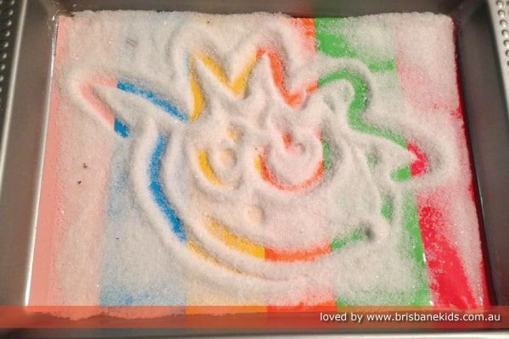  - Starfall.com is a great website/app for literacy. Its an interactive site that has content for learning letters and sounds, playing with words and phonics, as well as shared reading.  www.starfall.com
Numeracy | - Give your child a task to count items in your house. How many forks? Spoons? Bowls? Rolls of Toilet Paper? When they finish, if you can, have them write the numeral down on paper, or even in a pan full of flour.  - There are great counting songs on The Singing Walrus Channel on You Tube.  https://www.youtube.com/playlist?list=PLt7Se3SAnZY7l09Oc51Lau2SFsqfDkEuM
Other areas of interest/learning experiences | - Playing games were dice are involved is great for numeracy skills. Board games are also great for oral language, building social skills, and literacy skills for reading simple pictures or words.  - Hopefully you have been able to get outside for some fresh air. If you see melting snow, streams, puddles, mud, etc., have your child take time and explore the world around them. Spring has just begun. It is an exciting time to talk about what the melting snow is revealing from the fall before and tracking how things change and grow in the next few weeks as grass, leaves, and some flowers emerge. Talk with your child about the growing hours of sun time that we are getting, and try to connect it to raising temperatures, plants beginning to grow, and creatures like bugs starting to come out.

