|  |
| --- |
| **FES the Fox.jpgFlorenceville Elementary School**  **At FES our vision is to be a community where everyone is empowered to be lifelong learners.** |

|  |
| --- |
| **PRIMARY HOME LEARNING PLAN** |

|  |  |
| --- | --- |
| **Grade:** | **Grade 2 French Immersion** |
| **TEACHER** | **Molly Kearney:** [**molly.kearney@nbed.nb.ca**](mailto:molly.kearney@nbed.nb.ca)    **Charlotte Dufort:** [**charlotte.dufort@nbed.nb.ca**](mailto:charlotte.dufort@nbed.nb.ca) |
| **Sarah Mahar**  **Bridget Nugent** | **Principal:** [**sarah.mahar@nbed**](mailto:Sarah.mahar@nbed)**.nb.ca;**  **Vice-Principal:** [**bridget.nugent@nbed.nb.ca**](mailto:bridget.nugent@nbed.nb.ca) |
| **Cindy Crowhurst** | **Resource:** [**cynthia.crowhurst@nbed.nb.ca**](mailto:cynthia.crowhurst@nbed.nb.ca) |
| **Dianne Lord** | **Guidance:** [**dianne.lord@nbed.nb.ca**](mailto:dianne.lord@nbed.nb.ca) |
| **School** | [**florencevilleelementary@nbed.nb.ca**](mailto:florencevilleelementary@nbed.nb.ca) |

|  |  |
| --- | --- |
| In accordance with the communication sent from our Minister of Education, Dominic Cardy, on April 2, 2020, Home learning opportunities to support literacy and numeracy outcomes will be made available online weekly by Teachers.  Families are encouraged to:  -Support their children to complete the options below for an average of one hour per day.  -Read aloud with their children daily; and  -consider daily physical activity and free play as an important part of their child’s mental health and skill development. | |
| **Subjects** | **Description of Learning Activities** |
| **GENERAL INFO** | ***Week 6: May 11th – May 12th***  **Visit blog this week and take time to explore different pages**  BLOG: *madamekearney.edublogs.org* |
| **Science:** |  |
| **Literacy: Vocabulary Games** | Vocabulary games (at the bottom of this document to print if possible)  -La phrase secrete (new version for week 6)   * Print paper or snap shot page. * One person choose a sentence and writes it down without the other one seeing. * Then the player has to try to guess the sentence by using the correct sentence structure.   -Serpent et échelle (snakes and ladders) continued from week 5   * Roll the dice, and move your player the number of spaces on the dice. * If you want on a question is must be answered in a full sentence out loud ☺ * If you land on the bottom of a ladder, you slide to the top of the ladder. * If you want on the head of a snake, you slide to the bottom of the snake! |
| **Literacy:**  **Online** | * **Sight words of the week**   -comment  -court  -courir  -deux  -doit  Link: <https://www.youtube.com/watch?v=7dMECbtTd7E&feature=youtu.be>  You can then create a sentence using the words. Don’t forget your capital letter a  and the period at the end.   * **Le Corona Monstre (continued from week 5)**   Image also posted the blog:    -On the blog page : “Sound Work” Madame Dufort reads the story above on what she has been up to during this time at home! Listen to her read, and try reading her story on your own, THEN, it’s your turn to write us a story on what YOU have been up to! ☺  -Qu’est-ce que tu fais pour passer le temps? (What have you been doing during quaratine to pass the time? Write to us and post it on the Facebook group or on the FES website!   * CONTINUE : **Spend 15-20 mins of reading & activities on the Litteratout site**   EXTRA: Another great blog is [www.asdw2fi.weebly.com](http://www.asdw2fi.weebly.com/) |
| **Literacy:**  **Video links** | MINI TFO:  Video for Mother’s Day (La fête des mères):  <https://www.youtube.com/watch?v=kt_9dA4sbzA>  “Le printemps”  <https://www.youtube.com/watch?v=0I95awpaDpY&feature=youtu.be> |
| **Literacy: Reading** | * **ONLINE BOOKS :**   Gloup’s! J’ai avalé Cornebidouille!  <https://www.youtube.com/watch?v=f4eQve746M8>      les monsieur madame sport  <https://www.youtube.com/watch?v=hsFFGsfELE4>    Les Monsieur Madame - Oiseaux  <https://www.youtube.com/watch?v=58RF7JGquXc>      Compilation sur les animaux : LES OISEAUX    <https://www.youtube.com/watch?v=QuIHCGnPXvA>        les monsieur madame cuisinier    <https://www.youtube.com/watch?v=r209b84uxtM>  Read books that you have at home. Try reading to a parent, sibling, stuffie, or find a quiet place to read to yourself. Get creative! Find a comfy spot outside to read.  Maybe have a FLASHLIGHT day!!  Literal response questions (read the lines): Find the page that tells us…..What happened first? Next? Who are the characters? What is the setting?  Inferential response questions (read between the lines): What does this picture tell us about the story? Why did this character say …..? How is this character feeling?  Personal Connections: Has anything like this happened to you? What is your favourite part and why? Does this character and yourself have anything in common?  When you’re reading this week, think about the characters you’ve met. (Suggestions)  · What’s the character (s) like?  · How is the character similar to you?  · How is the character different than you?  · How was the character feeling / acting? |
| **Numeracy:**  **Online** | 1. Continue with IXL   <https://ca.ixl.com/>  https://www.ixl.com   1. Video: Compter par 10   <https://www.youtube.com/watch?v=SIYLlgGjSAM&list=PLMb4QBzxFwX-UyVbCbS6HUnFOg-AnHKoS&index=13> |
| **Numeracy:**  **Activities to try at home** | **Math Flower**  WEEK 6: PICK A NEW NUMBER ☺  Draw or cut out a circle. Put a number (between 30-100) in the middle of your circle. For each petal added, represent your number in a different way (word, dots, tallymarks, addition, subtraction).        **Math Monster** |
| **Numeracy:**  **Games** | Grade 2 Choice Board:    **Find the change at home to buy these items:** |
| **Numeracy Videos** | * Listen to a French counting video for numbers 50-70. Title:   « Les chiffres et les nombres de 50 à 70 – alain le lait » Click on the link below to see the video (put cursor over the link then hit your ctrl button + click) Link: <https://www.youtube.com/watch?v=oIYvC7r05mU>  Count by 10’s from 0-100 in French. Link: <https://www.youtube.com/watch?v=aqvgZIQ0zJo>  Give your child a collection of 100 small objects (example: Cheerios, macaroni noodles, … and have him/her make groups of 10 until there are 10 groups of 10, which makes 100. Then, ask your child to point at each group and count by 10’s in French. |
| **Physical Education/ Getting outside** | **MOVING WITH PURPOSE! MAY 2020 (below)**    Cosmic Kids Yoga  <https://www.youtube.com/user/CosmicKidsYoga>  Moovlee  <https://www.youtube.com/channel/UCsSS5kMpKCaJ_HhTM9-HKHg/featured>  Kids HIIT workout  <https://www.youtube.com/watch?v=lc1Ag9m7XQo>  Dance Along with Kidz Bop to “Memories”  <https://www.youtube.com/watch?v=gFEuf3Bvj0c&list=PLMr-d2PLsO95ydptpBnsxdQNSKc9iUNU0&index=4> |
| **Art** | Choice 1: Make a birdhouse from recycled materials at home…  C:\Users\duforchl\AppData\Local\Microsoft\Windows\INetCache\Content.MSO\7040387A.tmpC:\Users\duforchl\AppData\Local\Microsoft\Windows\INetCache\Content.MSO\6FB165B9.tmpC:\Users\duforchl\AppData\Local\Microsoft\Windows\INetCache\Content.MSO\804C3164.tmp  Je fabrique une maison pour les oiseaux!   * Utilise le matériel recycler. (Use recycled material) * Utilise ton imagination. (Use your creativity)   Then ask a parent to post your bird house.  C:\Users\duforchl\AppData\Local\Microsoft\Windows\INetCache\Content.MSO\7801967E.tmpC:\Users\duforchl\AppData\Local\Microsoft\Windows\INetCache\Content.MSO\C0D460D.tmpC:\Users\duforchl\AppData\Local\Microsoft\Windows\INetCache\Content.MSO\95078E9F.tmp  Choice 2: continued  Look through magazines and newspaper at home!  Cut out images or words and place them together/ glue them on a page to describe things about you!  Choice 2:  Choose 5-10 items around your house that best describe you!  THEN… Take a picture and post on the classroom Facebook page! We want to see what you are up to! |

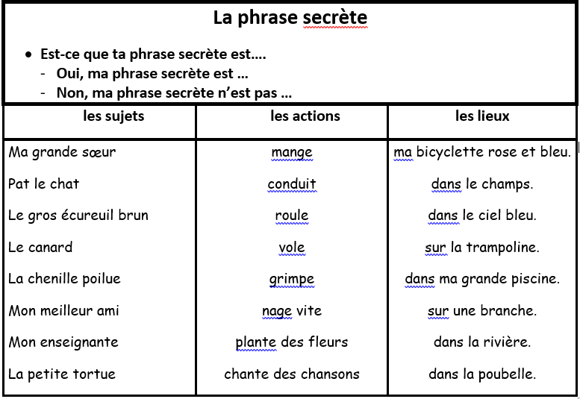

|  |  |  |  |  |  |  |
| --- | --- | --- | --- | --- | --- | --- |
| 42  http://us.cdn2.123rf.com/168nwm/tawng/tawng1007/tawng100700028/7404152-set-of-editable-snakes-designs-black-and-white.jpg | 43  Quel âge  as-tu ? | http://cdn7.fotosearch.com/bthumb/CSP/CSP814/k8149793.jpg 44  Quel âge a ton frère ou papa? | 45 | 46  http://us.cdn2.123rf.com/168nwm/tawng/tawng1007/tawng100700028/7404152-set-of-editable-snakes-designs-black-and-white.jpgQuelle couleur sont tes cheveux? | 47  **FIN !** |  |
| 41 | 40 | 39  Quand est la fête de ta mère ou ton père? | 38 | 37 | 36  Quel est ton fruit préféré? | 35 |
| 28 | 29  Est-ce que tu aimes la laitue ou les carottes?  http://cdn7.fotosearch.com/bthumb/CSP/CSP814/k8149793.jpg | 30  http://us.cdn2.123rf.com/168nwm/tawng/tawng1007/tawng100700028/7404152-set-of-editable-snakes-designs-black-and-white.jpgEst-ce que tu préfères les chats ou les chiens ? | 31    http://cdn7.fotosearch.com/bthumb/CSP/CSP814/k8149793.jpg | 32  http://us.cdn2.123rf.com/168nwm/tawng/tawng1007/tawng100700028/7404152-set-of-editable-snakes-designs-black-and-white.jpg | 33    Quelle est ta saison préférée? | 34  Quel est ton sport favori? |
| 27  Décris tes vêtements? | 26 | 25  Quel est ton activité d’été préférée? | 24  Quand est la fête de ton ami? | 23 | 22  Quelle couleur sont tes yeux? | 21 |
| 14  Quel est ton livre préféré? | http://us.cdn2.123rf.com/168nwm/tawng/tawng1007/tawng100700028/7404152-set-of-editable-snakes-designs-black-and-white.jpg 15 | 16 | 17  Comment s’appelle ton ami? | 18 | 19 | 20  Quel âge a ton ami? |
| 13 | 12  Quelle est ta couleur préférée? | 11 | http://cdn7.fotosearch.com/bthumb/CSP/CSP814/k8149793.jpg 10 | 9 | http://us.cdn2.123rf.com/168nwm/tawng/tawng1007/tawng100700028/7404152-set-of-editable-snakes-designs-black-and-white.jpg 8 | 7  Qu’est-ce-que tu aimes faire en été? |
| **DÉPART** | 1 | 2  Comment s’appelle tes amis de classe? | 3 | 4 | 5  Quand est ta date d’anniversaire? | 6  Quel légume que tu détestes? |

Débutant #2