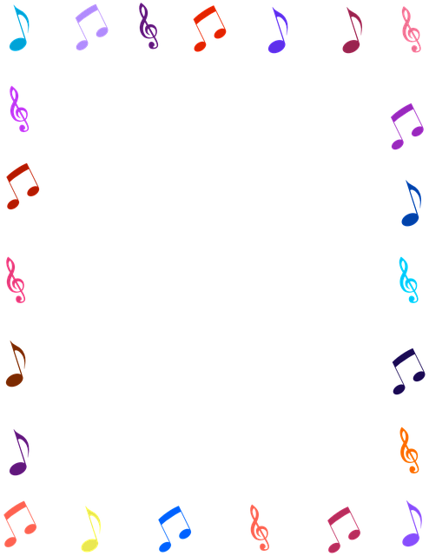
K-2 APRIL music with mrs. Lord
Missing my students everyday and thought they might like to
sing and dance along with some of our favorites, perhaps learn some
new songs or read along and sing. Each is a link to songs and/or stories.
Grade 2 had been doing more with instruments and theory but they
should enjoy these as well. Have fun!

FEW OF OUR FAVORITES:
Color Song
https://www.youtube.com/watch?v=gavT_q9CLME
Hokey Pokey
https://www.youtube.com/watch?v=iZinb6rVozc
Head and Shoulders
https://www.youtube.com/watch?v=WX8HmogNyCY

SOMETHING NEW:
Spring is Here
https://www.youtube.com/watch?v=Cz1Hs-4TfFQ

Boom Chic a Boom (This changes with seasons, etc so this is the lastest)
https://www.youtube.com/watch?v=9nKq4jm4LD8

READ AND SING:
Five Green and Speckled Frogs
Book: https://www.youtube.com/watch?v=hI6y0AVqBFA
Song: https://www.youtube.com/watch?v=ziGG_L9C12o
Over in the Meadow
Book: https://www.youtube.com/watch?v=sV_MvCwQlWY&t=4s
Song: https://www.youtube.com/watch?v=WnkVe31zic0

