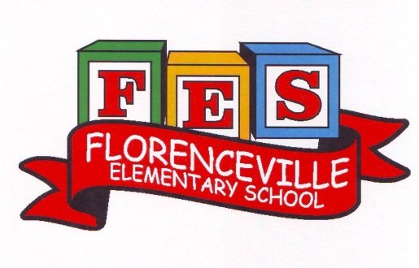
Florenceville Elementary School
Volunteer & Community Appreciation Breakfast

Thank You Volunteers & Community Members!!!
You have been a very positive support
for FES students and staff this school year.

You are invited: 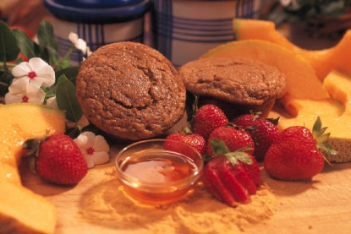
8:00 - 8:45 am, Friday. June 17
Florenceville Elementary School Gym
Continental Breakfast
(Coffee, tea, juice, Toast, Eggs, fruit, Yoghurt)

Please RSVP by June 13
Valerie Carmichael :
276-4008 or Valerie.carmichael@nbed.nb.ca

