Emma’s PJs
4th Annual Pajama Drive in Memory of
Emma Pearson
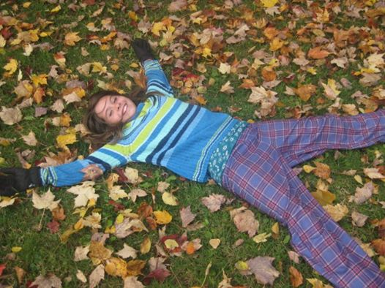

Collecting new pajamas for women and children until December 7th.

Donated pjs will go to Sanctuary House, Kinsmen Miracle Boxes, Valley Food Bank,
URVH, IWK, and local women and children in need.

Spreading Love Around, one pair of pajamas at a time, with a message of comfort, hope and love.


Thank you for helping us do that!

