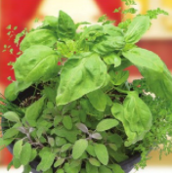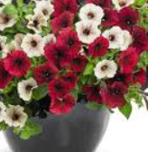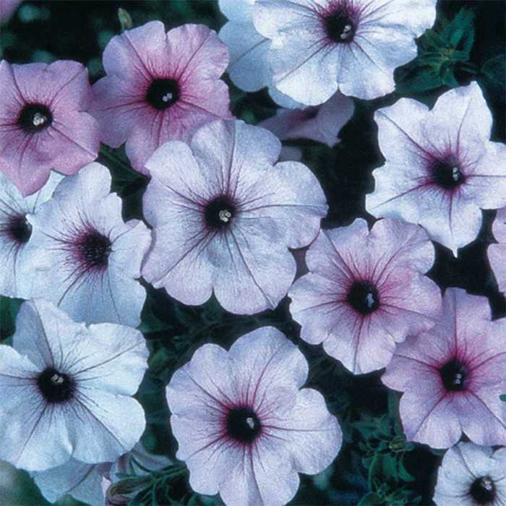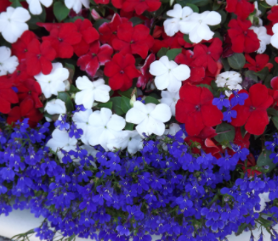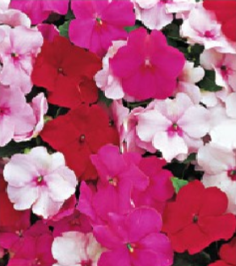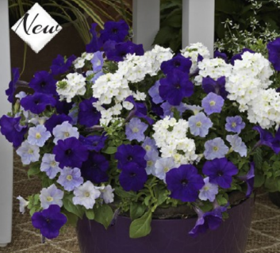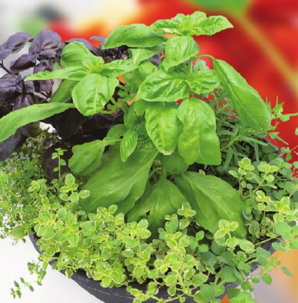

FMS

Spring

Fundraiser

LET’S GET READY FOR

SPRING!

FMS HAS PARTNERED WI

TH JOLLY FARMER TO

SELL HANGING BASKETS AND PLANTERS!

Order Due Date

March 14, 2018

Pick Up

Date TBA: First week of June

Contact

Ask an FMS Student/Staff/Parent,

or call Sally at 392

-

5115

Thank You

for supporting

various clubs, activities, and

sports at FMS!

10’’ Patio Herb $30:

Italian Chef’s Choice:

Country Kitchen:

Sunny Novelties $15

Red Velvet/White Petunia $15

Blue/Silver Petunia $15

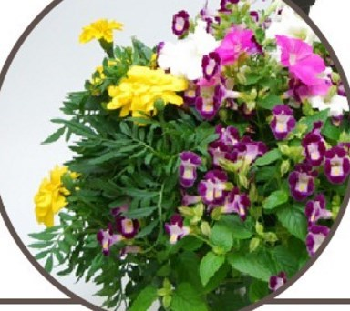

Porch Swing Mix:

Dark blue and light blue

Petunias with white verbena $15

Red/White/Blue Impatiens with Lobelia $15

Peppermint Mix

Impatiens

$15

Basil

Garlic Chives

Parsley

Thyme

Sweet Marjoram

Purple Sage

Sweet Basil

Purple Basil

Lemon Thyme

Spicy Oregano

Variegated Oregano

BBQ Rosemary