Here are the assessment results from last year:
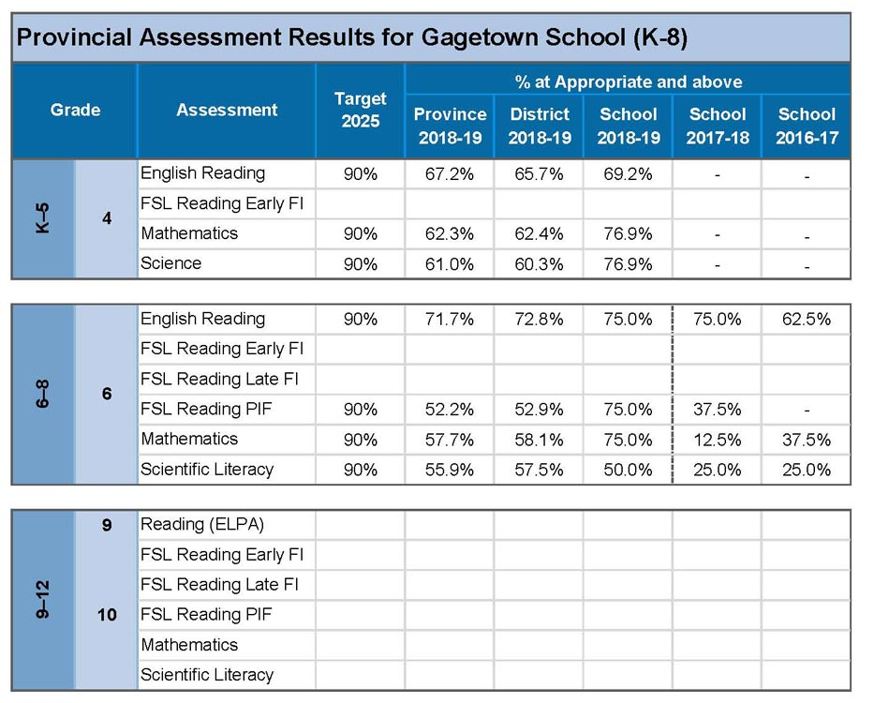

- NR = Not Reportable (too few students to report results in accordance with the Department’s confidentiality guidelines).
- All students are included when calculating the results, other than those who were absent when the assessment was administered. The percentage of students with exemptions is counted in the Below Appropriate Achievement category.
- Grade 6 results should not be compared with previous years due to adjustment of the assessments in 2018-19 and application of new analysis methodology introduced for better alignment of the Francophone Sector and the Anglophone Sector.

