Equations & Graphs of Polynomial Functions

The zeros of any polynomial function y = f(x) correspond to the x-intercepts of the graph and to the roots of the corresponding equation, f(x)=0. For example, the zeros of the function are
x = 2, –3 and 5. Thus, the x-intercepts of the graph of the function will be at 2, –3 and 5. These will also be the roots of the corresponding equation .

Example 1: Analyze Graphs of Polynomial Functions

For each graph of a polynomial function shown, determine:
- the least possible degree of the function
- the sign of the leading coefficient
- the x-intercepts and the factors of the function with least possible degree
- the intervals where the function is positive and the intervals where it is negative

Graph A Graph B
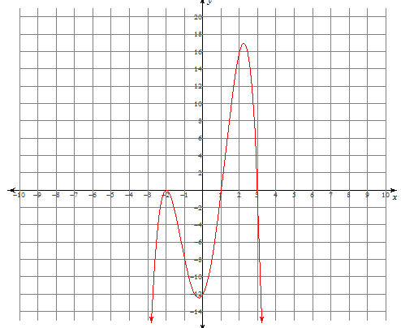
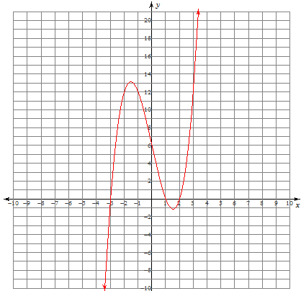

Solution:
Graph A  a. least possible degree: __3___  b. sign of the leading coefficient:_ positive______________  c. x-intercepts: _-3, 1, 2_______________________  factors of the function: _(x+3), (x-1)  (x-2)____________________  d. intervals where function is positive: (-3 to 1) and (2 to infinity)  intervals where function is negative: (-infinity to -3, 1 to 2). | Graph B  a. least possible degree: __4___  b. sign of the leading coefficient:____negaitve____________  c. x-intercepts: -2, 1, 3________________________  factors of the function: _(x+2), (x-1), (x-3)_____________________  d. intervals where function is positive: (1 to 3)  intervals where function is negative: (- infinity to -2, -2 to 1, 3 to infinity)
Multiplicity of a Zero
- The multiplicity of a zero refers to the number of times a zero (x-intercept) of a polynomial function occurs. For example, the function has a zero of multiplicity 2 (double root) at x = –3 and a zero of multiplicity 1 at x = 1 (single root).

- The multiplicity of a zero or root can also be referred to as the order of the zero or root.

- Polynomial functions change sign at x-intercepts that correspond to odd multiplicity. The graph crosses over the x-axis at these intercepts.

- Polynomial functions do not change sign at x-intercepts of even multiplicity. The graph touches, but does not cross, the x-axis at these intercepts.

To illustrate this concept, consider the following graphs of degree 3 polynomial functions:
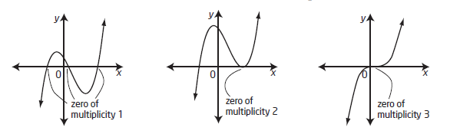

3 distinct roots
1 distinct root,
2 equal roots
3 equal roots

Sketching Graphs of Polynomial Functions

To sketch the graph of a polynomial function, determine characteristics such as:

- the degree of the function
- the sign of the leading coefficient
- end behaviour
- the y-intercept
- the x-intercepts and their multiplicity
- intervals where the graph is positive / negative → Note: 0 is not (+) or (–) and therefore not included
- other points on the graph

Example 2: Analyze Equations to Sketch Graphs of Polynomial Functions

Sketch the graph of each polynomial function.

- b. c.

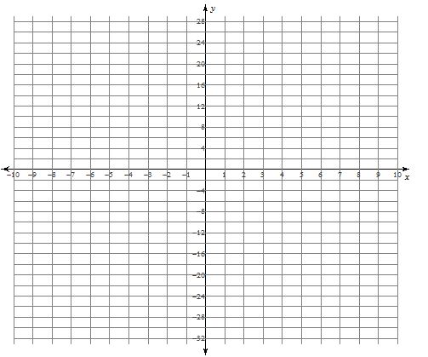
Solution:

Degree | 3
Leading Coefficient | positive
End Behaviour | 3 to 1
x-intercepts & multiplicity | -4, -2, 3 (all multiplicity 1)
y-intercept | -24
Interval(s) where the function is positive | (-infinity to -4), (-2, 3)
Interval(s) where the function is negative | (-4, -2) (3 to infinity)
Other points | Choose x-values to plug into equation

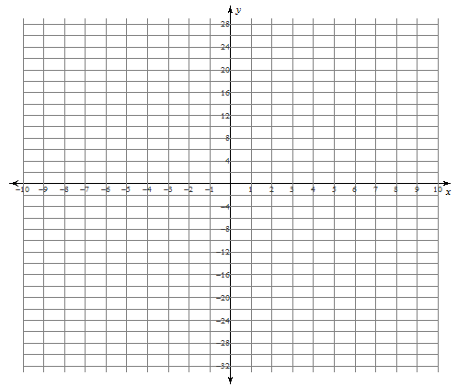
Degree | 4
Leading Coefficient | negative
End Behaviour | 3 to 4
x-intercepts & multiplicity | -3 (multiplicity 1), 1(multiplicity 3)
y-intercept | 3
Interval(s) where the function is positive | (-3, 1)
Interval(s) where the function is negative | (-infinity to -3), (1 to infinity)
Other points | Choose x-values to plug into equation

- Determine the factored form of the function:
fx = -2(x+2)(x-1)(x-1) →Use division/factoring to get these
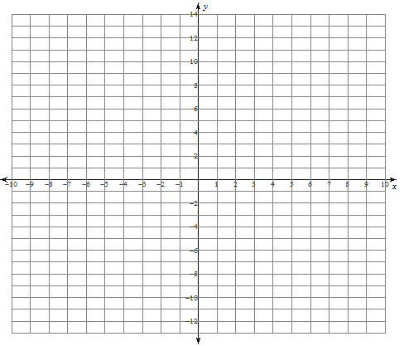
Degree | 3
Leading Coefficient | negative
End Behaviour | 2 to 4
x-intercepts & multiplicity | -2(multiplicity 1), 1(multiplicity 2)
y-intercept | -4
Interval(s) where the function is positive | (-∞, -2)
Interval(s) where the function is negative | (-2, 1), (1, ∞)
Other points | Choose x values to put in equation

Example 3: Determining the Equation of a Polynomial Function from its Graph

Determine the equation of the polynomial function that corresponds to the graph shown.

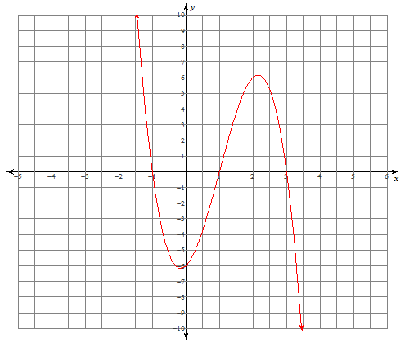
Solution:

The graph of the function has __3___ x –intercepts.
All of the x-intercepts are of ____odd____ multiplicity. The least possible multiplicity of each x-intercept is
_____1_, so the least possible degree is _3_____.

The graph extends up into quadrant __2____ and down into quadrant __4____, so the leading coefficient is ____negative________________.

The y-intercept is __-6____; this is the __________constant_____ term in the expanded form
of the equation of the function.

The x-intercepts are __-1____, __1____, and ___3___.

Use the above information to determine the factored form of the equation of the polynomial function:
f(x) = ______-2(x+1)(x-1)(x-3)

