Section 2.3 Extra Practice

1. Identify the point of perspective for each drawing.
a)
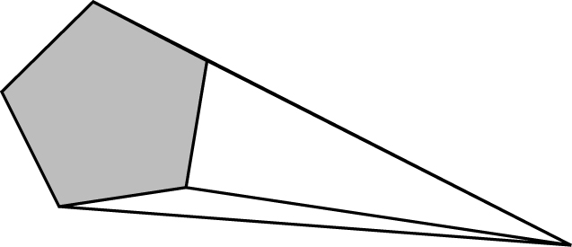
b)

c)
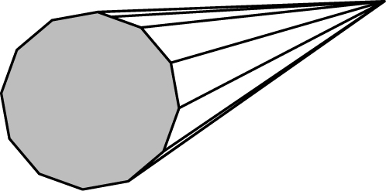
2. a) On the bottom of a piece of paper, sketch an object.
b) On the top right corner, place a vanishing point.
c) Draw lines from the top and bottom of the object to the vanishing point.
d) Using the lines as a guide, draw a vanishing row of the object you drew.
3. a) On grid paper, write your day of birth as block numbers.
b) Locate a vanishing point to the right of the birth day.
c) Create a one-point perspective drawing of your birth day.
d) What is the point of perspective of your drawing?

4. a) List the ingredients that an employee would use to make a breakfast sandwich at a fast food restaurant.
b) Starting with the bottom piece, list the ingredients in the order that the person would build the breakfast sandwich.
c) Create and label an exploded view diagram of the breakfast sandwich.
5. A bed is made up of a number
of parts.
a) List the parts and the quantities of each part that make up a bed.
b) Write a sequence of steps for assembling the bed.
c) Draw an exploded view diagram of the bed.

