Physical Geography 110 Name:
Unit 3 Assignment 1: Geology
1. Using your own words as much as possible, explain the three main sources of the Earth’s internal heat. [3 points]

2. Calculate the approximate percentage of the distance to the centre of the Earth humans have actually travelled. What is your personal reaction to this percentage? [2 points]

3. Describe the three main ways scientists know about the internal composition of the planet. Explain what information is provided by each of these processes. [6 points]

4. Seismic energy produces two kinds of waves, which seismometers detect and graphically record. a. Describe and differentiate between P-waves and S-waves. [2 points]

5. How have meteorites helped scientists to learn about the composition of the Earth? (Consult Internet sources to inform your answer.) [3 points]

6. What is the “Richter scale”? Provide some details (Internet research is expected). [2 points]

7. How is the Earth like a pot of boiling water? Be sure to include a detailed explanation of convective heat transfer in your response. [3 points]

8. Mount St. Helens, in Washington State (USA), has long been the most active volcano in the Pacific Northwest. Watch this great NASA imagery of devastation and recovery at Mount St. Helens covering the time period 1979-2011: http://earthobservatory.nasa.gov/Features/WorldOfChange/sthelens.php Describe the environmental changes which occurred as a result of the May 18, 1980 eruption of Mt. St. Helens and the estimated time for the surrounding area to recover. [3 points]

9. Study the illustration below. What is its main message with respect to plate tectonic theory? [2 points]
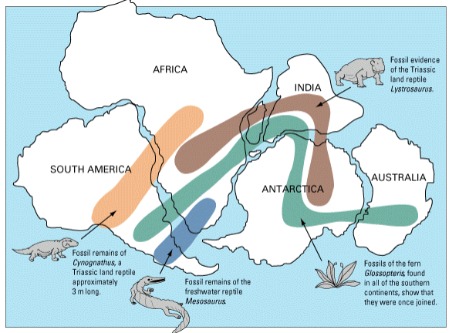 (http://cimss.ssec.wisc.edu/sage/geology/lesson2/concepts.html )

10. Most of the action associated with tectonics occurs at the boundaries of the moving plates, where two plates meet. Describe the differences between the three types of plate boundaries by both describing their characteristics and identifying some specific events that may occur in each case. [6 points]

11. Go to the link below and read the article and watch the short video clip on the drying up of the Haida Gwaii hot springs in November, 2012. What happened to the hot springs and why do scientists believe it occurred? http://www.cbc.ca/news/canada/british-columbia/haida-gwaii-hot-springs-shut-off-byearthquake-1.1210851 . [2 points]

12. Identify and describe three positive effects of tectonic activity and volcanic eruptions. [3 points]

